

**APPENDICES**

**Children and Young People with**

**Special Educational Needs and Disabilities (SEND)**

**Joint Strategic Needs Assessment (JSNA)**

**2024**

# Appendix 1: Map 1: Cumberland – number of children and young people aged 0-25 years by Ward.

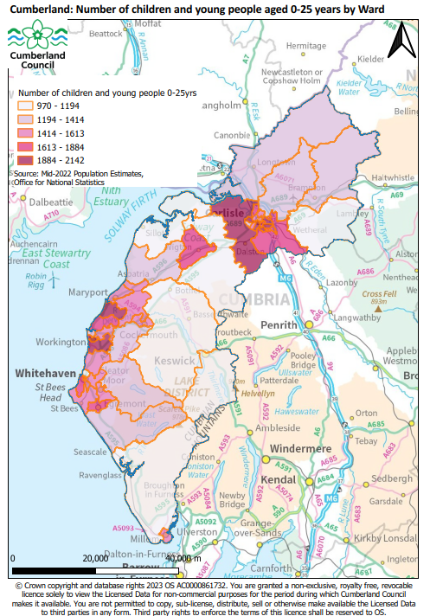

# Appendix 2: Map 2: Cumberland – Child Poverty; proportion of children (0-15 years) in relative low income families by Ward.

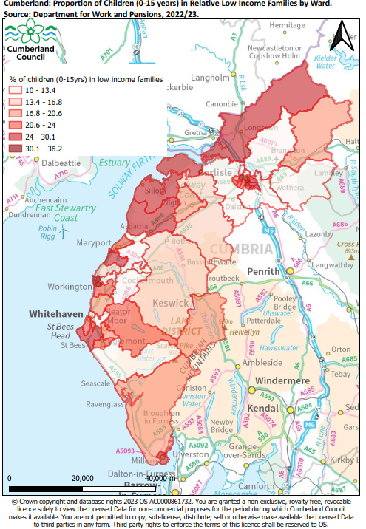

# Appendix 3: Map 3: Cumberland – Children and young people (0-25 years) with an EHCP by Ward (based on postcode of where the child lives or is registered).

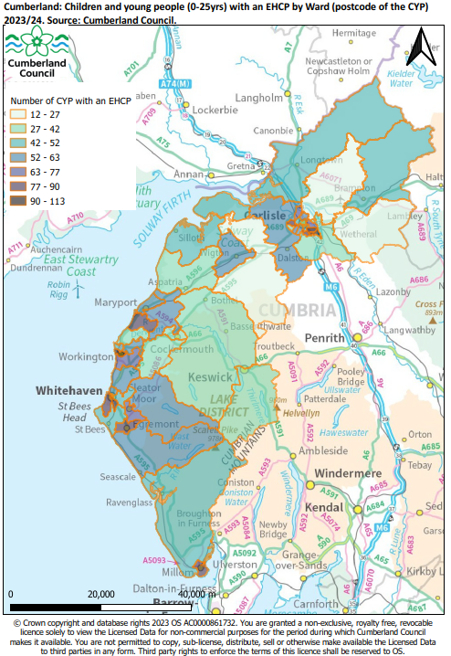

# Appendix 4: Map 4: Cumberland – Children and young people (0-25 years) with SEN support by Ward (based on postcode of where the child lives or is registered).

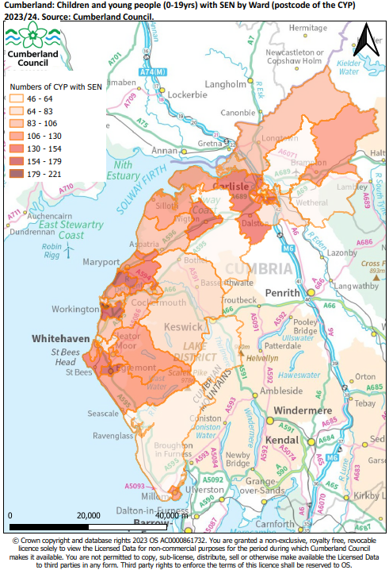

# Appendix 5: Map 5: Cumberland – pupils with an EHCP by school Ward (based on postcode of the school location).

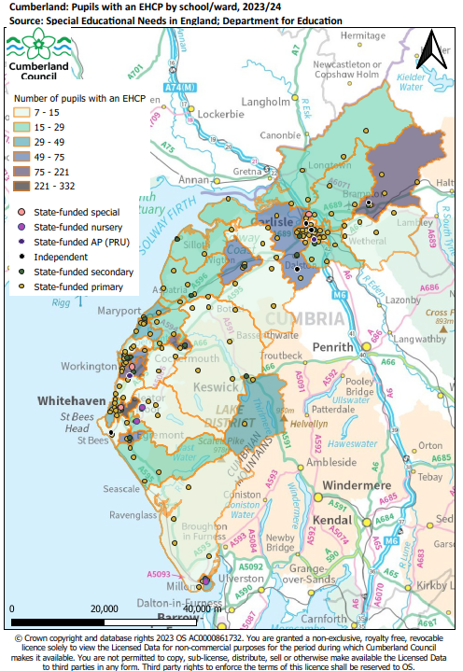

# Appendix 6: Map 6: Cumberland – pupils with SEN support by school Ward (based on postcode of the school location).

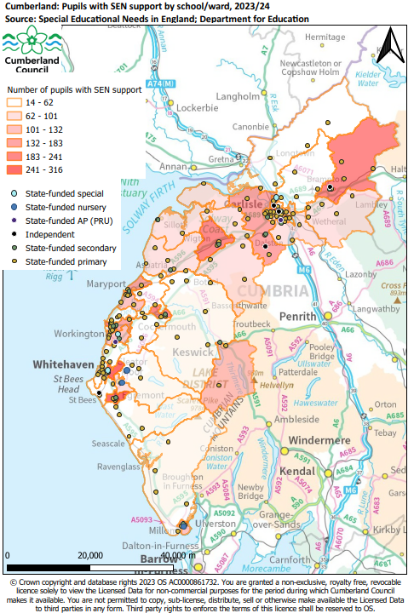

# Appendix 7 – Table 1: Location of children and young people with SEND by Ward (child postcode)

Using data sourced from Cumberland Council, Table X presents numbers of pupils with SEN support and EHCPs by Ward using the postcode of where the child or young person lives (is registered) and not where the child attends school.

Table 1: Children and young people by SEN status and by Ward (where they live); June 2024

|  |  |  |  |  |  |  |
| --- | --- | --- | --- | --- | --- | --- |
| WD23NM | Former district | SEN support | EHCP | Total SEND | SEN support | EHCP |
| Moss Bay and Moorclose | Allerdale | 221 | 99 | 320 | 69.1% | 30.9% |
| Harraby North | Carlisle | 162 | 110 | 272 | 59.6% | 40.4% |
| Upperby | Carlisle | 179 | 87 | 266 | 67.3% | 32.7% |
| Egremont | Copeland | 172 | 88 | 260 | 66.2% | 33.8% |
| Maryport South | Allerdale | 173 | 85 | 258 | 67.1% | 32.9% |
| Belle Vue | Carlisle | 154 | 89 | 243 | 63.4% | 36.6% |
| Harrington | Allerdale | 160 | 77 | 237 | 67.5% | 32.5% |
| Harraby South | Carlisle | 120 | 113 | 233 | 51.5% | 48.5% |
| Mirehouse | Copeland | 127 | 90 | 217 | 58.5% | 41.5% |
| Belah | Carlisle | 149 | 67 | 216 | 69.0% | 31.0% |
| Wigton | Allerdale | 149 | 63 | 212 | 70.3% | 29.7% |
| Kells and Sandwith | Copeland | 117 | 89 | 206 | 56.8% | 43.2% |
| Dearham and Broughton | Allerdale | 147 | 56 | 203 | 72.4% | 27.6% |
| Dalston and Burgh | Carlisle | 140 | 61 | 201 | 69.7% | 30.3% |
| Millom | Copeland | 112 | 86 | 198 | 56.6% | 43.4% |
| Denton Holme | Carlisle | 136 | 60 | 196 | 69.4% | 30.6% |
| Cleator Moor West | Copeland | 127 | 68 | 195 | 65.1% | 34.9% |
| Botcherby | Carlisle | 118 | 73 | 191 | 61.8% | 38.2% |
| Egremont North and St Bees | Copeland | 137 | 52 | 189 | 72.5% | 27.5% |
| Cleator Moor East and Frizington | Copeland | 120 | 63 | 183 | 65.6% | 34.4% |
| Solway Coast | Allerdale | 130 | 51 | 181 | 71.8% | 28.2% |
| Morton | Carlisle | 114 | 58 | 172 | 66.3% | 33.7% |
| Maryport North | Allerdale | 113 | 58 | 171 | 66.1% | 33.9% |
| Gosforth | Copeland | 112 | 59 | 171 | 65.5% | 34.5% |
| Howgate | Copeland | 104 | 62 | 166 | 62.7% | 37.3% |
| Brampton | Carlisle | 112 | 50 | 162 | 69.1% | 30.9% |
| Seaton | Allerdale | 114 | 41 | 155 | 73.5% | 26.5% |
| Longtown | Carlisle | 105 | 44 | 149 | 70.5% | 29.5% |
| Aspatria | Allerdale | 106 | 39 | 145 | 73.1% | 26.9% |
| St John's and Great Clifton | Allerdale | 89 | 56 | 145 | 61.4% | 38.6% |
| Cockermouth North | Allerdale | 94 | 41 | 135 | 69.6% | 30.4% |
| Cockermouth South | Allerdale | 89 | 40 | 129 | 69.0% | 31.0% |
| Hillcrest and Hensingham | Copeland | 80 | 47 | 127 | 63.0% | 37.0% |
| Castle | Carlisle | 78 | 49 | 127 | 61.4% | 38.6% |
| St Michael's | Allerdale | 77 | 48 | 125 | 61.6% | 38.4% |
| Stanwix Urban | Carlisle | 69 | 55 | 124 | 55.6% | 44.4% |
| Yewdale | Carlisle | 78 | 41 | 119 | 65.5% | 34.5% |
| Currock | Carlisle | 69 | 48 | 117 | 59.0% | 41.0% |
| Millom Without | Copeland | 64 | 52 | 116 | 55.2% | 44.8% |
| Bransty | Copeland | 58 | 57 | 115 | 50.4% | 49.6% |
| Bothel and Wharrels | Allerdale | 83 | 31 | 114 | 72.8% | 27.2% |
| Wetheral | Carlisle | 69 | 42 | 111 | 62.2% | 37.8% |
| Keswick | Allerdale | 59 | 35 | 94 | 62.8% | 37.2% |
| Thursby | Allerdale | 51 | 27 | 78 | 65.4% | 34.6% |
| Corby and Hayton | Carlisle | 55 | 12 | 67 | 82.1% | 17.9% |
| Houghton and Irthington | Carlisle | 46 | 18 | 64 | 71.9% | 28.1% |
| Out of area or unknown |  | 80 | 77 | 157 |  |  |
| Cumberland Total |  | 5,218 | 2,814 | 8,032 |  |  |

Source: Cumberland Council

# Appendix 7 – Table 2: Location of children and young people with SEND by Ward (location of school)

Using data published by the Department for Education, Table X below presents the number of pupils with SEN support and EHCPs by Ward based on the location of the school.

Table 2: Pupils by SEN status and by Ward of school location; June 2024

|  |  |  |  |  |  |  |  |
| --- | --- | --- | --- | --- | --- | --- | --- |
| Ward Name | Former district | Total pupils | SEN support | EHC plan | Total SEND | SEN support % | EHC plan % |
| Hillcrest and Hensingham | Copeland | 2,597 | 295 | 332 | 627 | 11.4% | 12.8% |
| Castle | Carlisle | 2,000 | 316 | 84 | 400 | 15.8% | 4.2% |
| Belah | Carlisle | 1,148 | 164 | 221 | 385 | 14.3% | 19.3% |
| Egremont | Copeland | 1,824 | 304 | 75 | 379 | 16.7% | 4.1% |
| Cockermouth North | Allerdale | 1,923 | 241 | 100 | 341 | 12.5% | 5.2% |
| Brampton | Carlisle | 1,732 | 210 | 105 | 315 | 12.1% | 6.1% |
| Upperby | Carlisle | 1,373 | 235 | 74 | 309 | 17.1% | 5.4% |
| St Michael's | Allerdale | 1,416 | 235 | 49 | 284 | 16.6% | 3.5% |
| Wigton | Allerdale | 1,738 | 220 | 60 | 280 | 12.7% | 3.5% |
| St John's and Great Clifton | Allerdale | 1,829 | 179 | 70 | 249 | 9.8% | 3.8% |
| Dalston and Burgh | Carlisle | 1,625 | 183 | 65 | 248 | 11.3% | 4.0% |
| Harrington | Allerdale | 1,066 | 132 | 89 | 221 | 12.4% | 8.3% |
| Maryport North | Allerdale | 1,149 | 161 | 45 | 206 | 14.0% | 3.9% |
| Yewdale | Carlisle | 1,190 | 146 | 48 | 194 | 12.3% | 4.0% |
| Harraby North | Carlisle | 1,050 | 131 | 55 | 186 | 12.5% | 5.2% |
| Keswick | Allerdale | 1,513 | 123 | 44 | 167 | 8.1% | 2.9% |
| Maryport South | Allerdale | 756 | 131 | 32 | 163 | 17.3% | 4.2% |
| Millom | Copeland | 888 | 122 | 38 | 160 | 13.7% | 4.3% |
| Belle Vue | Carlisle | 799 | 101 | 36 | 137 | 12.6% | 4.5% |
| Mirehouse | Copeland | 549 | 109 | 22 | 131 | 19.9% | 4.0% |
| Cleator Moor West | Copeland | 425 | 90 | 23 | 113 | 21.2% | 5.4% |
| Currock | Carlisle | 725 | 86 | 27 | 113 | 11.9% | 3.7% |
| Solway Coast | Allerdale | 407 | 87 | 17 | 104 | 21.4% | 4.2% |
| Wetheral | Carlisle | 684 | 71 | 29 | 100 | 10.4% | 4.2% |
| Thursby | Allerdale | 557 | 85 | 14 | 99 | 15.3% | 2.5% |
| Denton Holme | Carlisle | 418 | 84 | 15 | 99 | 20.1% | 3.6% |
| Botcherby | Carlisle | 1,212 | 71 | 26 | 97 | 5.9% | 2.1% |
| Kells and Sandwith | Copeland | 661 | 60 | 37 | 97 | 9.1% | 5.6% |
| Aspatria | Allerdale | 445 | 73 | 20 | 93 | 16.4% | 4.5% |
| Corby and Hayton | Carlisle | 507 | 73 | 11 | 84 | 14.4% | 2.2% |
| Bransty | Copeland | 515 | 60 | 22 | 82 | 11.7% | 4.3% |
| Dearham and Broughton | Allerdale | 558 | 59 | 21 | 80 | 10.6% | 3.8% |
| Gosforth | Copeland | 405 | 59 | 19 | 78 | 14.6% | 4.7% |
| Longtown | Carlisle | 456 | 57 | 20 | 77 | 12.5% | 4.4% |
| Howgate | Copeland | 368 | 59 | 13 | 72 | 16.0% | 3.5% |
| Seaton | Allerdale | 490 | 62 | 9 | 71 | 12.7% | 1.8% |
| Houghton and Irthington | Carlisle | 441 | 52 | 18 | 70 | 11.8% | 4.1% |
| Cleator Moor East and Frizington | Copeland | 339 | 56 | 12 | 68 | 16.5% | 3.5% |
| Moss Bay and Moorclose | Allerdale | 349 | 43 | 20 | 63 | 12.3% | 5.7% |
| Egremont North and St Bees | Copeland | 369 | 55 | 7 | 62 | 14.9% | 1.9% |
| Millom Without | Copeland | 310 | 50 | 12 | 62 | 16.1% | 3.9% |
| Morton | Carlisle | 449 | 53 | 8 | 61 | 11.8% | 1.8% |
| Cockermouth South | Allerdale | 401 | 48 | 11 | 59 | 12.0% | 2.7% |
| Bothel and Wharrels | Allerdale | 320 | 43 | 9 | 52 | 13.4% | 2.8% |
| Harraby South | Carlisle | 167 | 25 | 11 | 36 | 15.0% | 6.6% |
| Stanwix Urban | Carlisle | 393 | 14 | 11 | 25 | 3.6% | 2.8% |
| Grand Total |  | 40,536 | 5,313 | 2,086 | 7,399 | 13.1% | 5.1% |

Source: Special Educational Needs in England, DfE, 2023/24.