

**Children and Young People with**

**Special Educational Needs and Disabilities (SEND)**

**Joint Strategic Needs Assessment (JSNA)**

**Published December 2024**

**Report produced by:**

Ali Bragg, Senior Analyst, Performance and Insight

Hayley Stewart, Partnership and Improvement Manager - Cumberland SEND Partnership

Daniel Walker, SEND Project Manager

Sally Senejko, Senior Manager SEND and Inclusion

**Contents**

1 Introduction 4

1.1 Background 4

1.2 What are Special Educational Needs and Disabilities? 4

2 Recommendations 5

3 Key issues and gaps 5

4 National and Local Strategic context 7

4.1 National strategic context 7

4.2 Local strategic context 8

4.2.1 SEND Inspection in former Cumbria – CQC/Ofsted. 8

4.2.2 Current development of SEND services in Cumberland 9

4.3 Funding System 10

5 Overview of Cumberland and the SEND population 12

6 What Risk Factors are associated with SEND? 16

7 Characteristics of children and young people with SEND 29

7.1 Prevalence of SEND 30

7.2 Projected prevalence of SEND 33

7.3 Primary and secondary SEND needs 34

7.4 Characteristics of the SEND population 40

7.5 Outcomes for children and young people with SEND 59

7.6 Identification of need 71

7.7 SEND Assessment process 75

7.8 Activity level of SEND services 75

8 Current services and assets in Cumberland 82

8.1 SEND and Alternative Provision Strategic Partnership Board 82

8.2 SEND Local Offer 82

8.3 Special (Specialist) Schools 83

8.4 Resourced Provisions (RP) 84

8.5 Pupil Referral Units and Alternative Provision 87

8.6 SEND Teaching Support Team 87

8.7 Children with Disabilities – Child and Family workers service 89

8.8 Autism Education Trust 89

8.9 Autism Hub – online resource 89

8.10 Carer Support Organisations 89

8.11 Quality Assurance 90

8.12 Preparing for Adulthood and Transition 91

9 Voices of Children and Young People with SEND, their families and stakeholders 93

9.1 Cumberland SEND Youth Forum – Unique Voices 93

9.2 SEND Alliance Cumbria – our Parent Carer Forum 94

9.3 Cumberland SENDIASS 95

9.4 Family Hub 95

9.5 Co-production work 96

10 References 97

# Introduction

## Background

The purpose of this Joint Strategic Needs Assessment (JSNA) is to assess the current and future health and social care needs of children and young people aged 0-25 years with a special educational need including a learning difficulty and/or disability (SEND). Findings from the JSNA help to identify priorities in order to improve health and wellbeing outcomes and reduce inequalities.

## What are Special Educational Needs and Disabilities?

Special educational needs and disabilities (SEND) can affect a child or young person’s ability to learn. They can affect behaviour and ability to socialise; to understand things; concentration levels; reading and writing; as well as physical abilities.

A child or a young person has Special Educational Needs (SEN) if they have a learning difficulty or disability which requires special educational provision, in addition to standard provision.

Children and young people aged 0-25 years (up to their 25th birthday) with SEN are entitled to additional support (SEN support) however not all require this. Furthermore, children and young people with SEN and more complex needs are entitled to request a needs assessment for an EHC Plan (Education, Health and Care Plan) however, not all children have these depending on their needs.

SEN can vary significantly therefore children and young people may require a range of support to ensure their health and educational needs are met. [*Previous to EHC Plans were “statements” which were replaced with EHC Plans from September 2014; children and young people requiring a new assessment and support receive an EHC Plan*].

There is a wide spectrum of SEN and many pupils have interrelated needs. The SEND Code of Practice (2015) sets out the four broad areas of need, these are:

1. **Communication and interaction** – includes speech, language and communication needs (SLCN). Children and young people will have difficulty in communicating with others; they may have difficulty with one, some or all aspects and at different times of their lives. This area includes Autistic Spectrum Disorder for children and young people who have difficulties with social interaction.
2. **Cognition and learning** – learning difficulties cover a wide range of needs including moderate learning difficulties (MLD), severe learning difficulties (SLD); and profound and multiple learning difficulties (PMLD); this range of needs also includes specific learning difficulties (SpLD) which includes conditions such as dyslexia, dyscalculia and dyspraxia.
3. **Social, emotional and mental health difficulties** – children and young people may be withdrawn or isolated; display challenging, disruptive or disturbing behaviour. There may be underlying mental health difficulties such as anxiety or depression, self-harming, substance misuse, eating disorders or unexplained physical symptoms. Can also include disorders such as attention deficit disorder, attention deficit hyperactive disorder or attachment disorder.
4. **Sensory and/or physical needs** – includes pupils with visual impairment (VI), hearing impairment (HI) or a multi-sensory impairment (MSI); severe physical disability (PD).

# Recommendations

This assessment has been written as a factual account of the Cumberland SEND population and landscape. It is recommended that Senior Leaders from across the SEND Partnership; education; and health and care system consider this assessment when formulating ideas, making decisions to inform strategy and policy; and when planning and commissioning services for children and young people with Special Educational Needs and Disabilities. In particular, leaders should note the key issues and gaps which, in Cumberland, are often underpinned by rurality or deprivation.

This assessment will serve as the evidence base for the SEND and Alternative Provision Strategy and SEND Sufficiency Strategy.

# Key issues and gaps

Key issues and gaps for children and young people with SEND have been identified by Partners are presented below. This JSNA is intended to be used as a tool for Partners to support their service planning and aid identification of gaps and key issues, and to aid development of both short and longer term strategies to improve the outcomes and experiences of children and young people with SEND and their families.

Key Issues:

* The Neurodevelopmental Pathway is delivered over two Trusts; Cumbria, Northumberland, Tyne & Wear (CNTW) for ADHD; and North Cumbria Integrated Care (NCIC) for Autism. This can be problematic where there is comorbidity i.e. patients presenting with both (or other) conditions.
* Long waiting times for ADHD assessment and a high and increasing number of referrals for ADHD assessment is problematic to manage within the current resources allocated for this service.
* Data sharing between partners is inconsistent.
* Overall outcomes for children and young people with SEND have not consistently improved since 2019, which is similar to the national picture.
* Demand for EHCPs has outstripped local authority staffing capacity across multiple services.
* The proportion of children and young people with SEND is projected to increase over the next 5 years.
* EHCPs are most common amongst children and young people who live in the most deprived areas.

Gaps in Service:

* There is currently no commissioned Avoidant Restrictive Food Intake Disorder (ARFID) pathway in Cumberland to provide this service, however demand for support for children and young people affected is high.
* There is currently no commissioned Post Diagnostic Autism Pathway in Cumberland. Autism assessment sits with NCIC; and early intervention for challenging behaviour, which is often linked to autism and ADHD, sits with CNTW for children up to age 11.
* Responsibility for diagnosis of and support for Developmental Language Disorder is unclear.

# National and Local Strategic context

## National strategic context

“The Department for Education (DfE) is accountable to Parliament for the SEN system and alternative provision, alongside securing value for money from the funding it provides, through local authorities, to schools and other education settings.”

“Based on a National Audit Office estimate, around 1.9 million children and young people aged 0 to 25 years in England (11%) were identified as having special educational needs (SEN) in January 2024, with 1.7 million at school.”

“Since 2015, demand for EHC plans has increased 140%, leading to 576,000 children with plans in 2024. There has also been a 14% increase in the number of those with SEN support, to 1.14 million pupils in school. These changes have increased the cost of the SEN system.”

“DfE’s dedicated funding for those with greater needs totalled £10.7 billion in 2024-25, with other organisations also using wider funding to support SEN.”

“Although DfE has increased high-needs funding, with a 58% real-terms increase between 2014-15 and 2024-25 to £10.7 billion, the system is still not delivering better outcomes for children and young people or preventing local authorities from facing significant financial risks.”

“With an increase in EHC plans, real-terms funding per plan fell by 35%”

“DfE estimates that some 43% of local authorities will have deficits exceeding or close to their reserves in March 2026. This contributes to a cumulative deficit of between £4.3 billion and £4.9 billion when accounting arrangements that stop these deficits impacting local authority reserves are due to end. As such, the current system is not achieving value for money and is unsustainable.”

“DfE has been implementing its 2023 plan for system improvement, but there remain significant doubts that current actions will resolve the challenges facing the system.”

“The government has not yet identified a solution to manage local authority deficits arising from SEN costs, and ongoing savings programmes are not designed to address these challenges.” (Source 37).

## Local strategic context

Cumberland is a new local authority area, established in April 2023 when Local Government Reform ceased the previous arrangements and set up two new local authorities in the previous Cumbria County Council footprint.

Cumberland SEND and Alternative Provision (AP) Partnership is made up of practitioners from across education, health and social care and SEND Alliance Cumbria, our parent carer forum. The Partnership Board provide governance and oversight for our ongoing work to improve outcomes and experiences for children and young people with SEND and their families.

We believe that children and young people with SEND and those accessing Alternative Provision in Cumberland deserve high quality, local support, services and provision.

We are ambitious and know that there is still much to do to ensure children and young people with SEND and who’s needs are best met by accessing Alternative Provision have the best possible outcomes and experiences, which we are determined to deliver for our children and young people and their families.

## SEND Inspection in former Cumbria – CQC/Ofsted.

Cumbria Local Area was inspected in 2019, with inspectors highlighting 9 areas of significant weakness requiring urgent attention. Cumbria as a Local Area delivered a significant improvement programme for our children and young people with SEND between 2019, when Ofsted and CQC Inspectors found nine areas of significant weakness during a local area visit, and December 2022, when inspectors revisited and found improvements in all areas, with seven of the nine areas of weaknesses judged to have made sufficient progress.

The two remaining areas for focus, and subject to an Accelerated Progress Plan (APP), were around improving the trust and faith of parents and carers, and support for the emotional health and wellbeing of children and young people with SEND, particularly those who are autistic. The APP was carried forward into the planned workstreams by Cumberland Local Area when the local government arrangements changed in 2023, and these areas of focus have now been incorporated into the Strategic Plans for the Cumberland SEND and AP Strategic Partnership for 2024-2028.

It is widely expected that Cumberland Local Area will receive its first inspection notification before the end of 2024, and certainly before April 2026.

## Current development of SEND services in Cumberland

Our SEND and Alternative Provision (AP) strategy has been developed by Cumberland SEND and Alternative Provision Partnership, which includes Cumberland Council, North East and North Cumbria Integrated Care Board, SEND Alliance Cumbria (our Parent Carer Forum), education and health providers, and links with Lancashire and South Cumbria Integrated Care Board which commissions health services for the Millom area of Cumberland’s local authority footprint.

The Cumberland Local Area SEND and Alternative Provision Strategy 2024 - 2028 sets out the vision and strategic priorities to support children and young people with SEND and their families. We believe that children and young people with SEND and those accessing Alternative Provision in Cumberland deserve high quality, local support, services and provision. It is essential that the right support is delivered at the right time and in the right place, in line with the national SEND and AP improvement plan. We will achieve this vision by:

* Delivering the priorities set out in the strategic plan.
* Capturing and utilising high quality local area data from across education, health and social care to inform out decision making.
* Valuing our relationships with each other as stakeholders, particularly with young people and their parents and carers, working in partnership to plan high quality, timely support.
* Ensuring intervention at the earliest possible point by supporting early years settings and schools to have confidence in identifying and meeting the needs of children and young people with SEND and ensuring pathways to support are clear and accessible.

The priorities for action outlined in the strategic plan are:

* Working together and building trust
* High quality local services and provision
* Improving outcomes
* Preparing for and moving into adulthood
* Supportive, effective Alternative Provision
* Achieving best value for our children and young people with SEND

## Funding System

### **Education provision**

Funding for SEN provision in educational settings is from three main sources:

1. All schools receive money for each pupil, based on actual pupil numbers (weighted using the Age Weighted Pupil Unit). Some of this money is for general SEN provision.
2. There is a dedicated SEN budget (known as the notional SEN budget) provided by the local authority which is distributed to schools using a formula based on criteria including deprivation and attainment factors. Government guidance states that schools should provide up to the first £6,000 of additional support for children with SEN annually.
3. Schools can request additional funding if they are responsible for children requiring very expensive provision that would require a large amount of the SEN budget. This is known as the ‘high needs block’ or ‘top-up funding’ and is managed by the local authority.

### **Personal budgets**

A personal budget is the amount of money identified by the local authority to deliver the support set out in a child’s EHC plan. It offers more control to children and families about the SEND services they receive to best support the child’s individual needs. Personal budgets can include resources from education, health and/or social care services.

A personal budget can be requested during the drafting of an EHC plan or once the EHC plan has been issued and is under review. A young person with an EHC plan can ask for their own Personal Budget after the end of the school year in which they become 16. A personal budget can include any top up funding and SEN funding managed by the school or college if the Head Teacher/Principal agrees.

Families and young people can manage a personal budget using:

* Direct Payments - individuals receive the cash to contract, buy and manage a service themselves.
* Arrangement (or notional budget) - the school or college, or local authority hold the funds and will commission the support specified in the plan.
* Third party arrangements: funds are paid to and managed by an individual or an organisation on behalf of the child’s parent or the young person.
* A combination of direct payments, arrangement or third-party arrangement.

### **Continuing care**

Some children and young people with SEND will also have very complex health needs that cannot be met by existing universal or specialist services alone. Children with these complex health needs are entitled to a continuing care package up to their 18th birthday. When a young person reaches 18, the adult NHS continuing healthcare arrangements apply if the young person is eligible.

After a child has been assessed for a continuing care need, a multi-agency decision- making panel will consider the evidence and develop a package of care for the child if suitable. The package of care will be kept under regular review by commissioners and should be considered alongside the EHC plan where appropriate to produce a single set of needs and outcomes.

# Overview of Cumberland and the SEND population

### **Geography**

Cumberland is a place of contrast. It is a large, rural and sparsely populated area with vast countryside including part of the Lake District National Park. It also consists of a number of ex-industrial towns including along the West Cumbrian coast as well as other towns and villages; and in the north is the City of Carlisle. Covering an area of 3,012 square km, Cumberland is much more sparsely populated than England with an average of just 91 people per square km, this compares to 395 people in England. Furthermore, more than half of Cumberland’s population live in a rural area, accounting for 51.7%, this compares to just 17.1% for England. (Source 2).

Some communities across Cumberland are among the most deprived nationally; a total of 14 areas fall within the 10% most deprived in England accounting for approximately 8.3% of Cumberland’s population (22,850 people). It is generally in these deprived areas where there are high levels of child poverty and lower household income; unemployment and crime rates tend to be higher while levels of educational attainment are lower and health outcomes are poor. In contrast, there are communities across Cumberland classed as some of the least deprived nationally with approximately 6.0% of the population living in those areas (16,500 people). (Source 3).

The diverse geography of Cumberland demonstrates health and socio-economic inequalities between the most and least deprived areas with life expectancy differing significantly depending on where you live. Life expectancy at birth for both males and females in Cumberland are below the national averages. The life expectancy of a male born in Cumberland is 77.2 years compared to 78.9 years in in England; furthermore, males born in some of the most deprived areas of Cumberland can expect to live 11 years less than those born in the least deprived areas. A female born in Cumberland can expect to live on average 81.4 years compared to 82.8 years in England; furthermore, females born in some of the most deprived areas of Cumberland can expect to live 10 years less than those born in the least deprived areas. (Source 4).

The rurality of Cumberland brings about many challenges when providing and delivering services and in particular for the most vulnerable people including children and young people with special educational needs and disabilities. Furthermore, it is important to consider the emotional and mental wellbeing of children and young people potentially attributed by social isolation and loneliness living in rural areas with limited access to services.

### **Population and demography**

There are 275,390 people living in Cumberland. Compared to England, Cumberland has an older population; there are fewer children (0-18years) 19.7% (54,260 children) this compares to 22.0% nationally. There are fewer children and young people aged 0-25 years, 26.2% (72,207) compared to 30.4% nationally. There are also fewer working age people (16-64 years), 59.9% (164,842 people) compared to 62.9% nationally. However, there are higher proportions of older people (65+yrs) living in Cumberland, 23.5% (68,843 people) compared to 18.6% nationally. (Source 5).

Cumberland’s population is an ageing population with numbers of children and young people (0-25 years) and working age (16-64 years) people projected to decrease (by 2030) while older people (65+yrs) are projected to increase. By 2030, the number of children aged 0-18 years are projected to decrease by -5.8% (-3.2k); the number of children and young people aged 0-25 years are projected to decrease by -5.2% (-3.9k). The working age population are projected to decrease by -6.2% (10.1k) while older people aged 65+ years are projected to increase by +20.9% (13k).

As reported in the Mid-2022 population estimates, there are 72,207 children and young people aged 0-25 years living in Cumberland, accounting for 26.2%, this compares to 30.4% nationally. In 2024, there were 2,656 children and young people aged 0-25 years identified as having an EHCP in Cumberland (Source 6). (See Appendices Map 1 and Map 3).

In 2023/24, there were 40,536 pupils attending schools in Cumberland of which 7,399 were identified as having SEND, accounting for 18.3%, this is similar to the England average at 18.4%. Of those 7,399 children with SEND, 5.1% (2,086 pupils) had an EHCP, this is just above the national average at 4.8%; while 13.1% (5,313 pupils) were identified as having SEN Support, just below the national average of 13.6%. (Source 1).

### **Ethnicity and language**

Cumberland’s population isn’t as ethnically diverse as the rest of England with low proportions of ethnic minority groups. 95.1% of Cumberland’s residents identified their ethnic group as ‘White British’ this compares to 74.4% nationally. Just 4.9% of residents in Cumberland identified as ethnic minority backgrounds, this compares to 25.6% in England and Wales. Despite this, there is some variation across Cumberland’s wards from 1.7% in Seaton ward in the west to 17.6% in Castle ward in Carlisle.(Source 7).

The picture is similar for pupils in Cumberland. As reported in the January 2024 School Census, 89.4% (35,649 pupils) identified as White British ethnicity, this compares to 61.3% in England. Just 8.4% (3,348 pupils) identified as ethnic minority backgrounds, this compares to 37.0% in England. For pupils with SEND, 92.5% identify as White British, this compares to 68.4% nationally; while just 5.2% identify as ethnic minority backgrounds, this compares to 30.0% nationally. (Source 7).

The 2021 Census reported that the ethnic group reporting the poorest health, the highest proportion of disabled people and the highest rates of providing unpaid care were people who identified as White: Gypsy or Irish Traveller. Just 0.1% of Cumberland residents (264 people) identified their ethnic group as White: Gypsy or Irish Traveller (0.1%), similar to the national average. Across Cumberland’s wards, Houghton and Irthington ward in the former Carlisle district had both the greatest number and proportion of residents who identified their ethnic group as White: Gypsy or Irish Traveller (28 persons, 0.5%). (Source 7).

The picture is similar for pupils in Cumberland with just 0.2% (91 pupils) identifying as White: Gypsy or Irish Traveller, similar to England at 0.4%. For pupils with SEND, just 0.3% (25 pupils) identify as White: Gypsy or Irish Traveller, similar to 0.6% nationally.

94.5% (37,701 pupils) are ‘known or believed to be English’ in Cumberland, this compares to 78.6% nationally. 5.1% (2,024 pupils) are ‘known or believed to be other than English’ this compares to 20.8% nationally. For pupils with SEND, 96.7% (6,984 SEND pupils) are ‘known or believed to be English’ in Cumberland, this compares to 84.2% nationally. 3.0% (217 SEND pupils) are ‘known or believed to be other than English’ this compares to 15.3% nationally. (Source 8).

### **Socio-economic**

Levels of household income in Cumberland are below the national average with the estimated median household income in Cumberland at £30,603 compared to £37,600 in England. Household income varies considerably across Cumberland with the lowest levels in the wards of Moss Bay & Moorclose in former Allerdale (£18,156); followed by Maryport South ward (£19,161). Furthermore, there are an estimated 7.8% of households in Cumberland with an income of £10,000 or below, this is greater than the national average of 6.1%; in some areas (in the wards of Moss Bay & Moorclose in Workington, and Morton in Carlisle) this more than doubles. (Source 9: © Experian 2023 - All rights reserved).

(See Risks chapter)In 2022/23, there were 9,613 children (aged 0-15 years) living in poverty (Relative low-income families) in Cumberland, accounting for 21.0%; this is just above the England average of 19.8%. Levels of child poverty have been increasing, reflecting the national picture.

Across Cumberland, there are areas with significantly high levels of child poverty; in the former Allerdale district, more than 1 in 3 children (36.2%) who live in the St. Michael’s ward are living in poverty; in Carlisle, levels are greatest in the Castle ward (34.2%); and in the former Copeland are, 1 in 4 children (26.7%) living in the Millom ward are living in poverty. (Source 10). (See Appendices - Map 2).

Levels of unemployment in Cumberland are below national levels with around 4.1k working age people claiming unemployment benefits, accounting for 2.5% compared to 3.7% nationally. However, there is significant variation across Cumberland with rates in some areas in the west and parts of Carlisle much higher than the national average. (Source 11).

In Cumberland, 8,457 pupils are known to be eligible for free school meals (FSM), accounting for 21.2%, this is below the national average of 24.6% in England. For pupils with SEND, free school meal eligibility in Cumberland increases to 36.4% (2,631 pupils) this compares to 39.3% nationally. For pupils with an EHCP it is 38.4% (England 42.2%); for pupils with SEN Support it is 35.7% (England 38.3%); and for pupils with no SEN, it is 17.8% (England 21.4%). (Source 1).

### **Health**

There are a range of child health measures significantly worse than the national average in Cumberland. 1 in 4 children Reception age (4-5 yrs) are overweight/obese, accounting for 24.4% this compares to 21.3% in England. For Year 6 children (10-11 yrs) this increases to 39.4%, this compares to 36.6% nationally (Source 25). Teenage pregnancy rates are higher in Cumberland, as are hospital admissions due to substance misuse, alcohol, mental health conditions and self-harm (Source 12).

# What Risk Factors are associated with SEND?

There is no defined cause(s) for SEN, the cause is often unknown or can be due to a combination of recognised risk factors. Some conditions can be acquired through genetics, some after birth, some developmental, and can be impacted by environmental factors such as where and how a child grows up. A child from any background may have SEN but certain factors may increase the chances of conditions developing. Some of the recognised risks of SEN are set out below; by understanding these it can help to ensure the right services can be delivered in Cumberland to the right children and young people and their families.

### **Gender**

Special Educational needs are more prevalent in boys than girls. In Cumberland, 72.8% of pupils with an EHCP are boys, similar to the national picture at 72.4% in England; and 59.7% of pupils with SEN support are boys, below the national average at 62.8%.

There are further gender differences in the primary SEN need. In Cumberland, boys are more likely to have a primary need of Autistic Spectrum Disorder than girls, 19.8% compared to 13.3%. Boys are also more likely to have a Speech, Language and Communications need than girls, 19.5% compared to 15.5%. Girls in Cumberland are more likely than boys to have a specific learning difficulty, 24.4% compared to 17.5%. These gender differences in primary need are also reflected nationally. (Source 1).

There are a number of reasons which may be associated with gender differences including genetics or biological differences; boys are more likely to display behaviour difficulties; while girls can use compensatory behaviours to mask social challenges (Source: 13).

### **Genetic and chromosomal conditions**

Chromosomes contain DNA which is responsible for our genetic make-up. Chromosomes are inherited from parents and can also occur as a new variation; sometimes these variations can cause difficulties including conditions such as down’s syndrome and Fragile X which affect learning and intellectual difficulties as well as physical health and development. (Source 14).

### **Alcohol misuse in Pregnancy**

The harm of alcohol during pregnancy is significant including miscarriage, still birth, small for gestational size and Fetal Alcohol Spectrum Disorder (FASD). FASD refers to the range of neurodevelopmental problems caused by pre-natal exposure to alcohol; the effects are wide ranging and impact on the individual throughout their life. FASD is a lifelong condition and can have a significant impact on early-years development and life chances. Nationally and locally there is a lack of reliable data including prevalence estimates and numbers of alcohol-exposed pregnancies, however, information on drinking habits of the general population is gathered by the [Health Survey for England](https://digital.nhs.uk/data-and-information/publications/statistical/health-survey-for-england/2019).

FASD is associated with learning and behavioural problems; developmental delays and disabilities; speech, language and communication difficulties; all of which increase the risk of SEN. These symptoms can be permanent however early intervention can reduce the impact on a child’s life. Both the type and severity of conditions can depend on how often and how much the mother drank during pregnancy, the greater the volume of alcohol consumed the more severe symptoms. (Source 15).

Currently, the most reliable estimates of women who drink during pregnancy are available in the Infant Feeding Survey 2010, it reported that:

* Two in five mothers (40%) drank alcohol during pregnancy;
* Mothers aged 35 or over (52%), mothers from managerial and professional occupations (51%) and mothers from a White ethnic background (46%) were more likely to drink during pregnancy;
* Mothers in England (41%) and Wales (39%) were more likely to drink during pregnancy compared to mothers in Scotland (35%) and Northern Ireland (35%).

A study in 2017 estimated alcohol consumption during pregnancy in the UK at 41%. A further UK cohort study suggested a higher proportion with 79% of pregnant women drinking in the first trimester, declining thereafter. (Source 16).

### **Smoking during pregnancy**

Smoking during pregnancy can cause premature births, miscarriages and perinatal deaths. It also increases the risk of stillbirth, complications in pregnancy, low birthweight; and increases the risk of the child developing other conditions in later life (Source 12). Smoking during pregnancy can also cause neurodevelopmental impairments including speech and language development and cognitive functioning. Prenatal smoking may also increase the risk of behavioural problems including aggressive and hyperactive behaviour (Source: 17).

Smoking data for the Cumberland LA is not yet available; however, 2022/23 data for the former district areas show that proportions of ‘mothers known to be smokers at the time of delivery’ were similar to the national average: Allerdale 10.0%; Carlisle 10.1%; and Copeland 10.1%, compared to 8.8% nationally (Source 12).

### **Maternal age of a mother**

The age of a mother can have a significant risk on an unborn child including developmental conditions and complications at birth which can result in disability. The risk of chromosomal abnormality increases with maternal age and the chance of having a baby affected by Down Syndrome. (Source 18). For young mothers, higher risks can include mental health problems, infant mortality rates and behavioural problems. Teenage mothers are more likely to suffer from post-natal depression and experience poor mental health as well as an increased risk of living in poverty which is also associated with SEND (Source 12). Rates of ‘teenage mothers’ in Cumberland are similar to the national average, in 2022/23 0.7% of deliveries were to mothers aged under 18 years, England 0.6%. (Source 12).

### **Premature births**

Preterm babies are at a greater risk of conditions such as cerebral palsy, mental and developmental conditions, visual and hearing impairments as well as poor health and growth. Babies born just a few weeks early (34-36 weeks) can have difficulties including behavioural and social-emotional problems; learning difficulties; and have an increased risk of Attention Deficit-Hyperactivity Disorder (ADHD). Premature babies are more likely to need SEN services. (Source 19).

Premature births (less than 37 weeks gestation) data for the Cumberland LA is not yet available; however, 2019-21 data for the former district areas show crude rates of ‘premature live births (24-36 weeks’ were similar to the national average in Allerdale (76.8 per 1,000) and Copeland (77.0 per 1,000); but were above and worse in Carlisle (92.2 per 1,000); this compares to 77.9 per 1,000 in England. (Source 12).

### **Low birth weight**

Low birth weight increases the risk of childhood mortality, subnormal growth and developmental problems, impaired immune function and increased risk of infectious diseases; and is associated with poorer health in later life. Risks are increased as birth weight decreases. Low birth weight is associated with inequalities in relation to both socio-economic status of the mother and potential inequalities in the provision of maternity services. (Source 12). Nationally, there is a link between deprivation and low birth weight babies with greater numbers and proportions of babies being born to mothers who live in the most deprived areas in England (Source 20).

Studies show that there are notable delays in physical and neurobehavioural development of low birth weight infants’ compared to normal birth weight infants. Furthermore, there are increased risks of attention deficit hyperactivity disorder, cerebral palsy, visual impairment and deafness. (Source 21).

Low birth weight data for the Cumberland LA is not yet available; however, 2021 data for the former district areas show the proportion of ‘low birth weight of term babies’ were similar to the national average in Allerdale (3.2%) and Copeland (2.6%); and lower/better in Carlisle (1.1%); this compares to 2.8% in England. (Source 12).

### **Infections**

There are a wide range of infections which can be dangerous during pregnancy; some infections can cause problems for unborn babies including hearing loss, visual impairment or blindness, learning difficulties and epilepsy. Infections that can cause problems in pregnancy include: chickenpox, CMV (cytomegalovirus), Group B streptococcus, Infections transmitted by animals, Hepatitis B, Hepatitis C, herpes, HIV, slapped cheek, rubella, STIs, and Zika (Source 22). Mothers who contract infections such as rubella, herpes and CMV are at a greater risk of their babies being born with disabilities including learning disabilities, motor impairment; and sight and hearing loss.

Global data suggests that infection is a leading cause of developmental disability in children. Reviews have shown one of the most common causes of hearing impairment are meningitis, measles and congenital rubella. Infections can also be an underlying cause of other disabilities including intellectual impairment. Many childhood infections that can lead to disability can be prevented by vaccines including congenital rubella syndrome; pneumococcal, meningococcal and Haemophilus influenzae type b (Hib); and meningitis/sepsis. (Source 23).

### **Obesity**

It has been recognised for a number of years that people with learning disabilities are at an increased risk of being overweight or obese compared to the general population, they often have poorly balanced diets and low levels of physical activity which can lead to many other health and wellbeing issues in the future. As well as physical risks, there are links between obesity and poverty, poor housing, poor mental wellbeing and social isolation all of which are more likely to be experienced by people with learning disabilities.

Excess weight and obesity in the general population increases the risk of cardiovascular disease; diabetes; cancer; bullying in childhood; and poor mental health. For people with learning disabilities, rates of diabetes, heart failure and stroke are notably higher. (Source: 24).

Levels of childhood obesity in the general population in Cumberland are significantly worse than England for Reception age children (4-5 years) at 24.4% compared to 21.3%. For Year 6 children (aged 10-11 years) levels of obesity increase to 39.4%, significantly worse at 36.6%. Levels of childhood obesity tend to be higher in more deprived areas. (Source 25).

### **Dental Health**

As reported in the former Public Health England national guidance “Oral care and people with learning disabilities, 2019” good oral health is an important factor in the whole population’s general health and quality of life and in particular those with learning disabilities. People with learning disabilities have poorer oral health and more problems accessing dental services compared to the general population. Due to cognitive, physical and behavioural factors, people with learning disabilities often need additional support with their oral care and when trying to access dental treatment.

Research and evidence show that people with learning disabilities are at a greater risk of gum disease, gingival inflammation, missing teeth and toothlessness, higher plaque levels, greater unmet oral health needs and poorer access to dental services. There are higher rates of missing teeth and toothlessness in people with learning disabilities compared to the general population, of which increase with age. Some studies have shown a third of people with learning disabilities aged over 50 have no teeth furthermore most do not have dentures highlighting the need for good, preventative oral care.

There are many physical, psychological and social impacts of poor oral health. It can lead to pain and discomfort, which people with learning difficulties may find difficult to communicate. It is associated with major chronic diseases such as cardiovascular disease, diabetes, respiratory disease and stroke. Furthermore, poor oral health can affect self-esteem, enjoyment of food, communication and ability to socialize. (Source 26).

### **Learning Disability prevalence**

In Cumberland in 2023-24, 0.6% of patients (all ages) were registered with a learning disability on GP Practice registers, reflecting the England average of 0.6%. Proportions of LD patients on GP Practice registers have remained the same over recent years. Across the North Cumbria ICB health area there is variation between GP Practices with the highest proportion of patients with a learning disability recorded at Maryport Health Services at 0.9% compared to just 0.2% at Castlehead Medical Centre in Keswick. (Source 12).

In 2022-23, there were 610 patients (all ages) on GP Practice Registers in North Cumbria ICB recorded as having a learning disability, accounting for 0.8% of all patients; this compares to 0.5% in England. 175 patients were aged 0 to 24 years accounting for 28.7% of all LD patients. [Please note, this analysis is based on experimental statistics and does not include all patients; the coverage includes 55.1% of patients registered in England; and 87.2% of patients registered on GP Registers in North Cumbria ICB]. (Source 27).

6.9% of LD patients (all ages) in North Cumbria ICB (included in this publication) had a recorded diagnosis of ADHD, this compares to 8.6% in England. The proportion of patients with a learning disability and a diagnosis of ADHD is greatest in those aged 10 to 17 years accounting for 16.6%, similar to England (16.8%). The proportion of patients who have a learning disability and an ADHD diagnosis have been increasing each year from 4.4% in 2018-19 to 6.9% in 2022-23, reflecting increases seen nationally.

The proportion of LD patients with a diagnosis of autism is much greater compared to patients without. In 2022-23, 29.1% of patients with a learning disability also had a diagnosis of autism, below the England average (32.4%). For patients in North Cumbria ICB without LD, this falls to just 1.1%, similar to England (1.0%). The proportion of patients who have a learning disability and an autism diagnosis in North Cumbria ICB have been increasing significantly each year from 21.3% in 2018-19 to 29.1% in 2022-23, reflecting increases seen nationally.

In 2022-23, 74.5% of patients with a learning disability in North Cumbria ICB had received a Learning Disability Health Check, this is below the England average of 79.8%. Despite being below the England average, proportions of patients with a learning disability receiving a health check have increased compared to the previous year from 65.8% in 2021-22; furthermore, they have increased from 65.5% in 2018-19, reflecting national increases.

Fewer younger people aged 14 to 24 years in North Cumbria ICB with a learning disability receive a health check compared to older patients, reflecting the national picture. In 2022-23, 64.6% of children aged 14 to 17 years had received a health check, below the England average of 68.6%. For young people aged 18 to 24 years this increases to 68.2%, below England at 75.2%. Coverage for both cohorts are below coverage levels for the rest of the patient population reflecting the national picture.

In North Cumbria ICB, 10.9% of patients with a learning disability also have a Down syndrome diagnosis, similar to England at 11.0%. Proportions of patients with a Down syndrome diagnosis in North Cumbria ICB have decreased in recent years from 11.6% in 2021-22; and from 13.1% in 2018-19, reflecting national decreases.

### **Poverty**

There are strong correlations not only between poverty and overall health outcomes but also between poverty and SEND. Where a child is born and where they live significantly impacts their health and SEND status. Poverty and deprivation is a significant risk, it can be both a cause and an effect of SEND. Children from low-income families are more likely to be born with SEND, develop SEND and less likely to move out of SEND during education compared to children who aren’t from low-income families. Although children from low-income families are more likely to be identified as having SEND, they are less likely to receive support; parents are less likely to be successful in seeking support and therefore less likely to receive support from schools and more likely to end up excluded or dropping out of school. Children with SEND from low-income families face multiple disadvantages and increased risk and vulnerability. (Source 29).

### **Child Poverty – Low Income Families**

Child Poverty is one of the main national measures of poverty. It is measured using the Children in Low-Income Families statistics which provide information on the number and proportion of children (aged under 16) living in Relative and Absolute low income Before Housing Costs. A family must have claimed Child Benefit and at least one other household benefit (Universal Credit, tax credits or Housing Benefit) at any point in the year to be classed as low income. In 2022/23, there were 9,613 children (aged 0-15 years) living in relative low-income families in Cumberland, accounting for 21.0%; this is just above the England average of 19.8%. Levels of child poverty have been increasing, reflecting the national picture. (See **Figure 1**).

Across Cumberland, there are areas with significantly high levels of child poverty; in the former Allerdale district, more than 1 in 3 children (36.2%) who live in the St. Michael’s ward are living in poverty; in Carlisle, levels are greatest in the Castle ward (34.2%); and in the former Copeland are, 1 in 4 children (26.7%) living in the Millom ward are living in poverty. (Source 10). (See Appendices - Map 2).

**Figure 1**: % Children (aged 0-15 years) in Relative Low Income Families, 2014/15 to 2022/23

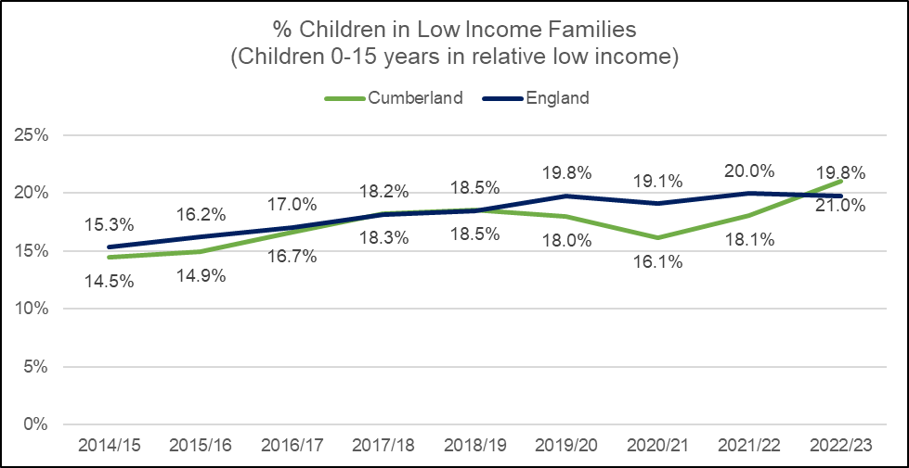

Source: Department for Work and Pensions, 2024. (Data prior to 2023 has been produced by combining former district areas).

### **Deprivation**

Deprivation can be measured using the English Indices of Multiple Deprivation (IMD). The IMD is the official measure of relative deprivation at small area level (Lower Super Output Area) across England. Levels of overall deprivation vary across Cumberland with 14 communities (LSOAs) falling within the 10% most deprived nationally. These communities (LSOAs) are spread across the former districts as follows: Allerdale (7), Carlisle (4) and Copeland (3). It is generally in these deprived areas that unemployment and crime rates are higher, household incomes are lower; educational attainment is lower; and where life expectancy is lower and overall health outcomes are poor. Around 8.3% (n.22,850) of Cumberland’s total population are living in the 10% most deprived LSOAs; this increases to 10.1% (n.5,600) for children aged 0-18 years; and 9.9% (n.7400) of children and young people aged 0-25years. (See **Figure 2**).

**Figure 2**: Cumberland population by Deprivation decile

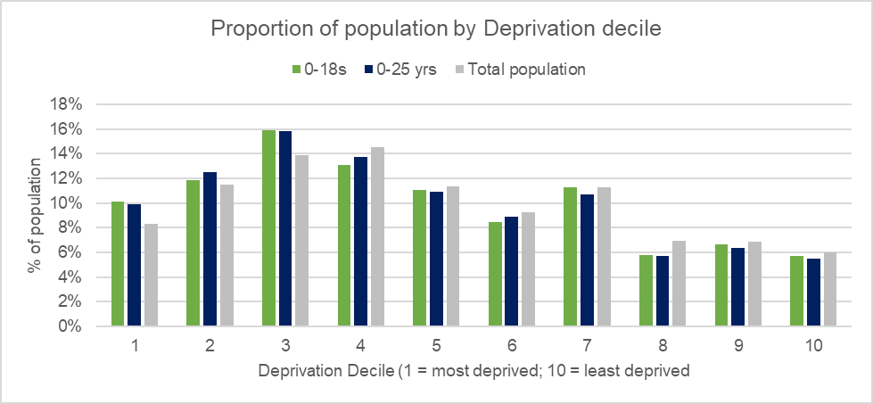

Source: Indices of Multiple Deprivation, 2019.

For children and young people with SEND, proportions of those living in the most deprived areas in Cumberland increases compared to the general population. 14.3% (n.395) of children and young people aged 0-25 years with an EHCP live in the 10% most deprived LSOAs in England; furthermore, more than two thirds (70.5%) are living in areas (LSOAs) within the 50% most deprived. (Based on recorded deprivation information).

The picture of deprivation is similar for children with SEN with 14.3% (n.740) of children with SEN support living in the 10% most deprived LSOAs in England; while more than two thirds (70.5%) are living in LSOAs within the 50% most deprived. (See **Figure 3**).

**Figure 3**: Proportion of children and young people with SEND (SEN Support or EHCP) by Deprivation Decile

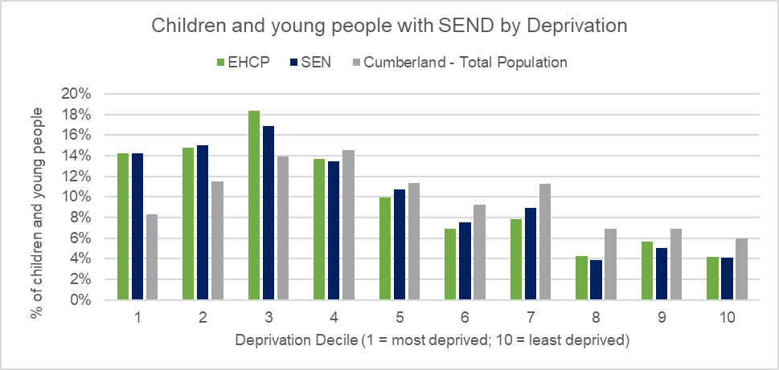

Source: Cumberland Council - ONE system; and January 2024 Census. Indices of Multiple Deprivation, 2019.

### **Free School Meals**

Free school meal eligibility is an indicator used to measure children living in poverty. As reported earlier, the proportion of pupils with SEND who are eligible for free school meals in Cumberland is significantly higher than pupils without SEND. 21.2% of all pupils in Cumberland are eligible for FSM, for pupils without SEN this falls to 17.8%, however, for pupils with SEND (SEN support or an EHCP) this increases to 36.4%. The difference in FSM eligibility between pupils with and without SEN reflects the national picture. (Source 1).

### **Youth Offending**

Special Education Needs are more common among young offenders, compared with non-offenders. Research shows that dyslexia (seen in around 50% of young people who offend) and communication disorders (seen in 60-90%) are notably higher in young offenders compared to those without SEN. Other disorders, such as ADHD, autism and traumatic brain injury are also more common in young offenders. (Source 30).

The DfE’s ‘Education, children’s social care and offending, Descriptive Statistics, March 2022 reports that children who had been cautioned or sentenced for an offence were more likely to be recorded as having SEND than the all pupil cohort (based on Key Stage 4 academic years 2012/13 to 2014/15. 80% of pupils with SEND (67% SEN Support; 13% EHCP) had been cautioned or sentenced for an offence, this compares to 20% of pupils with no identified SEN. The most prevalent type of SEN of pupils who had been cautioned or sentenced for an offence was social, emotional and mental health (or previously recorded as behaviour, emotional and social difficulties accounting for 47%. The second most prevalent type of SEN was moderate learning difficulties, accounting for 31%. (Source: 30).

In Cumberland, more than 1 in 3 (38.7%) of children in contact with youth offending services have a record of SEND or an Additional Learning Need while 16.3% have a recorded EHCP (as at Jul-24); these proportions are likely to be higher as many of the children in contact with the youth offending services have not been assessed. It is estimated that around 50% of the children in contact with the services are dyslexic, however, not all children are assessed for dyslexia by their school therefore it is unlikely this is recorded. (Source 34).

### **Mental Health and social issues**

Children and young people with SEN are more at risk of mental health issues in particular/for example those with moderate and severe learning difficulties are much more likely to have an anxiety disorder. Evidence also suggests that children and young people with SEN are more likely to have social difficulties with their peers such as being bullied or bullying others.

As reported in the Mental Health of Children and Young People in England survey, 2017, nationally special educational needs were more common in children with a mental health disorder (35.6%) than in those without a disorder (6.1%). (Source 31).

### **Abuse and neglect**

Children and young people with SEN are more likely than their peers to be abused or neglected, often this is because of a range of factors including: high care needs and dependency; difficulties in expressing their needs and concerns; lack of effective communication; and the inability to understand what is happening or to seek help. Furthermore, the additional stresses and challenges of parenting and caring for children and young people with SEN can increase the risk of neglect. (Source 32).

### **Social Care**

As mentioned above, a child or young person can be at risk of mistreatment because of a physical and/or mental impairment. A cohort of children and young people with SEND are likely to be in receipt of social care services in addition to support with education and health. Social care provision includes the following:

* Looked After Child (LAC), is a child who is housed by the Local Authority and not their parents. This can be a temporary arrangement for example during a crisis or it can be permanent in circumstances where it is not safe for the child to return home. (Source 33: Children's Act 1989; and Children and Families Act 2015).
* Child in Need (CIN), as defined under the Children Act 1989, is a child who is unlikely to reach or maintain a satisfactory level of health or development, or their health or development will be significantly impaired, without the provision of services, or the child is disabled.
* Child Protection Plans will be put in place by a local authority where there has been investigation into possible abuse or neglect and it is felt that the child or young person is suffering or likely to suffer significant harm. Child protection plans outline what needs to be put in place in order to ensure the child or young person is protected.

Social care data can help to determine levels of need and demand across Cumberland as well as helping to identify potential risks for children and young people with SEN.

### **Cared for Children**

After consultation with children and young people Cumberland Council has adopted “Language that Cares”. This changes the language we use to be aligned with how children/young people want to be referred to and/or spoken about. With this in mind, “Children Looked After” are now referred to as “Cared for Children”.

There are 482 Cared for Children in Cumberland (at 31st March 2024), equating to a rate of 93 per 10,000; the rate is significantly higher than England at 70 per 10,000, but similar to the North West region at 94. Local data indicates that numbers of Cared for Children in the Cumberland area have been increasing over recent years, reflecting the national trend.

### **Children in Need**

There are 1,771 Children in Need in Cumberland (as at 31st March 2024), equating to a rate of 342.1 per 10,000, this is above the national rate at 332.9 but below the North West region at 379.5. Data published by the DfE is not available for previous years (prior to 2024) for the Cumberland authority area, however, local data at Cumberland Council suggests that despite fluctuations rates have been decreasing from 2019 to 2023.

### **Child Protection Plans**

There are 269 children with a Child Protection Plan in Cumberland (at 31st Mar 2024), equating to a rate of 52.0 per 10,000, this is above both the national rate at 41.6 and the North West region at 48.8. Data published by the DfE is not available for previous years (prior to 2024) for the Cumberland authority area, however, local data at Cumberland Council suggests that despite fluctuations rates have been decreasing from 2019 to 2023.

# Characteristics of children and young people with SEND

In order to examine the characteristics of children and young people with SEND, data is primarily sourced from the Department for Education’s key sources as follows:

* [Special Educational Needs in England](https://explore-education-statistics.service.gov.uk/find-statistics/special-educational-needs-in-england) publication, reporting from school census returns on all pupils (2-18/19 years); includes SEN Support and EHCP records from state-funded nursery, primary, secondary and special schools, non-maintained special schools and alternative provision (pupil referral units). Data includes type of SEN provision, type of need, age, year group, sex, ethnicity, English as a first language and free school meal eligibility. Further Education settings such as colleges are not included. Some pupils in special schools can continue their education up to the age of 19 years. There is limited data available from Independent Schools.
* [Education Health and Care Plans](https://explore-education-statistics.service.gov.uk/find-statistics/education-health-and-care-plans) publication, reporting on the SEN2 data collection returns. This dataset includes all children and young people aged up to 25 years. It includes those in non-maintained early years provision, further education, home education and NEET (not in education, employment or training).
* Local systems at Cumberland Council including One and the School Census. This provides real time data and enables analysis based on where the child or young person lives rather than where they attend school.

## Prevalence of SEND

In 2023/24, there were 40,536 pupils attending schools in Cumberland of which 7,399 were identified as having SEND (combined SEN support and EHCPs), accounting for 18.3%, this is similar to the England average at 18.4%. Of those 7,399 children with SEND, 5.1% (2,086 pupils) had an EHCP, this is just above the national average at 4.8%; while 13.1% (5,313 pupils) were identified as having SEN Support, just below the national average of 13.6%. Levels of pupils with SEND have been gradually increasing in Cumberland, from 14.6% in 2017/18 (England 14.5%) to 18.3% in 2023/24 (England 18.4%) reflecting the increasing national picture. (See **Figure 4**).

**Figure 4**: Proportion of pupils attending school in Cumberland with SEND (combined SEN Support and EHCPs) compared to England; 2017/18 to 2023/24

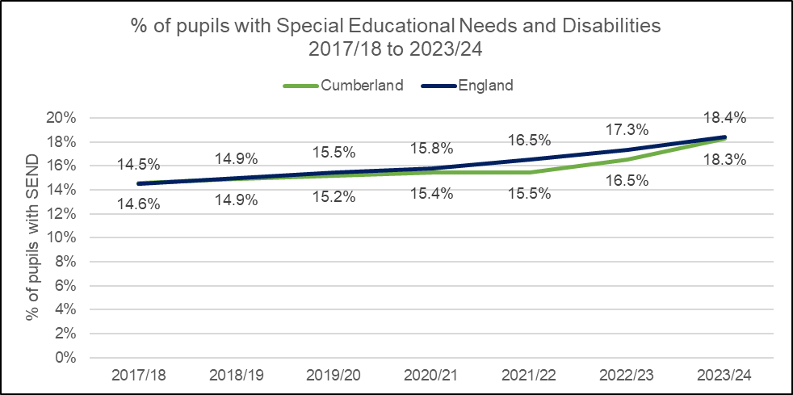

Source: Special Educational Needs and Disabilities in England; DfE; June 2024. Data prior to 2023 has been produced by combining former district areas.

**SEN support – pupils in Cumberland schools**

In 2023/24, there were 5,313 pupils identified as having SEN Support, accounting for 13.1% of all pupils, this is just below the national average of 13.6%. Levels of pupils with SEN Support have been gradually increasing in Cumberland, from 11.8% in 2017/18 (England 11.7%) to 13.1% in 2023/24 (England 13.6%) reflecting the increasing national picture. (See **Figure 5**).

**Figure 5**: Proportion of pupils attending school in Cumberland with SEN Support compared to England; 2017/18 to 2023/24

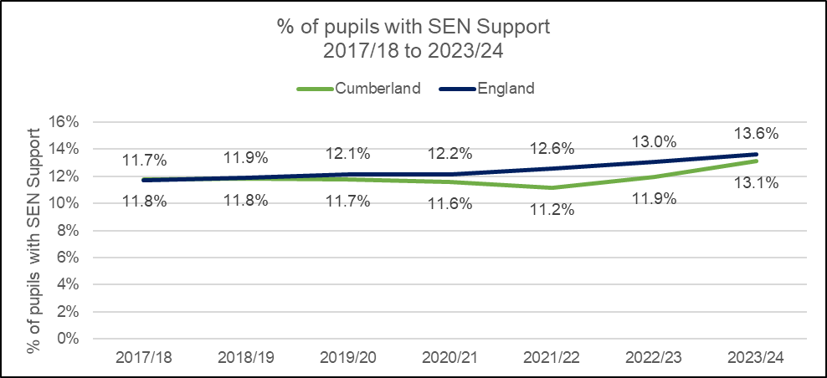

Source: Special Educational Needs and Disabilities in England; DfE; June 2024. Data prior to 2023 has been produced by combining former district areas.

**EHCPs – pupils in Cumberland schools**

In 2023/24, 2,086 pupils had an EHCP accounting for 5.1%, this is just above the national average at 4.8%. Levels of pupils with an EHCP have been steadily increasing in Cumberland, from 2.8% in 2017/18 (England 2.8%) to 5.1% in 2023/24 (England 4.8%) reflecting the increasing national picture. (See **Figure 6**).

**Figure 6**: Proportion of pupils attending school in Cumberland with an EHCP compared to England; 2017/18 to 2023/24

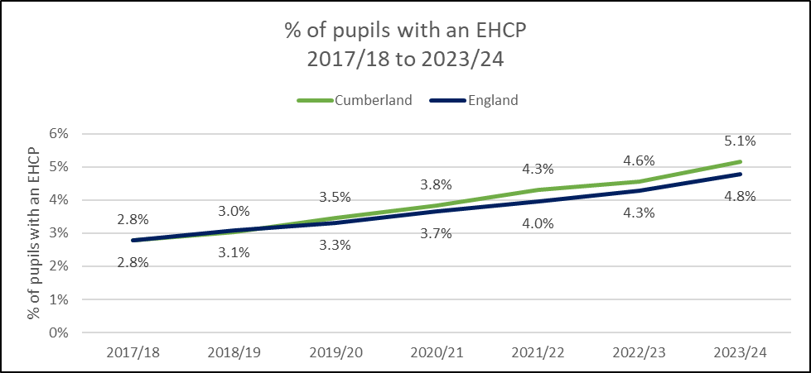

Source: Special Educational Needs and Disabilities in England; DfE; June 2024. Data prior to 2023 has been produced by combining former district areas.

**EHCPs – all children and young people 0-25 years**

In June 2024, there were 2,656 children and young people aged 0-25 years identified as having an EHCP in Cumberland. Using local data from Cumberland Council, it shows that numbers of children and young people aged 0-25 years with an EHCP have been steadily increasing year on year over the last five years reflecting the increasing national picture See **Figure 7**. (A map presenting numbers of children and young people across Cumberland with an EHCP by Ward is available in the Appendices – see Map 3).

**Figure 7**: Cumberland: Children and young people (0-25yrs) with an EHCP; 2018 to 2023

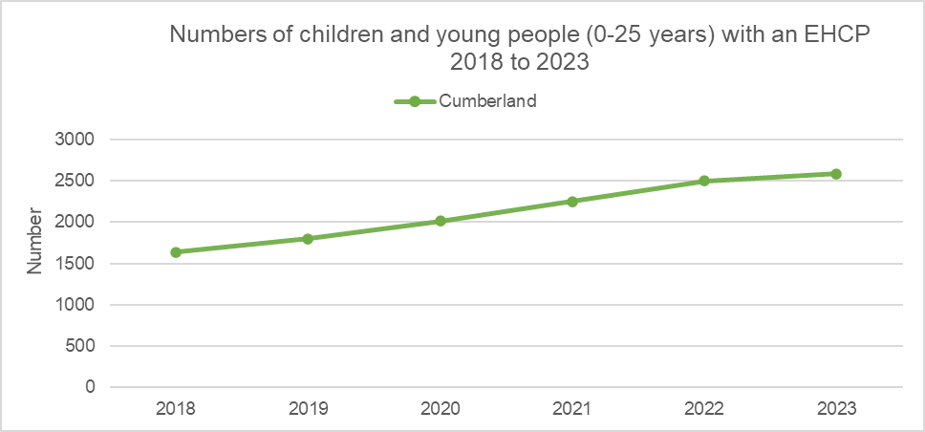

Source: Cumberland Council; One system.

## Projected prevalence of SEND

Cumberland Council (and former Cumbria) has experienced significant increases in the numbers of children and young people with EHCPs requiring specialist provision to ensure they are able to have their complex needs fully met and that they receive the specialist support that is required for them to thrive. It is projected that demand for specialist places will continue to grow across all sectors. The increases seen in Cumberland reflects increases seen nationally and across most other local authorities in England in the last decade.

EHCPs have ‘cultural’ and demand elements associated with them that make accurate forecasting much more challenging than forecasting mainstream numbers. Much of the base data available relates to the former Cumbria County Council footprint therefore projections should be used with caution and should be seen as an illustration of what could happen rather than what will happen. The projections for Cumberland are in line with the projections of many other local authorities across England.

There were 2,656 children and young people aged 0-25 years with an EHCPs in Cumberland, as reported in the June 2024 SEN2, this compares with 2,300 in 2022 and just over 2,400 in 2023; this number already exceeds previous projections for 2026 illustrating the level of volatility. The current number of EHCPs represents significant increases, approximately +75% in the 8 years since 2016. Future projections indicate further increases to around 3,600 EHCPs by the early 2030s, this may be an underestimate; however, projections will be refined when more ‘actual’ data becomes available for Cumberland.

Growth on this scale is unprecedented and inevitably brings additional pressure to settings and budgets; the Council’s High Needs Block remains substantially in deficit. The growth in EHCP numbers comes at a time when the general school-age population is falling, which means the proportion of children and young people with an EHCP is increasing. Despite recent expansions, the number of specialist places in Cumberland is likely to be insufficient to meet future demand, and further new provision will be needed if we are to avoid excessive use of the independent sector.

## Primary and secondary SEND needs

As detailed in Chapter 1, the SEND Code of Practice (2015) sets out four broad areas of need: communication and interaction; cognition and learning; social, emotional and mental health difficulties; and sensory and/or physical needs. The primary needs of the child or young person are assessed within the broad areas and then either SEN Support or an EHCP is identified. In addition to a primary need, a secondary need may also be identified as part of the assessment. It is important to note that the individual needs of a child or young person are determined by individual practitioners and/or school(s) which can vary depending on professional opinions therefore caution should be made when interpreting the data.

In Cumberland, the greatest primary need for pupils with SEN Support is Specific Learning Difficulty, 1,383 pupils accounting for 26.6% of all pupils with SEN Support, this compares to just 13.9% in England. In Cumberland, there are notably fewer pupils with a primary need of Speech, Language and Communications needs compared to England, 17.2% v 25.6%. (See **Table 1** and **Figure 8**).

**Table 1**: Number and proportion of pupils by Primary Need and SEN Status; 2023/24

|  |  |  |  |  |  |  |
| --- | --- | --- | --- | --- | --- | --- |
|  | EHCP | | SEN Support | | Total SEN | |
|  | No. | % | No. | % | No. | % |
| Autistic Spectrum Disorder | 694 | 34.4% | 565 | 10.9% | 1,259 | 17.4% |
| Hearing Impairment | 20 | 1.0% | 59 | 1.1% | 79 | 1.1% |
| Moderate Learning Difficulty | 19 | 0.9% | 697 | 13.4% | 716 | 9.9% |
| Multi- Sensory Impairment | 2 | 0.1% | 5 | 0.1% | 7 | 0.1% |
| Other Difficulty/Disability | 14 | 0.7% | 177 | 3.4% | 191 | 2.6% |
| Physical Disability | 100 | 5.0% | 94 | 1.8% | 194 | 2.7% |
| Profound & Multiple Learning Difficulty | 44 | 2.2% |  | 0.0% | 44 | 0.6% |
| Severe Learning Difficulty | 368 | 18.2% | 15 | 0.3% | 383 | 5.3% |
| Social, Emotional and Mental Health | 272 | 13.5% | 1,173 | 22.5% | 1445 | 20.0% |
| Specific Learning Difficulty | 63 | 3.1% | 1,383 | 26.6% | 1446 | 20.0% |
| Speech, Language and Communications needs | 403 | 20.0% | 898 | 17.2% | 1301 | 18.0% |
| Visual Impairment | 20 | 1.0% | 34 | 0.7% | 54 | 0.7% |
| SEN support but no specialist assessment of type of need |  |  | 106 | 2.0% | 106 | 1.5% |
| Total | 2,019 |  | 5,206 |  |  |  |

Source: Special Educational Needs and Disabilities in England; DfE; June 2024. *Data does not include Independent Schools.

**Figure 8**: SEN Support - Proportion of pupils by Primary Need; Cumberland and England; 2023/24

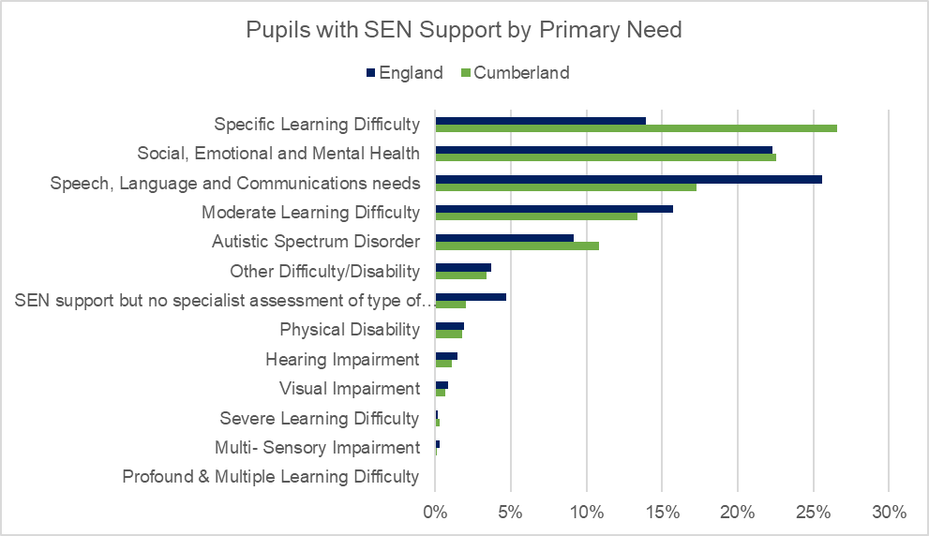

Source: Special Educational Needs and Disabilities in England; DfE; June 2024. Data does not include Independent Schools.

In Cumberland, the greatest primary need for pupils with an EHCP is Autistic Spectrum Disorder, 694 pupils accounting for 34.4% of all pupils with an EHCP, this is similar England at 33.0% reflecting the national picture. In Cumberland, there are notably more pupils with a primary need of Severe Learning Difficulty compared to England, 18.2% v 7.9%; while there are notably fewer pupils with a primary need of Moderate Learning Difficulty, 0.9% v 8.5%. (See **Table 1** and **Figure 9**).

**Figure 9**: EHCP - Proportion of pupils by Primary Need; Cumberland and England; 2023/24

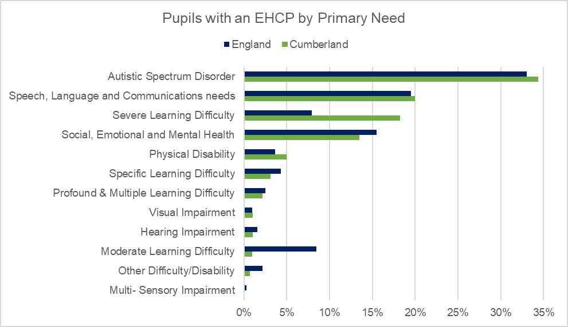

Source: Special Educational Needs and Disabilities in England; DfE; June 2024. Data does not include Independent Schools.

**Primary Needs trends**

In Cumberland, there have been increases in a range of primary needs for pupils with SEN Support. In the past 5 years, the most notable increases have been seen in numbers of pupils with the primary need of Social, Emotional and Mental Health have increased by +67.6%; and pupils with Autistic Spectrum Disorder have increased by +59.6%. Conversely, numbers have decreased for pupils with the primary need of Other Difficulty/Disability -63.6%. (See **Figure 10**).

**Figure 10**: SEN Support by Primary Need and Academic Year; 2019/20 to 2023/24

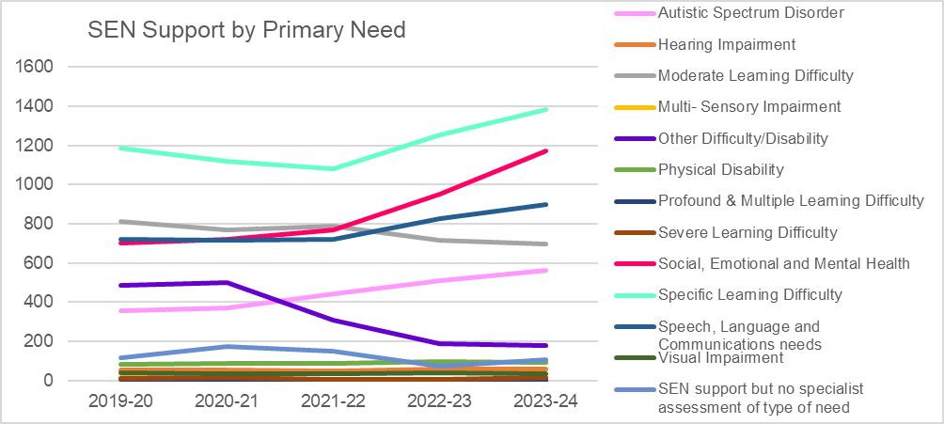

Source: Special Educational Needs and Disabilities in England; DfE; June 2024. Data does not include Independent Schools.

For pupils with EHCPs, there have been notable increases across a range of primary needs in the past 5 years. Numbers of pupils with the primary need of Speech, Language and Communication needs have more than doubled increasing by +144.2%; there has been a 70.0% increase in the number of pupils with Social, Emotional and Mental Health needs; and a 53.5% increase in the number of pupils with Autistic Spectrum Disorder. (See **Figure 11**).

**Figure 11**: EHCPs by Primary Need and Academic Year; 2019/20 to 2023/24

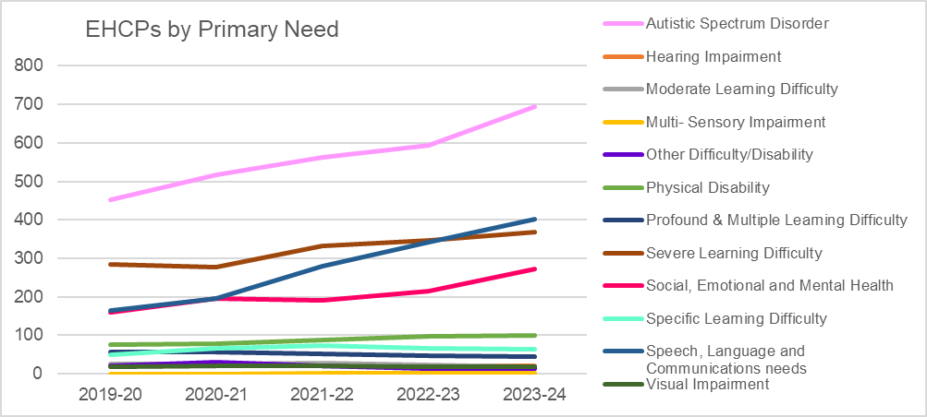

Source: Special Educational Needs and Disabilities in England; DfE; June 2024. Data does not include Independent Schools.

**Secondary Needs**

In Cumberland schools, there are 1,034 pupils with a secondary need, accounting for 14.3% of all pupils with SEND (n7,225) (please note this data does not include Independent schools). The greatest secondary need is for social, emotional and mental health needs, identified for 222 pupils (21.5%) closely followed by Autistic Spectrum Disorder, 208 pupils (20.1%). See **Table 2**.

For pupils with SEN Support, the greatest secondary need is for social, emotional and mental health needs, identified for 157 pupils (31.2%). For pupils with an EHCP, the greatest secondary need is Autistic Spectrum Disorder, 159 pupils (30.0%).

Pupils with a primary need of either a Profound & Multiple Learning Difficulty or a Severe Learning difficulty are more likely to have a secondary need, with around half of both cohorts having a recorded secondary need.

For all pupils with SEND, those with the primary need of ASD account for the greatest proportion of secondary needs (24.2%). While more than half of pupils (51.9%) with a secondary need of ASD were pupils with a primary need of Severe Learning Difficulty.

**Table 2**: Number and proportion of pupils with a secondary need by SEN status; 2023/24

|  |  |  |  |  |  |  |
| --- | --- | --- | --- | --- | --- | --- |
|  | EHCP | % | SEN Support | % | Total | % |
| Autistic Spectrum Disorder | 159 | 30.0% | 49 | 9.7% | 208 | 20.1% |
| Hearing Impairment | 10 | 1.9% | 8 | 1.6% | 18 | 1.7% |
| Moderate Learning Difficulty | 19 | 3.6% | 55 | 10.9% | 74 | 7.2% |
| Multi- Sensory Impairment | 4 | 0.8% | 3 | 0.6% | 7 | 0.7% |
| Other Difficulty/Disability | 15 | 2.8% | 37 | 7.3% | 52 | 5.0% |
| Physical Disability | 38 | 7.2% | 20 | 4.0% | 58 | 5.6% |
| Profound & Multiple Learning Difficulty | 6 | 1.1% | 0 | 0.0% | 6 | 0.6% |
| Severe Learning Difficulty | 53 | 10.0% | 1 | 0.2% | 54 | 5.2% |
| Social, Emotional and Mental Health | 65 | 12.3% | 157 | 31.2% | 222 | 21.5% |
| Specific Learning Difficulty | 59 | 11.1% | 112 | 22.2% | 171 | 16.5% |
| Speech, Language and Communications needs | 93 | 17.5% | 52 | 10.3% | 145 | 14.0% |
| Visual Impairment | 9 | 1.7% | 7 | 1.4% | 16 | 1.5% |
| SEN support but no specialist assessment of type of need |  |  | 3 | 0.6% | 3 | 0.3% |
| Total | 530 |  | 504 |  | 1034 |  |

Source: Special Educational Needs and Disabilities in England; DfE; June 2024. Data does not include Independent Schools.

**Figure 12**: SEN Support - Proportion of pupils by Secondary Need; Cumberland and England; 2023/24

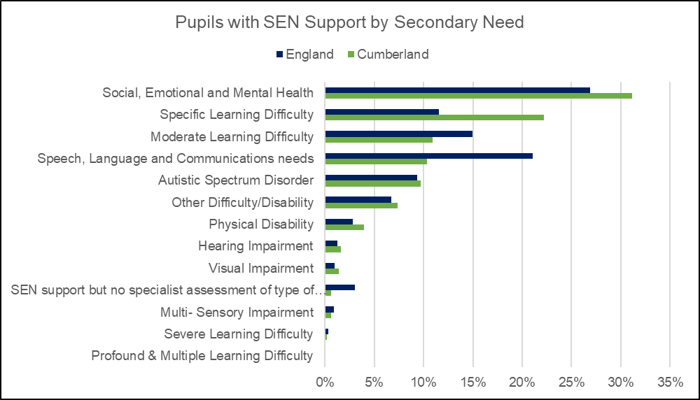

Source: Special Educational Needs and Disabilities in England; DfE; June 2024. Data does not include Independent Schools.

**Figure 13**: EHCP - Proportion of pupils by Secondary Need; Cumberland and England; 2023/24

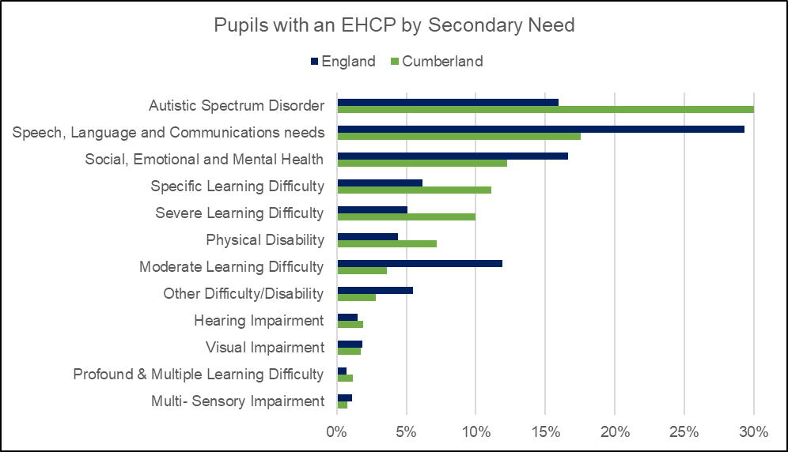

Source: Special Educational Needs and Disabilities in England; DfE; June 2024. Data does not include Independent Schools.

## Characteristics of the SEND population

### **Gender**

As reported in Chapter 2.2 (Risks associated with SEND) special educational needs are more prevalent in males than females.

In Cumberland, more than two thirds (71.7%) of children and young people aged 0-25 years with an EHCP are male reflecting the national picture (England 71.3%); while 28.3% in Cumberland are female, similar to England at 28.7%.

There are further gender differences in the primary needs; in Cumberland, boys are more likely to have a primary need of Autistic Spectrum Disorder than girls, 19.8% compared to 13.3%. Boys are also more likely to have a Speech, Language and Communications need than girls, 19.5% compared to 15.5%. Girls in Cumberland are more likely than boys to have a specific learning difficulty, 24.4% compared to 17.5%. These gender differences in primary needs are also reflected nationally.

**Figure 14**: Cumberland - Children and young people 0-25years with an EHCP by Gender

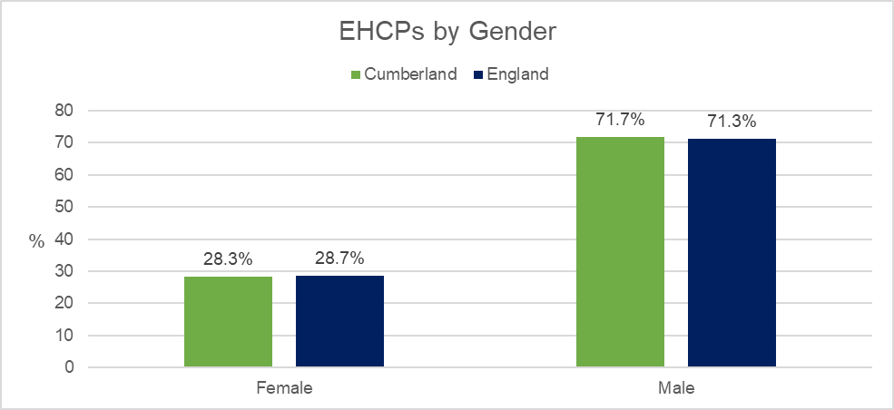

Source: Education, Health and Care Plans; SEN2 DfE; June 2024

72.8% of pupils with an EHCP in Cumberland schools are boys, similar to England at 72.0%. For pupils with SEN Support the differences aren’t as stark however it remains more prevalent in boys with more than half at 59.7%, just below the national average of 62.0%.

**Figure 15**: Pupils with an EHCP by Gender; 2023/24

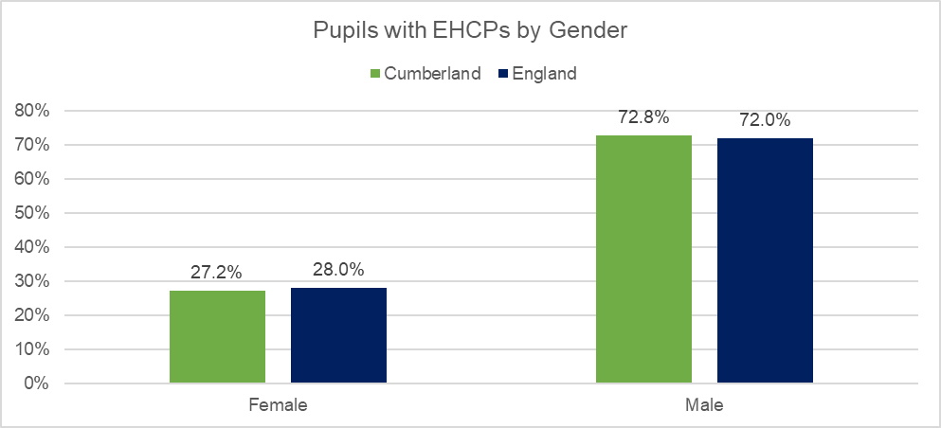

Source: Special Educational Needs in England; DfE, June, 2024. Does not include data from Independent schools.

**Figure 16**: Pupils with SEN Support by Gender; 2023/24

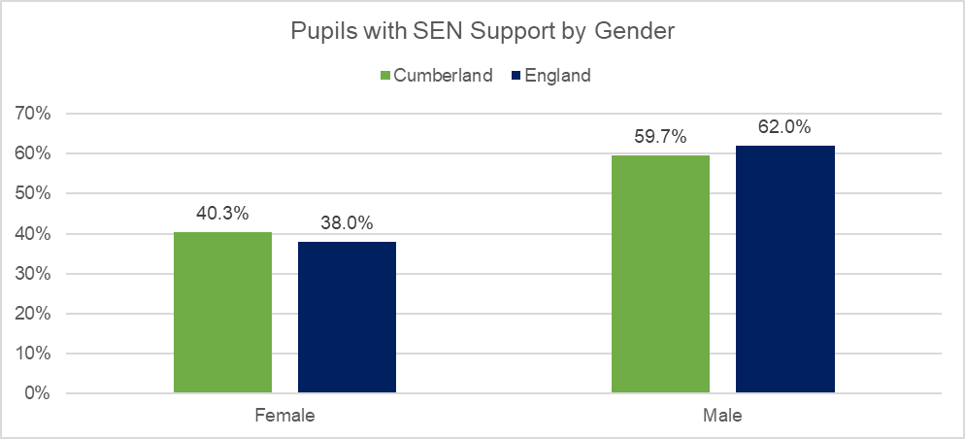

Source: Special Educational Needs in England; DfE, June, 2024. Does not include data from Independent schools.

### **Age**

In Cumberland schools, most pupils with SEN Support are children of primary age 5 to 10 years, 2457 accounting for almost half (47.2%); closely followed by children of secondary school age 11 to 15 years, 2,221 pupils accounting for 42.7%. The picture is similar for pupils with an EHCP with most pupils aged 5 to 10 years, 934 pupils accounting for 42.2%; closely followed by those aged 11 to 15 years, 853 pupils accounting for 42.2%. (See **Table 3**).

**Table 3**: Cumberland – Pupils by SEN status and by Age

|  |  |  |  |  |  |  |
| --- | --- | --- | --- | --- | --- | --- |
|  | EHCP | | SEN | | No SEN | |
|  | Number | % | Number | % | Number | % |
| 0-4 years | 141 | 7.0% | 429 | 8.2% | 4,399 | 13.5% |
| 5 to 10 years | 934 | 46.3% | 2,457 | 47.2% | 14,124 | 43.2% |
| 11 to 15 years | 853 | 42.2% | 2,221 | 42.7% | 12,147 | 37.2% |
| 16 to 18 years | 91 | 4.5% | 99 | 1.9% | 1,993 | 6.1% |
| 19 years and over | 0 | 0.0% | 0 | 0.0% | 0 | 0.0% |
| Total | 2,019 |  | 5,206 |  | 32,663 |  |

Source: Special Educational Needs in England; DfE, June, 2024; June 2024. Does not include data from Independent schools.

Compared to England, there are slightly fewer pupils aged 5 to 10 years in Cumberland schools with SEN Support, 47.2% compared to 51.1%; but slightly more pupils aged 11 to 15 years, 42.7% compared to 38.7%. (See **Figure 17**).

**Figure 17**: Pupils with SEN Support by Age; Cumberland and England; 2023/24

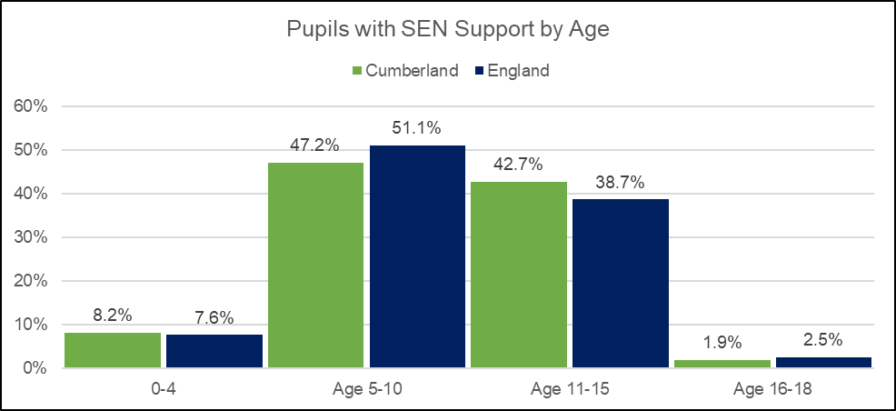

Source: Special Educational Needs in England; DfE, June, 2024; June 2024. Does not include data from Independent schools.

Compared to England, the age breakdown in Cumberland schools for pupils with an EHCP is very similar with some minor differences across each age band. (See **Figure 18**).

**Figure 18**: Pupils with an EHCP by Age; Cumberland and England; 2023/24

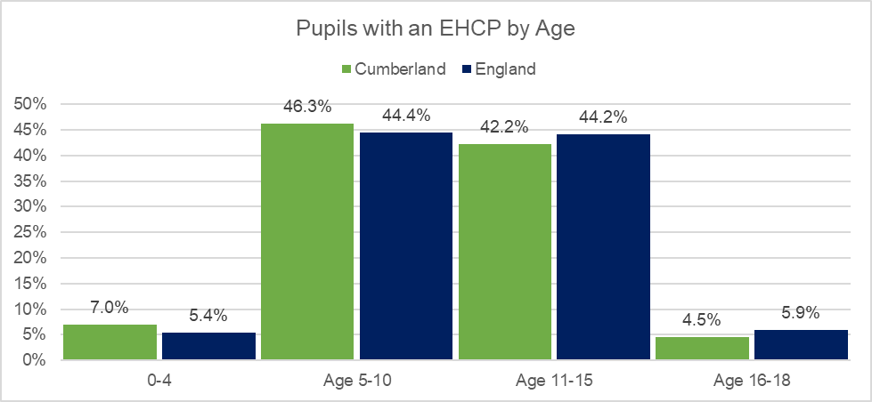

Source: Special Educational Needs in England; DfE, June, 2024; June 2024. Does not include data from Independent schools.

In Cumberland, there are almost equal proportions of children and young people aged 0-25 years with an EHCP in both primary age (37.0%) and secondary age (36.0%). Compared to England, there are fewer proportions of young people aged 16 to 19 years and 20 to 25 years with an EHCP in Cumberland; however, there are slightly more children under 5 years. (See **Table 4** and **Figure 19).**

**Table 4**: Cumberland - Children and young people 0-25years with an EHCP by Age

|  |  |  |  |  |
| --- | --- | --- | --- | --- |
|  | Cumberland | | England | |
|  | Number | % | Number | % |
| Under 5 years | 189 | 7.1% | 26,527 | 4.6% |
| Age 5 to 10 years | 982 | 37.0% | 187,165 | 32.7% |
| Age 11 to 15 years | 956 | 36.0% | 208,609 | 36.4% |
| Age 16 to 19 years | 457 | 17.2% | 115,002 | 20.1% |
| Age 20 to 25 years | 72 | 2.7% | 35,526 | 6.2% |
| Total | 2,656 |  | 575,963 |  |

Source: Education, Health and Care Plans; SEN2 DfE; June 2024. Some age breakdowns for England are not available therefore totals may not sum.

**Figure 19**: Children and young people 0-25years with an EHCP by Age; 2024

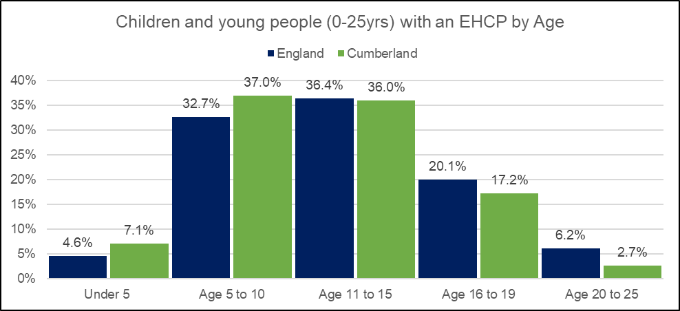

Source: Education, Health and Care Plans; DfE; June 2024

### **Educational settings and School Phase**

Pupils with SEN and disabilities are educated in a variety of settings. Most pupils are able to attend mainstream schools with school-based support and additional specialist support. Some pupils attend special schools (please note the term ‘specialist schools’ is used locally) and some alternative provision because they have health or behavioral difficulties which cannot be met at a mainstream school.

There are 177 schools across Cumberland including mainstream schools (nurseries, primaries and secondaries); special (specialist) schools; independent schools; and alternative provision (pupil referral units). Numbers of schools in Cumberland by Phase Type and Type of Establishment are set out in **Tables 5 and 6** below.

All 177 schools in Cumberland report having pupils with SEND (requiring either SEN support or EHCP) emphasizing the need for provision across the whole of Cumberland and in all school settings.

(Please note that a small number of pupils travel outside of Cumberland to attend school; while some pupils who live outside of Cumberland travel in to attend school).

**Table 5**: Cumberland schools by Phase Type; Total pupils and pupils by SEN status; 2023/24

|  |  |  |  |  |  |
| --- | --- | --- | --- | --- | --- |
| Phase Type | Number of schools | Total  Pupils | Pupils with  SEN Support | Pupils with EHCP | Total SEN |
| Independent school | 5 | 648 | 107 | 67 | 174 |
| State-funded AP school | 2 | 112 | 80 | 32 | 112 |
| State-funded nursery | 3 | 144 | 15 | 1 | 16 |
| State-funded primary | 145 | 22,131 | 2,871 | 858 | 3,729 |
| State-funded secondary | 19 | 17,022 | 2,239 | 650 | 2,889 |
| State-funded special school | 3 | 479 | 1 | 478 | 479 |
| Total | 177 | 40,536 | 5,313 | 2,086 | 7,399 |

Source: Special Educational Needs in England, DfE, 2023/24.

**Table 6**: Cumberland schools by Type; Total pupils and pupils by SEN status; 2023/24

|  |  |  |  |  |  |
| --- | --- | --- | --- | --- | --- |
|  | Number of Schools | Total  Pupils | Pupils with  SEN Support | Pupils with EHCP | Total SEN |
| Academy converter | 30 | 10,569 | 1,285 | 390 | 1,675 |
| Academy special converter | 1 | 189 | 1 | 188 | 189 |
| Academy sponsor led | 13 | 6,406 | 816 | 235 | 1051 |
| Community school | 62 | 12,126 | 1,735 | 500 | 2,235 |
| Community special school | 1 | 234 | 0 | 234 | 234 |
| Foundation school | 8 | 986 | 150 | 31 | 181 |
| Free schools special | 1 | 56 | 0 | 56 | 56 |
| Local authority nursery school | 3 | 144 | 15 | 1 | 16 |
| Other independent school | 3 | 586 | 105 | 8 | 113 |
| Other independent special school | 2 | 62 | 2 | 59 | 61 |
| Pupil referral unit | 2 | 112 | 80 | 32 | 112 |
| University technical college | 1 | 371 | 4 | 14 | 18 |
| Voluntary aided school | 24 | 4,803 | 634 | 202 | 836 |
| Voluntary controlled school | 26 | 3,892 | 486 | 136 | 622 |
|  | 177 | 40,536 | 5,313 | 2,086 | 7,399 |

Source: Special Educational Needs in England, DfE, 2023/24.

Pupils with SEN and disabilities are educated in a variety of settings. Most pupils are able to attend mainstream schools with school-based support and additional specialist support. Some pupils attend special schools and some alternative provision because they have health or behavioural difficulties which cannot be met at a mainstream school.

In Cumberland, most pupils with SEND attend state-funded primary schools this is likely a reflection of the greatest number of *all* pupils (with and without SEND) attending primary schools. 2,871 pupils with SEN Support attend state-funded primary schools, accounting for 54.0% of all pupils with SEN Support. For pupils with an EHCP, the picture is the same with the greatest number attending primary schools, 858 pupils accounting for 41.4% of all pupils with an EHCP. (See **Figure 20**).

**Figure 20**: Cumberland schools – number of pupils by SEN status and school phase type; 2023/24

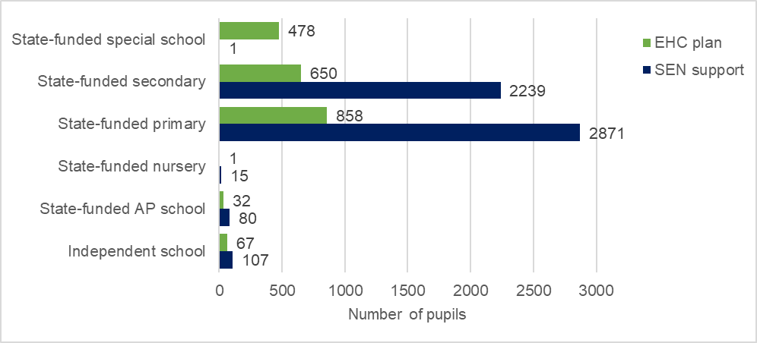

Source: Special Educational Needs in England, DfE, 2023/24.

Compared to England, there are notably fewer pupils with SEN Support in Independent schools in Cumberland, 2.0% compared to 8.0%; while there is a greater proportion of pupils in state-funded secondary schools, 42.1% compared to 38.1% nationally. For pupils with an EHCP, there are fewer pupils in Independent schools in Cumberland, 3.2% compared to 7.7%; and notably fewer pupils in state-funded special schools in Cumberland, 22.9% compared to 35.8%. While there are greater proportions of pupils with an EHCP in both state-funded primary schools, 41.1% in Cumberland compared to 31.5% nationally; and in state-funded secondary schools, 31.2% compared to 23.0% nationally. (See **Figure 21**).

**Figure 21**: Proportion of pupils by SEN status and school phase type; Cumberland and England; 2023/24

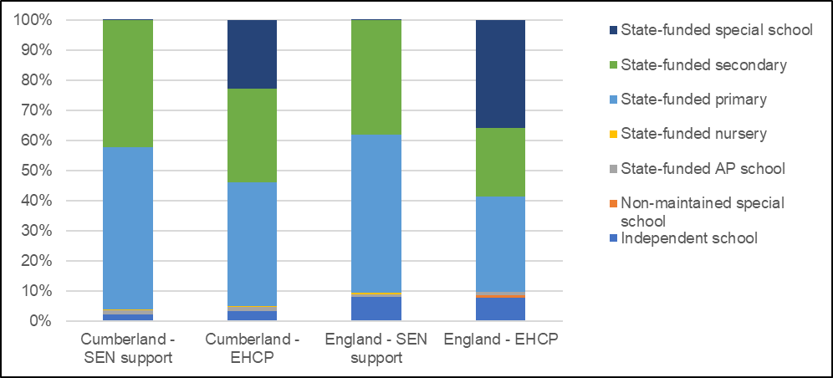

Source: Special Educational Needs in England, DfE, 2023/24.

There are differences in primary needs across schools in Cumberland. For EHCP pupils, those attending state-funded Alternative Provision schools (Pupil Referral Units), the greatest primary need accounting for the majority of pupils is social, emotional and mental health, 84.4%. EHCP pupils attending state-funded special schools, the greatest primary need is Severe Learning Difficulty accounting for more than half, 54.8%. In state-funded primary schools, the greatest need is Autistic Spectrum Disorder accounting for 40.6%; and in state-funded secondary schools, the greatest need is Autistic Spectrum Disorder accounting for 30.9%. (See **Figure 22**).

**Figure 22**: Cumberland - Proportion of pupils with an EHCP by school phase type and primary need; 2023/24

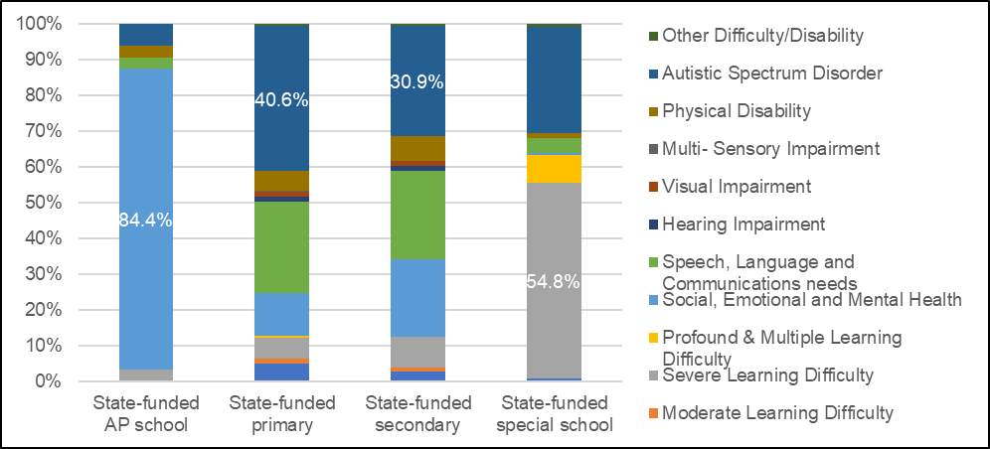

Source: Special Educational Needs in England, DfE, 2023/24.

There are differences in primary needs across Cumberland schools for SEN Support pupils. The greatest need for SEN Support pupils attending state-funded Alternative Provision schools (Pupil Referral Units) is social, emotional and mental health, accounting for the majority of pupils, 90%. Pupils attending state-funded nursery schools, the greatest need is Speech, Language and Communication needs, accounting for 46.7%; and in state-funded primary schools, accounting for 27.4%. In state-funded secondary schools, the greatest need for SEN Support pupils is Specific Learning Difficulty, accounting for 40.5%. (See **Figure 23**).

**Figure 23**: Cumberland - Proportion of pupils with SEN Support by school phase type and primary need; 2023/24

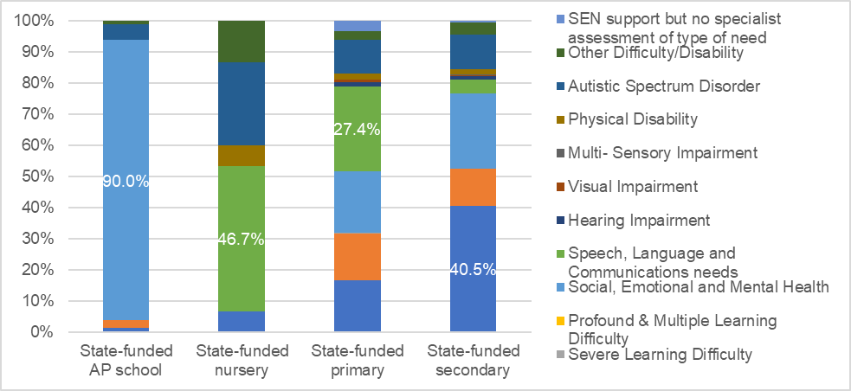

Source: Special Educational Needs in England, DfE, 2023/24.

### **Ethnicity**

(See Section 1.2 Overview of Cumberland and the SEND population for further information).

As reported in the January 2024 School Census, 89.4% (35,649 pupils) attending schools in Cumberland identified as White British ethnicity, this is greater than England at 61.3%. Proportions of pupils in Cumberland from ethnic minority backgrounds are low at 8.4% (3,348 pupils), this is significantly lower than England at 37.0%.

For pupils with SEND in Cumberland, 92.5% (6,682 pupils) identify as White British, this compares to 68.4% nationally; while just 5.2% (379 pupils) identify as ethnic minority backgrounds, this compares to 30.0% nationally. 2.3% (164 pupils) with SEND in Cumberland are ‘unclassified’, this compares to 1.6% in England. See **Figures 24 and 25**.

**Figure 24**: Cumberland: SEND (combined SEN Support and EHCP) Pupils by Ethnicity

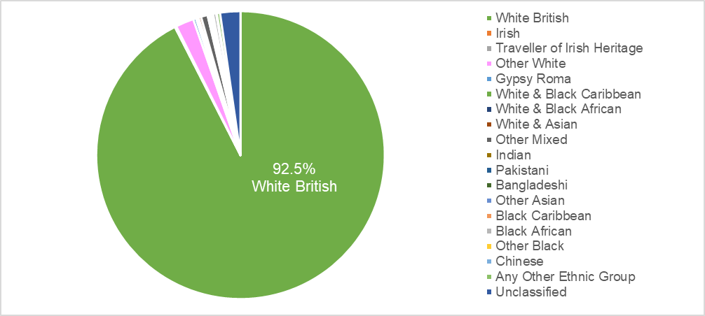Source: Special Educational Needs in England, DfE, 2023/24.

**Figure 25**: England: SEND (combined SEN Support and EHCP) Pupils by Ethnicity

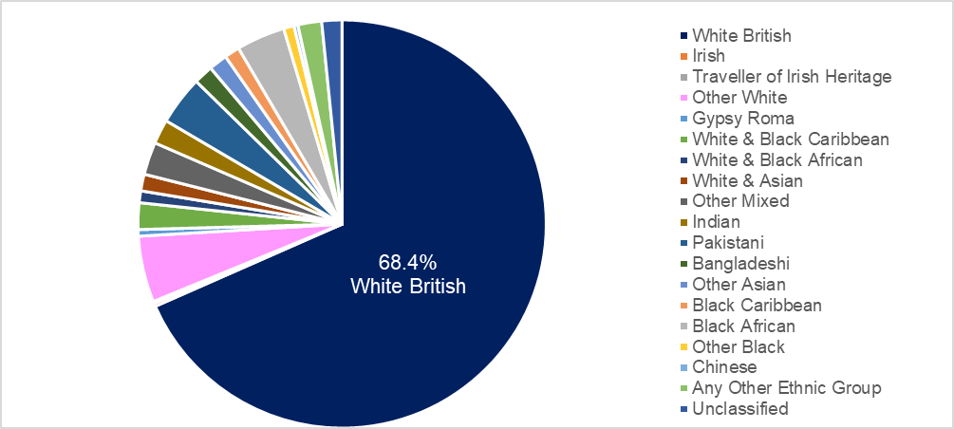Source: Special Educational Needs in England, DfE, 2023/24.

### **English as a first language**

In Cumberland, the majority of all pupils in schools have English as their first language or believed to be English. There are greater proportions of pupils in Cumberland schools who have English as their first language or believed to be English compared to England, 94.5% v 78.7%. The picture is similar for pupils with SEND; in Cumberland, 96.7% of pupils with SEND were recorded to have English as their first language or believed to be English, this compares to 84.2% in England. Please note this indicator is not a measure of English language proficiency or a proxy for immigration. This data does not include Independent schools.

### **Social care provision**

At the time of publication of the JSNA, data from the DfE has not yet been published for Cumberland local authority. In the meantime, data for former Cumbria local authority is presented below.

Looked After Children in Cumbria are more likely to have Special Educational Needs and Disabilities than their peers without SEND. At March 2023, there were a total of 371 Children Looked After in Cumbria; of those, 222 had SEND (combined SEN support and EHCPs) accounting for more than half (59.8%), similar to the national average at 58.1%. Of those with SEND, more than half had an EHCP (139 pupils). See **Figure 28**.

More than half of Children in Need in Cumbria have Special Educational Needs and Disabilities. At 31 March 2023, there were a total of 929 Children in Need in Cumbria, of those, 498 had SEND accounting for more than half (53.6%), just above the national average at 50.0%. Of those with SEND, more than half had an EHCP (312 pupils). See **Figure 27**.

Around 1 in 3 children in Cumbria with a Child Protection Plan have Special Educational Needs and Disabilities. At 31 March 2023, there were a total of 281 children with a Child Protection Plan in Cumbria; of those, 100 had SEND accounting for 35.6%, below the national average at 40.7%. Of those with SEND, more than half had SEN support (64 pupils). See **Figure 29**.

**Figure 26**: Cumbria: Number of pupils by Social Care status and SEN status; 2022/23

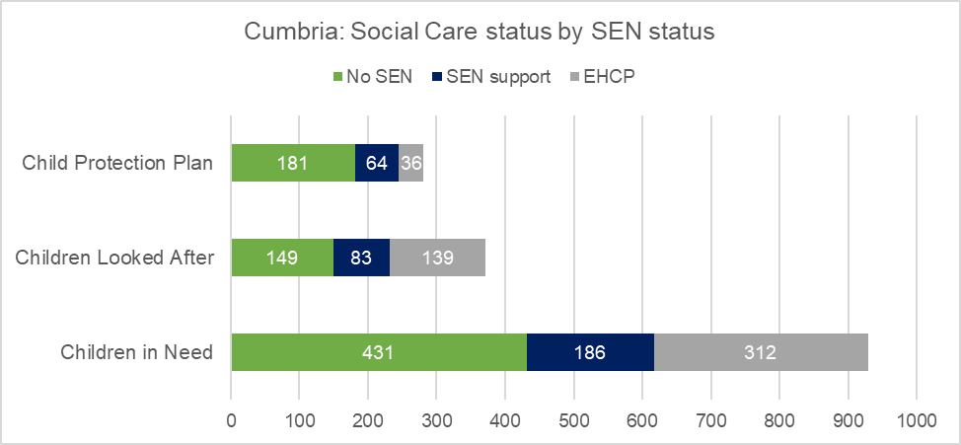

Source: Outcomes for children in need, including children looked after by local authorities in England; 2022/23

**Figure 27**: Cumbria v England: % of Children in Need by SEN status; 2022/23

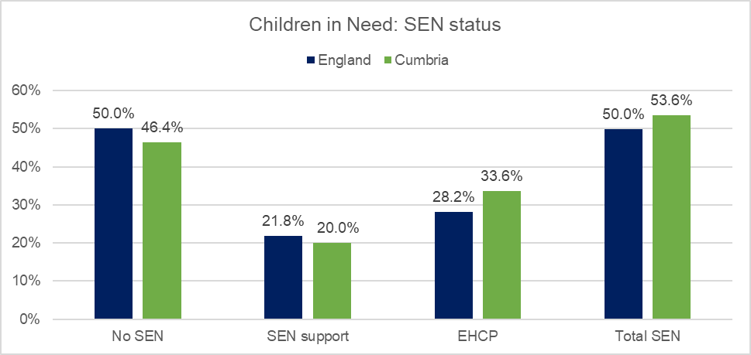

Source: Outcomes for children in need, including children looked after by local authorities in England; 2022/23

**Figure 28**: Cumbria v England: % of Children Looked After by SEN status; 2022/23

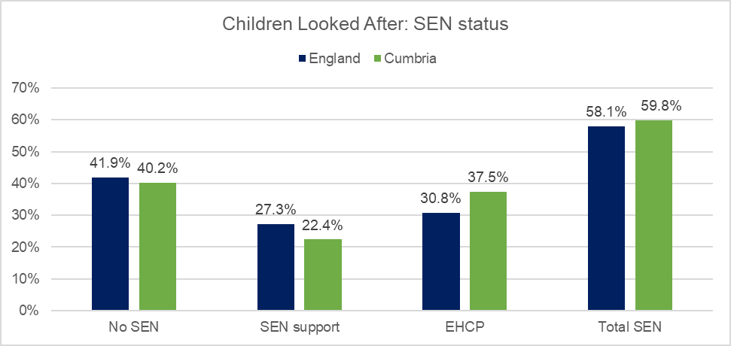

Source: Outcomes for children in need, including children looked after by local authorities in England; 2022/23

**Figure 29**: Cumbria v England: % of Children with a Child Protection Plan by SEN status; 2022/23

Source: Outcomes for children in need, including children looked after by local authorities in England; 2022/23

### **Free School Meals**

(As reported in Chapter 1.2 and 2.2) The proportion of pupils with SEND who are eligible for free school meals in Cumberland is significantly higher than pupils without SEND. 36.4% of pupils with SEND in Cumberland are known to be eligible for free school meals, this compares to 17.8% for pupils without SEN. The difference in FSM eligibility between pupils with and without SEN reflects the national picture. (See **Figure 30**).

Free school meal eligibility increases for pupils with an EHCP; in Cumberland, 38.4% of pupils with an EHCP are known to be eligible for free school meals, this compares to 42.2% in England; for pupils with SEN Support it is 35.7%, compared to 38.3% in England.

**Figure 30**: Free School Meal Eligibility by SEN Status

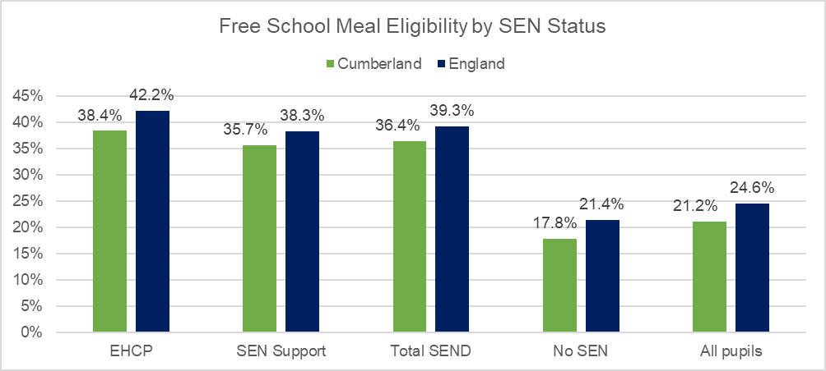

Source: Special Educational Needs in England, DfE, 2023/24.

### **Mental health by SEND status**

The Mental Health and Young People Survey (MHCYP) is a national survey that explores the mental health of children and young people aged 6 to 23 years living in England; it considers family life, education and services. Information is collected from children and young people and their parents. In 2017 and 2021, the surveys reported on the proportion of children with a probable mental disorder and SEND, both reporting higher proportions of mental disorders in children with SEND compared to their peers without. (Source 31).

Rates of probable mental disorders increased between 2017 and 2021 across all age groups and all children and young people. In 2021, 17.4% of children aged 6 to 16 years reported having a probable mental disorder, an increase from 11.6% in 2017.

In 2021, based on 3,667 children, the survey reported that more than half (56.7%) of 6 to 16 year olds with SEND had a probable mental disorder, this compares to 12.5% of children and young people without SEND. Compared to the 2017 survey, the proportion of 6 to 16 year olds with SEND and a probable mental disorder increased from 43.9% to 56.7; for children and young people without send, this increased from 8.2% to 12.5% (See **Figure 31**). The increases in mental disorders likely reflect the impact of the COVID-19 pandemic. The surveys report that rates of mental disorders and SEND were similar for both males and females. Identification of SEND was based on interviews held with parents.

**Figure 31**: Proportion of children and young people in England with a probable mental disorder by SEND status; 2017 v 2021.

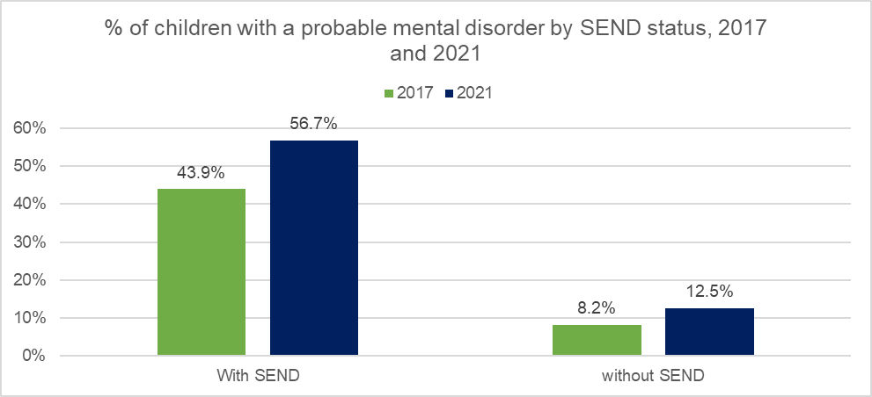

Source: Mental Health and Young People Survey, 2017 and 2021; NHS Digital

There have since been further follow-up surveys but unfortunately SEND data wasn't included therefore there are no more recent estimates.

### **Deprivation**

As reported in Chapter 2.2, around 8.3% of Cumberland’s total population are living in the 10% most deprived communities (Lower Super Output Areas) in England; 10.1% of children aged 0-18 years; and 9.9% children and young people aged 0-25years.

For children and young people with SEND, proportions of those living in the most deprived areas in Cumberland increases compared to the general population. 14.3% (n.395) of children and young people aged 0-25 years with an EHCP live in the 10% most deprived LSOAs in England; furthermore, more than two thirds (71%) are living in areas (LSOAs) within the 50% most deprived.

The picture of deprivation is similar for children with SEN with 14.3% (n.740) of children with SEN support living in the 10% most deprived LSOAs in England; while more than two thirds (70%) are living in LSOAs within the 50% most deprived. (See **Figure 32**).

**Figure 32**: Proportion of children and young people with SEND (SEN Support or EHCP) by Deprivation Decile

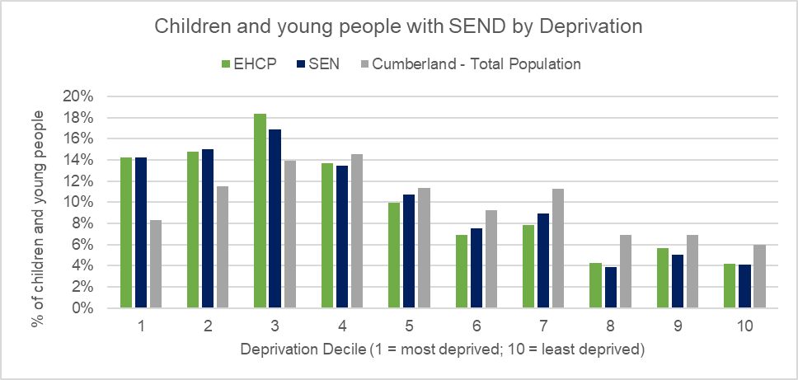

Source: Cumberland Council - ONE system; and January 2024 Census. Indices of Multiple Deprivation, 2019.

If we consider deprivation by location of school, there are 10 schools in Cumberland located in the 10% most deprived areas (LSOAs) nationally; within those schools, there are a total of 1,503 pupils accounting for 4% of all pupils. There are 258 pupils with SEN located at those schools, accounting for 4.9%; and 62 pupils with an EHCP, accounting for 3.0%. (See **Figure 33**).

**Figure 33**: Proportion of pupils by SEN status by Deprivation Decile – based on location of school

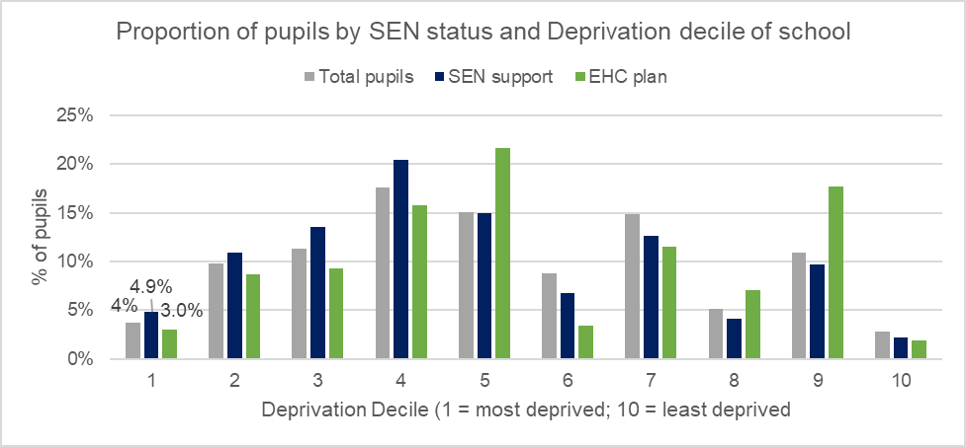

Source: Special Educational Needs in England, DfE, 2023/24. Indices of Deprivation 2019.

### **Location of children and young people with SEND by Ward**

Across Cumberland, the top five wards with the greatest numbers of children with SEND are: Moss Bay and Moorclose (320); Harraby North (272); Upperby (266); Egremont (260); and Maryport South (258). This data has been sourced from Cumberland Council and uses the postcode of where the child lives (is registered) and not where the child attends school. This data is presented in the **Appendices - see Table 1**.

Using the SEND data published by DfE, we can consider numbers of pupils with SEN support and EHCPs by ward based on the location of the school. Across Cumberland, the top five wards with the greatest numbers of pupils with SEND are: Hillcrest and Hensingham (627); Castle (400); Belah (385); Egremont (379); and Cockermouth North (341). This data is presented in the **Appendices - see Table 2.**

## Outcomes for children and young people with SEND

### **Education attainment**

The DfE provides information relating to the educational attainment of children and young people with SEND.

#### **Phonics screening check attainment**

The purpose of the phonics screening check is to confirm that all children have learned phonic decoding to an age-appropriate standard. All pupils (with some exceptions) who have reached the age of 6 by the end of the school year must take the check during that academic year.

In 2023/24, 46% of pupils with SEN in Cumberland met the expected standard in the phonics screening check in year 1, this is just above the England average of 44%. For pupils with an EHCP, this falls to 23% (England 20%); and for pupils with SEN support, this increases to 55% (England 52%). For pupils with no SEN, this increases to 87%, similar to the national average at 88%.

56% of pupils with SEN in Cumberland met the expected standard in the phonics screening check in year 2, this is below the England average of 61%. For pupils with an EHCP, this falls to 40% (England 31%); and for pupils with SEN support, this increases to 64% (England 70%). For pupils with no SEN, this increases to 96%, similar to the national average at 96%. See **Table 7**.

**Table 7**: Proportion of pupils meeting the expected standard in the Phonics Screening Check – Year 1 and end of Year 2; Cumberland and England; 2023/24

|  |  |  |  |
| --- | --- | --- | --- |
|  |  | Cumberland | England |
| All SEN | Phonics screening check in Year 1 | 46% | 44% |
|  | Phonics screening check end of Year 2 | 56% | 61% |
| EHC Plan | Phonics screening check in Year 1 | 23% | 20% |
|  | Phonics screening check end of Year 2 | 40% | 31% |
| SEN support | Phonics screening check in Year 1 | 55% | 52% |
|  | Phonics screening check end of Year 2 | 64% | 70% |
| No SEN | Phonics screening check in Year 1 | 87% | 88% |
|  | Phonics screening check end of Year 2 | 96% | 96% |

Source: Education statistics, Department for Education; 2023/24.

#### **Key Stage 2 - Reading, Writing and Maths Expected Standard**

Key Stage 2 covers Years 3 to 6 (primary school) for pupils aged between 7 and 11 years.

In the academic year 2023/24, 53% of all pupils in Cumberland had achieved the expected level of Reading, Writing and Maths at Key Stage 2, this is below the England average of 60%. For pupils in Cumberland with no SEN, this increases to 63% (England 71%); while for pupils with SEN, this falls to 17%, below the England average at 21%.

72% of all pupils in Cumberland had achieved the expected level in Reading at Key Stage 2, compared to 74% in England. For pupils in Cumberland with no SEN, this increases to 80% (England 84%); while for pupils with SEN, this falls to 38%, below national levels at 41%.

67% of all pupils in Cumberland had achieved the expected level in Writing at Key Stage 2, this compares to 72% in England. For pupils in Cumberland with no SEN, this increases to 79% (England 83%); while for pupils with SEN, this falls to 24%, below national levels at 30%.

68% of all pupils in Cumberland had achieved the expected level in Maths at Key Stage 2, this compares to 73% nationally. For pupils in Cumberland with no SEN, this increases to 77% (England 83%); while for pupils with SEN, this falls to 34%, below the England average at 37%. (See **Table 8**; and **Figure 34**).

**Table 8**: Key Stage 2 – % pupils meeting the expected standard by SEN status; Cumberland and England; 2022/23

|  |  |  |  |  |  |  |  |  |
| --- | --- | --- | --- | --- | --- | --- | --- | --- |
|  | Reading, Writing & Maths | | Reading | | Writing | | Maths | |
|  | Cumberland | England | Cumberland | England | Cumberland | England | Cumberland | England |
| All Pupils | 53% | 60% | 72% | 74% | 67% | 72% | 68% | 73% |
| All SEN | 17% | 21% | 38% | 41% | 24% | 30% | 34% | 37% |
| EHC Plan | 8% | 9% | 19% | 19% | 10% | 12% | 19% | 17% |
| No SEN | 63% | 71% | 80% | 84% | 79% | 83% | 77% | 83% |
| SEN Support | 20% | 26% | 45% | 48% | 28% | 36% | 39% | 44% |
| *SEN unclassified | 23% | 19% | 38% | 33% | 38% | 29% | 38% | 33% |

Source: Education statistics, Department for Education; 2023/24. *SEN unclassified includes pupils for whom SEN provision could not be determined.

**Figure 34**: Cumberland: Key Stage 2 – proportion of pupils meeting the expected standard by SEN status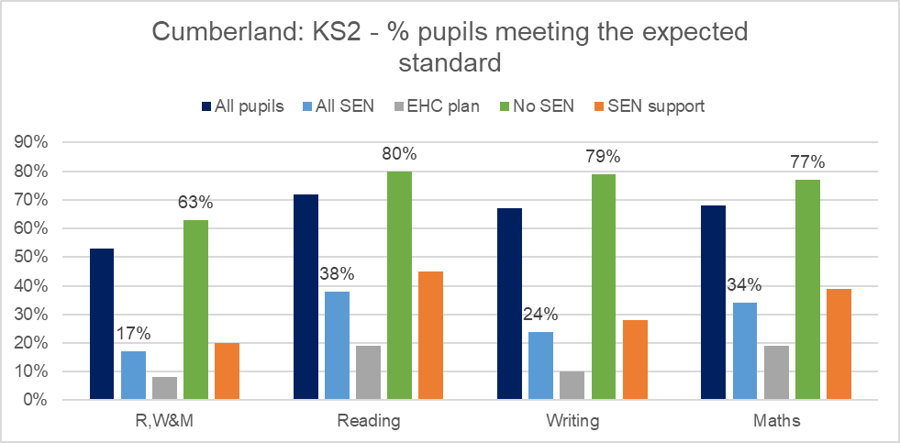

Source: Education statistics, Department for Education; 2023/24.

#### **Key Stage 4 – English and Maths Expected Standard**

Key Stage 4 covers Years 10 to 11 (secondary school) for pupils aged between 14 and 16 years, when most pupils take GCSEs.

The Attainment 8 score is a way of measuring how well pupils do at the end of Key Stage 4. It measures the results of pupils (in state-funded mainstream schools) across 8 GCSE level qualifications. The Attainment 8 subjects include: English, Maths, sciences, language and history, plus 3 other subjects. Each subject is assigned a score from 1 to 9 and then scores from each subject are added together.

In the academic year 2023/24, the Attainment 8 score for all pupils in Cumberland was 42.3, below the England average of 46.1. For pupils in Cumberland with no SEN, this increases to 45.4 compared to 50.0 in England; while for pupils with SEN, this falls to 25.7, below the England average at 27.8. The Attainment 8 score for pupils in Cumberland with SEN had fallen slightly in 2023/24 compared to the previous year 2022/23 at 26.0.

The Progress 8 score is a way of measuring the progress of pupils from the end of Key Stage 2 (the last year of primary school) to the end of Key Stage 4 (GCSEs), usually 11 to 16 years old. The higher a pupil’s Progress 8 score, the more progress they have made.

In the academic year 2023/24, the Progress 8 score for all pupils in Cumberland was -0.28, this is below the England average of -0.03. For pupils in Cumberland with no SEN, this increases to (is better) -0.19 compared to 0.10 in England; while for pupils with SEN, the score is -0.78 (is worse), and is below the England average at -0.63. (See **Table 9**; and **Figure 35**). The Progress 8 score for pupils in Cumberland with SEN had improved slightly in 2023/24 compared to the previous year 2022/23 at -0.80.

**Table 9**: Key Stage 4 performance – Attainment 8 and Progress 8 scores by SEN status; Cumberland and England; 2023/24

|  |  |  |  |  |
| --- | --- | --- | --- | --- |
|  | Attainment 8 score | | Progress 8 score | |
|  | Cumberland | England | Cumberland | England |
| All Pupils | 42.3 | 46.1 | -0.28 | -0.03 |
| All SEN | 25.7 | 27.8 | -0.78 | -0.63 |
| EHC Plan | 16.1 | 14.2 | -1.15 | -1.13 |
| No SEN | 45.4 | 50.0 | -0.19 | 0.10 |
| SEN Support | 29.6 | 33.1 | -0.63 | -0.45 |

Source: Education statistics, Department for Education; 2023/24.

In the academic year 2023/24, 59.4% of *all pupils* in Cumberland had achieved grades 4 or above in English and mathematics GCSEs, this is below the England average of 65.4%. For pupils in Cumberland with *no SEN*, this increases to 65.7%, below the England average of 72.7%; while for pupils *with* SEN, this falls to 24.9%, below the England average at 30.8%. See **Table 10**. The proportion of pupils achieving grades 4 or above (in English and mathematics GCSEs) in Cumberland with SEN had improved slightly in 2023/24 compared to the previous year 2022/23 from 23.5%.

**Table 10**: Key Stage 4 performance - GCSEs and English Baccalaureate by SEN status; Cumberland and England; 2023/24

|  |  |  |  |  |  |  |  |  |
| --- | --- | --- | --- | --- | --- | --- | --- | --- |
|  | Grades 4 or above in English and mathematics GCSEs | | Grades 5 or above in English and mathematics GCSEs | | English Baccalaureate grades 4 or above (A*-C in unreformed subjects) | | English Baccalaureate grades 5 or above (A*-C in unreformed subjects) | |
|  | Cumberland | England | Cumberland | England | Cumberland | England | Cumberland | England |
| All Pupils | 59.4% | 65.4% | 38.4% | 46.2% | 20.2% | 25.4% | 13.8% | 18.1% |
| All SEN | 24.9% | 30.8% | 12.0% | 17.5% | 4.6% | 6.6% | 3.1% | 4.2% |
| EHC Plan | 14.9% | 13.0% | 4.5% | 7.0% | 2.2% | 2.1% | 1.5% | 1.4% |
| No SEN | 65.7% | 72.7% | 43.2% | 52.3% | 23.0% | 29.4% | 15.7% | 21.1% |
| SEN Support | 29.1% | 37.7% | 15.2% | 21.6% | 5.6% | 8.4% | 3.7% | 5.2% |

Source: Education statistics, Department for Education; 2023/24.

**Figure 35**: Cumberland - Key Stage 4 performance by SEN status; 2023/24

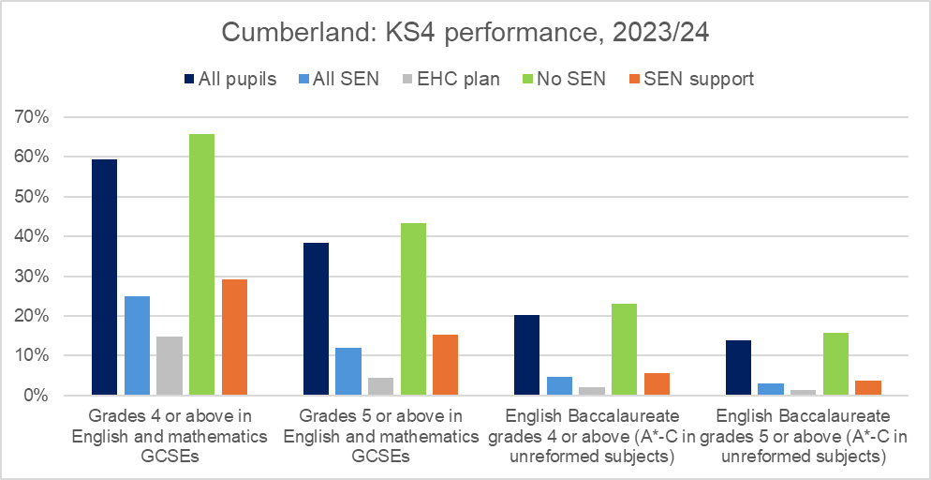

Source: Education statistics, Department for Education; 2023/24.

#### **Attainment by age 19 years**

At the time of publication of the JSNA, data from the DfE has not yet been published for Cumberland local authority. In the meantime, 2022/23 data for the former district areas (Allerdale, Carlisle and Copeland) has been aggregated to provide a Cumberland overview.

Fewer children with SEN in Cumberland achieve Level 2 and Level 3 education attainment compared to children without SEN by the age of 19 years. Level 2 and Level 3 attainment levels in Cumberland for children with SEN are similar to national averages with the exception of vocational qualifications where attainment levels are below England. See **Figure 36**.

In 2022/23, 39.9% of children aged 16-19 years with identified SEN had achieved Full Level 2 with English and Maths (GCSE or equivalent) by the age of 19 years; this is similar to the England average at 39.3%. For children with no identified SEN, this increases to 80.0% in Cumberland and 81.9% nationally.

In 2022/23, 11.9% of children aged 16-19 years with identified SEN had achieved Level 3 (A/AS Levels) by the age of 19 years; reflecting the England average at 11.9%. For children with no identified SEN, this increases to 34.8% in Cumberland and 42.3% nationally.

In 2022/23, 11.1% of children aged 16-19 years with identified SEN had achieved Level 3 (vocational qualifications) by the age of 19 years; this is below the England average at 17.8%. For children with no identified SEN, this increases to 17.0% in Cumberland and 21.3% nationally.

**Figure 36**: Cumberland and England - Proportion of children achieving Level 2 & 3 by 19 years by SEN status

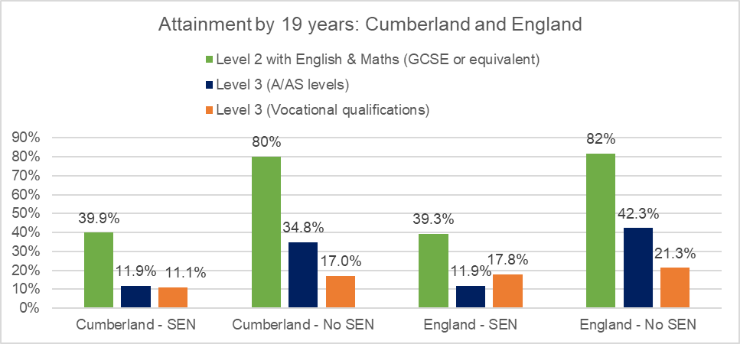

Source: Attainment by 19 years, Department for Education

#### **Not in Education, Employment or Training (NEET)**

Education attainment and employment outcomes are poorer for children and young people with SEND compared those without. Furthermore, pupils with SEN are less likely to participate in higher education.

In 2023/24, 3.5% of *all* children aged 16-17 years in Cumberland were either Not in Education, Employment or Training (NEET) or their activity was unknown, this is below the national average of 5.4%

At the time of publication of the JSNA, data from the DfE has not yet been published for Cumberland local authority. In the meantime, data for former Cumbria local authority is presented below.

In 2023, in Cumbria, a total of 342 children aged 16-17 years were either Not in Education, Employment or Training (NEET) or their activity was unknown, accounting for 3.3% (cohort 10,206). 223 were known to be NEET, accounting for 2.2%, this compares to 2.8% nationally.

For children with SEND, levels of those who are NEET/or not known are greater than children without SEND. In Cumbria, 90 children aged 16-17 years with SEND were either NEET/or their activity was unknown, accounting for 6.1% (cohort 1473); this compares to 2.9% for children without SEN. For those with SEND, 68 of those were known to be NEET, accounting for 4.6%; this compares to 1.8% for children without SEN.

33 children in Cumbria with an EHCP were NEET/or their activity was unknown, accounting for 6.5%, this compares to 10.1% nationally. 57 children with SEN support were NEET/or their activity was unknown, accounting for 5.9%, this compares to 9.3% nationally.

### **Progression onto Further Education**

At the time of publication of the JSNA, data from the DfE has not yet been published for Cumberland local authority. In the meantime, data for former Cumbria local authority is presented below.

Children with SEN are less likely to continue onto further education or apprenticeships in mainstream schools than those without SEN.

In 2019/20, 80.4% (n.78/97) of pupils with identified SEN in Cumbria continued to study at Level 4 or higher (sustained a level 4 or higher destination), this compares to 76.3% of pupils with no identified SEN. 75.3% (N.73/97) continued to study at degree level (sustained degree destination), this compares to 69.1% of pupils without SEN. This data is reporting on state-funded mainstream schools only; furthermore, data is not yet available for Cumberland.

### **School absences**

A child and young person’s attendance at school is not only important to their overall academic achievement but it helps to support their overall wellbeing and wider development. Regular school attendance is key in supporting children and young people’s educational, economic and social outcomes. Being at school enables positive peer relationships which contribute to better mental health and wellbeing. (Source 35).

Overall absence rates of pupils with SEND are greater than pupils with no identified SEN in both Cumberland schools and nationally. Overall absence rates are presented as the percentage of sessions missed due to all absences including authorised (e.g. illness, holidays, study, medical appointments) and unauthorised absences.

During the 2023/24 Autumn term, the overall absence rate of *all pupils* in Cumberland schools (this includes state-funded primary, secondary and special schools) was 7.0%, this was just above the national rate of 6.7%. Overall absence rates in Cumberland schools are slightly higher in girls (7.1%) than boys (6.9%).

For pupils in Cumberland with an EHCP, the overall absence rate increases to 11.4%, this compares to 12.3% in England; for pupils in Cumberland with SEN Support, the absence rate was 9.9% which was slightly above the national average at 9.6%. For pupils with no identified SEN, the absence rate was 6.2%, just above the national average of 5.8%.

**Figure 37**: Cumberland and England - Overall absence rate by SEN status; 2023/24 Autumn Term

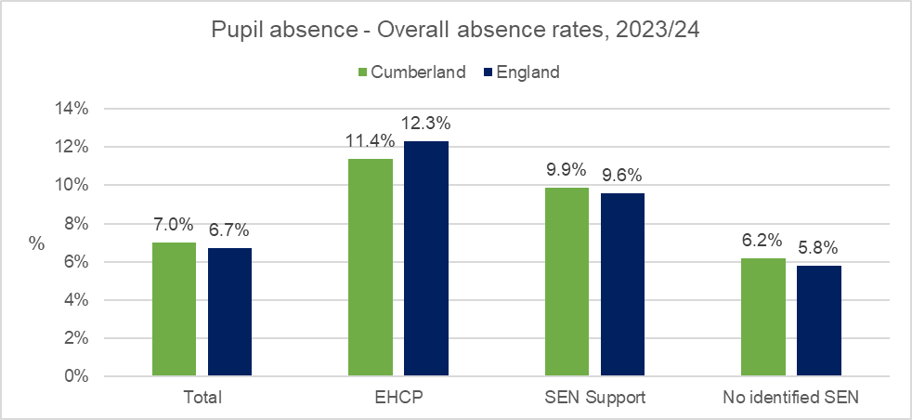

Source: Pupil absence in schools in England, Department for Education, 2023/24 Autumn Term

In Cumberland, overall absence rates in *all pupils* were highest in Year 9 (age 13 to 14 years, when pupils are typically preparing for GCSEs) at 10.4% compared to 8.9% in England; and Year 11 (age 15 to 16 years, when most children take their GCSEs) at 10.3%, compared to 9.6% in England.

Overall absence rates were highest in pupils in Cumberland with the primary need of multi-sensory impairment at 22.6%, compared to England the rate was significantly lower at 9.4%. In England the rate was highest in pupils with the primary need of Profound and multiple learning difficulty at 18.2%, in Cumberland the rate was 14.4%. It is important to note that the number pupils with a multi-sensory impairment and the number of overall absence sessions are relatively low; furthermore, it is important to note that pupils with multi-sensory impairment needs are likely to have significant, and in some cases life limiting conditions, which can explain higher absence rates. See **Figure 38**.

A persistent absence (pupil enrolment) is identified as persistently absent if 10% or more of possible sessions are missed, this translates to around 7 days of absence across a term.

Percentages of pupils with SEND who are persistent absentees are greater than pupils with no identified SEN in both Cumberland schools and nationally. 1 in 3 pupils in Cumberland with an EHCP are persistently absent compared to 1 in 4 pupils with no identified SEN.

During the 2023/24 Autumn term, the percentage of persistent absentees (10% or more sessions missed) of all pupils in Cumberland schools (including state-funded primary, secondary and special schools) was 21.8%, above national levels of 19.4%. Persistent absentee rates in Cumberland schools are slightly higher in girls (22.3%) than boys (21.3%).

For pupils in Cumberland with an EHCP, the percentage of persistent absentees increases to 33.6%, similar to England at 34.1%; for pupils in Cumberland with SEN Support, the percentage of persistent absentees was 31.0% which was above national levels at 28.2%. For pupils with no identified SEN, the percentage of persistent absentees was 19.2%, above national levels at 16.6%.

**Figure 38**: Cumberland and England - % of persistent absentees by SEN status; 2023/24 Autumn Term

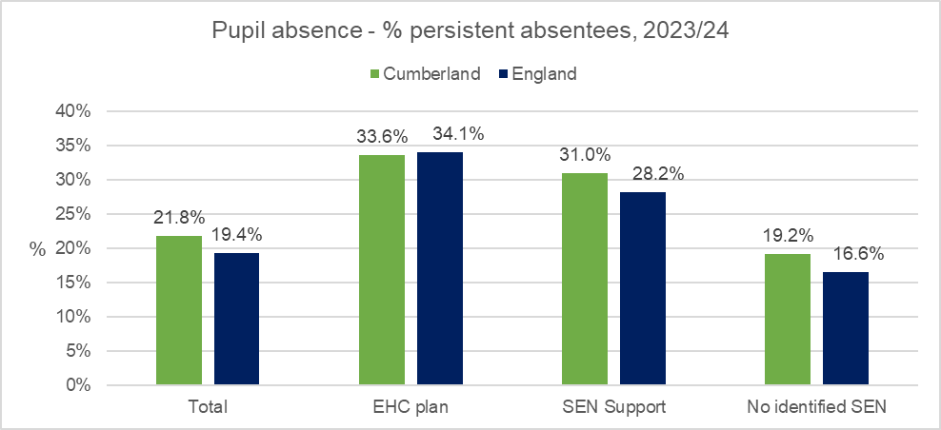

Source: Pupil absence in schools in England, Department for Education, 2023/24 Autumn Term

In Cumberland, persistent absentee rates in *all pupils* were highest in Year 12 and above (age 16 to 18 years, sixth form) at 50.0% compared to 34.2% in England; and Year 9 (age 13 to 14 years) at 32.2%, compared to 25.7% in England.

As reported above for overall absence rates, persistent absentee rates were highest in pupils in Cumberland with the primary need of multi-sensory impairment at 60%, compared to England the rate was significantly lower at 27.9%. In England the rate was highest in pupils with the primary need of Profound and multiple learning difficulty at 50.6%, in Cumberland the rate was similar at 45.5%. As mentioned earlier, it is important to note that numbers pupils with a multi-sensory impairment and numbers of persistent absence sessions are relatively low; furthermore, pupils with multi-sensory impairment needs are likely to have significant, and in some cases life limiting conditions, which can explain higher absence rates. See **Figure 39**.

**Figure 39**: Cumberland - % of pupil absence by SEND primary need; 2023/24 Autumn Term

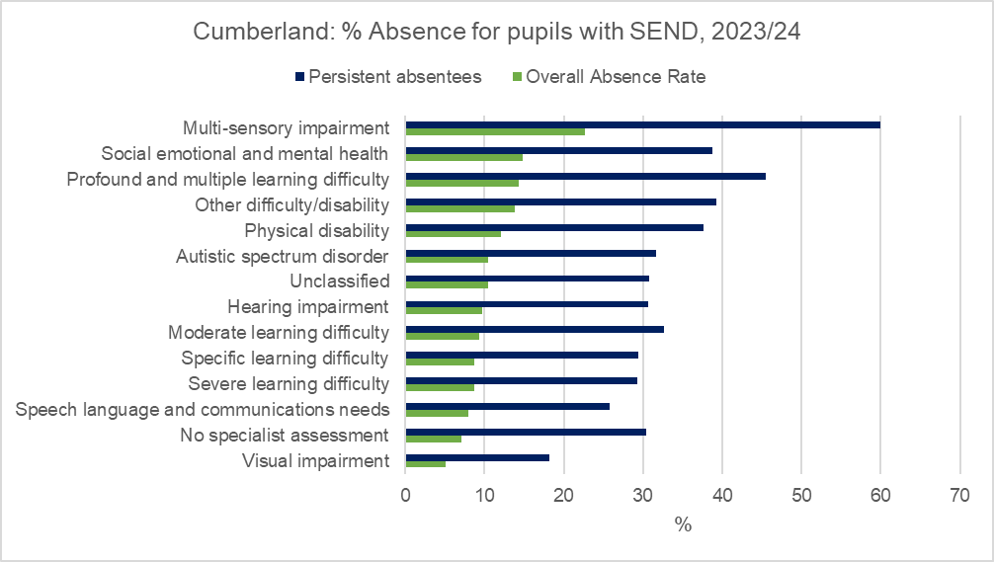

Source: Pupil absence in schools in England, Department for Education, 2023/24 Autumn Term

### **School suspensions and permanent exclusions**

School suspensions and permanent exclusions are sometimes necessary in order to encourage good behaviour so that all pupils benefit from being in school and the opportunities provided by education.

A suspension refers to when a pupil is excluded from a school for a set period of time including part of the school day, for one or more periods, and up to a maximum of 45 days.

School suspension rates for pupils in Cumberland with SEND are much greater (more than three times) than pupils with no SEN, reflecting the national picture.

In the 2023/24 Autumn term, there were 1,310 suspensions of *all pupils* in Cumberland schools equating to a suspension rate of 3.34 (per 100 pupils), this is below the national average of 4.13. Suspension rates for *all pupils* in Cumberland schools are higher in males (4.33) compared to females (2.33), reflecting a similar national picture.

For pupils in Cumberland schools with an EHCP, there were 191 suspensions equating to a rate of 10.10, this is similar to the national average of 10.05. For pupils in Cumberland with SEN Support, there were 425 suspensions, a rate of 8.96 which was below the national average of 11.27. For pupils with no SEN, there were 694 suspensions equating to a significantly lower rate of 2.13, below the national average of 2.69.

A permanent exclusion refers to a pupil who is excluded and who will not come back to that school (unless the exclusion is overturned).

In the 2023/24 Autumn term, there were 25 permanent exclusions of *all pupils* in Cumberland schools equating to a rate of 0.06 (per 100 pupils), which is similar to the national average of 0.05. Permanent exclusion rates in Cumberland schools are slightly higher in females (0.07) than males (0.06) however, numbers are relatively low.

There were no permanent exclusions for pupils in Cumberland with an EHCP, in England the rate was 0.11. For pupils with SEN Support, there were 11 permanent exclusions equating to a rate of 0.23, this is above the England average of 0.16. For pupils with no SEN, there were 14 permanent exclusions equating to a rate of 0.04, this is just above the national average at 0.03.

## Identification of need

Early identification of need benefits a child’s future. It allows early medical treatment where required and care support packages to be put in place, increasing the chances of children to be healthy and reach their academic potential.

The Children and Family Act 2014 requires local authorities to identify all children and young people in its area who have or may have special educational needs or a disability.

Section 22: Under the duty to cooperate partner agencies are required to support the Local Authority to discharge this requirement.

Section 3.46 SEND Code of Practice: If a GP, Integrated Care Board or NHS trust ‘forms an opinion’ that a child under compulsory school age has (or probably has) special educational needs or a disability, then the NHS body must discuss the opinion with the child’s parents (Section 23). The NHS body must then inform the appropriate local authority.

In Cumberland a comprehensive process is in place to identify these children and work to ensure the right support and provision is in place at the right time to enable access to educational provision.

In Cumberland, those with additional needs are identified and supported through a number of agencies and pathways.

In EYFS, identification and support is implemented at as early as possible through the SEN Inclusion Fund. This supports Early Years providers to implement support and receive funding without following the EHC pathway. The panel discusses referrals and allocates funds to those children/young people that have evidence of unmet need who would benefit from early intervention.

The Ordinarily Available Provision at SEND Support document has recently been updated through a consultation process with education providers across all age ranges. Education providers now have access to 3 Ordinarily Available documents covering:

* Early Years
* School Age
* Post 16

Provision in Cumberland, expected to be ordinarily available to all children and young people with SEND in mainstream schools, academies, free schools, early years and post-16 providers. It has been developed with a range of key professionals and experts in specific areas. Its aim is to provide support, information and advice in a clear and accessible way.

Ordinarily Available Provision at SEN Support Guidance for schools and settings has been developed as part of a suite of support materials including:

* The SEND Toolkit - The Cumberland Toolkit for Special Educational Needs and Disability (SEND) is aimed at all educational providers and settings supporting Cumberland children and young people aged 0-25 years.
* SEND Handbook -The SEND Handbook is a public document designed to provide guidance to schools and settings, parents, professionals and children and young people with special educational needs and disabilities (SEND) about how we intend to meet responsibilities for identifying and addressing SEN in Cumberland.
* SEND in a Nutshell - The ‘SEND in a Nutshell’ is a method of data analysis which helps senior leaders understand their school context both regionally and nationally. It provides a starting point for whole-school development planning. The document provides a template for using as your ongoing SEN Register whilst giving you key insights into national data and census information. The aim is to start discussions on SEND pedagogy, provision, resourcing and growing expertise, and help you to evaluate SEND within your schools according to the Four Broad Areas of Need. This supports schools to prioritise SEND within their development plans by presenting formats and tools for strategic, long-term planning and impact evaluation.

In Cumberland we strive to ensure that all children and young people with SEND, and their families have positive experiences in school and feel well supported. To achieve this, access to the right support, in the right place and at the right time is essential. Wherever children and young people live in Cumberland, we want them to have their additional learning needs met. For most children attending their local setting, with other children from their community is the best way to ensure this happens. To achieve this for the children and young people in Cumberland, all schools must have a core offer that meets the needs of all children, including those with SEND.

Education providers also have access to supportive tools to assist in training those in the early identification and support of those with SEND.

### **Newborn and Infant physical examination screening**

In 2022/23, 95.4% of eligible newborn babies (within 72 hours of birth) in Cumberland received a physical examination. Although considered acceptable (greater than or equal to 95.0%), this is below the England average of 96.2%. (Source 12).

### **Newborn hearing screening**

In 2022/23, 99.4% of eligible newborn babies in Cumberland received a newborn hearing screening (completed by 4/5 weeks). Coverage in Cumberland is above and the England average of 98.5%. (Source 12).

### **Health visitor service delivery**

The national Healthy Child Programme (HCP) was set up to improve the health and wellbeing of children aged 0 to 5 years. This is done through health and development reviews, health promotion, parenting support and screening and immunisation programmes. The Health Visiting Service consists of specialist community public health nurses and teams who provide information, assessments and interventions for babies, children and families including first time mothers and fathers with complex needs.

This information can be used by local authority commissioners and health professionals to track how many pregnant women, children and families in their local area have received health promoting reviews at particular points during pregnancy and childhood.

The Health Visitor Service delivery metrics currently cover the antenatal contact, new birth visit, 6-to-8-week review, the 12-month review and the 2 to 2½ year review.

**Table 11**: Health visitor service delivery metrics; Quarter 4, 2023/24.

|  |  |  |  |
| --- | --- | --- | --- |
|  | Cumberland* | North West | England |
| New Birth Visits (NBV) within 14 days | 279 | 85.1% | 83.6% |
| 6 to 8 week reviews | 319 | 88.1% | 82.2% |
| 12 month reviews by 12 months | 170 | 82.9% | 78.4% |
| 2 to 2½ year reviews | 354 | 83.9% | 79.9% |

Source: Office for Health Improvement and Disparities; Cumberland Council. * Data is submitted on a voluntary basis; % data for Cumberland is not published nationally and has therefore been sourced from the provider.

## SEND Assessment process

### **EHCP requests, assessments and new plans**

In 2023, there were 551 initial requests for an EHC Plan for children and young people in Cumberland; of those, 129 were refused while 423 assessments were undertaken. 104 EHC Plans (excluding exceptions) were issued within the timescale of 20 weeks, a rate of 27.1%, this is significantly below the national average of 50.3%. There were 402 new EHC Plans issued in Cumberland throughout 2023. See **Table 12**.

**Table 12**: EHC Plans - Initial requests, assessments, timeliness, new plans; 2023.

|  |  |  |
| --- | --- | --- |
|  | Cumberland | England |
| Number of initial requests for an EHC plan | 551 | 138,242 |
| Number of initial requests for assessment for an EHC plan that were refused | 129 | 33,141 |
| Timeliness - Number of EHC plans excluding exceptions issued within 20 weeks | 104 | 38,471 |
| Timeliness - Rate of EHC plans excluding exceptions issued within 20 weeks | 27.1% | 50.3% |
| Total number of assessments undertaken | 423 | 91,023 |
| Number of new EHC Plans which started during the calendar year | 402 | 84,428 |

Source: Education, Health and Care Plans, Department for Education. Timeliness figures are based on assessments completed within the calendar year where no mediation or tribunal has taken place.

Parents, carers and young people can register an appeal with the SEND tribunal for multiple reasons including if they are unhappy about the contents of the plan or there is a refusal to assess. In 2023 there were 26 Tribunal appeals. 20 of these (77%) appealed the placement named in the plan (Source 34: Cumberland Council).

## Activity level of SEND services

As reported in Cumberland’s Public Health Annual Report 2023/24 (Source: 36), increasing numbers of SEND and EHCPs are translating into rising demand for clinical support. **Figure 40** below presents the number of paediatric referrals into Children’s services provided by North Cumbria Integrated Care NHS Foundation Trust (NCIC). There have been increases across most services including Children’s Speech and Language Therapy (+20%); Children’s continence (+82%); Community Paediatrics (+68%); and Children’s Community Nursing (+65%). Please note consideration should be given to the period during the COVID pandemic.

Figure 40: Paediatric referrals into Children’s services provided by North Cumbria Integrated Care NHS Foundation Trust by service; 2020 to 2023

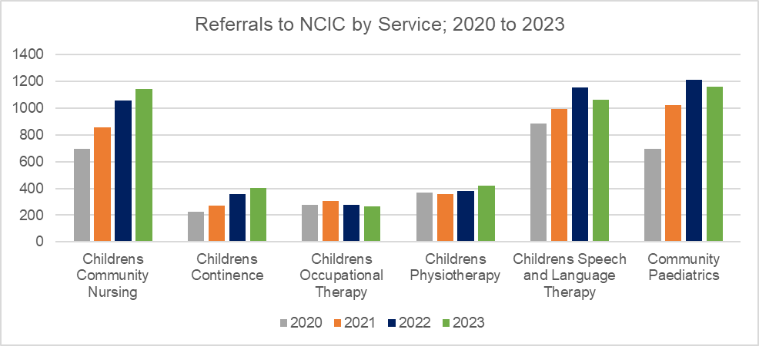

Source: North Cumbria Integrated Care NHS Foundation Trust

Within each service we can consider the reasons for referrals into paediatric services; again, as reported in Cumberland’s Public Health Annual Report 2023/24 (Source: 36), there has been a significant increase in numbers of referrals due to Autistic Spectrum conditions where numbers have increased six-fold in the last three years, from 160 referrals in 2020 to 1,204 referrals in 2023 (please note consideration should be given to the period during the COVID pandemic). See **Figure 41**. **Figure 41** also presents the referral reason of Speech and Language Problems, although the trend is not as clear there has been an overall increase in the numbers of referrals into the Speech and Language Therapy service as shown above in **Figure 40**.

**Figure 41**: Paediatric referrals by reason - ASD and Speech & Language Disorders; 2020 to 2023

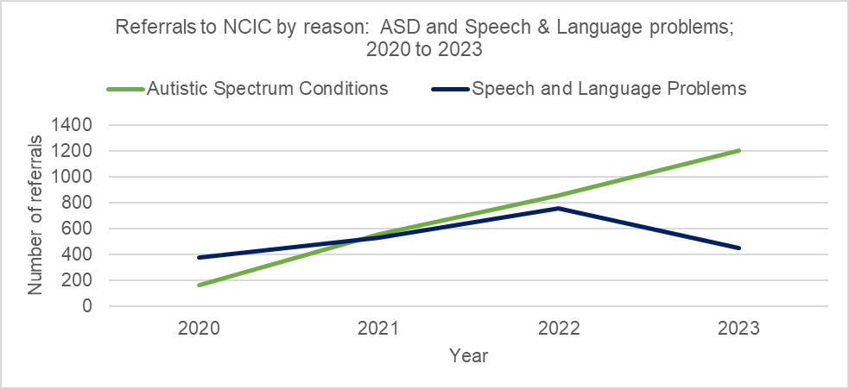

Source: North Cumbria Integrated Care NHS Foundation Trust

**Table 13** presents the waiting times (less than 18 weeks) for Children’s Community Services provided by North Cumbria Integrated Care NHS Foundation Trust across Cumbria. Most children and young people are waiting less than 18 weeks for all community services detailed below. Children and young people are waiting longer for community paediatric services (46.7%) and Speech and Language services (39.0%), likely reflecting increasing demand as mentioned above. Waiting times (less than 18 weeks) across all services at NCIC are better than England averages.

**Table 13**: Waiting times for Children and Young People’s Community Services, < 18 Weeks (Higher is Better); April 2024

|  |  |  |  |  |
| --- | --- | --- | --- | --- |
| CYP Community Service | NCIC | | England | NORTH EAST AND YORKSHIRE |
|  | No. | % | % | % |
| Audiology | 183 | 100.0% | 77.7% | 87.0% |
| Community nursing services (planned care and rapid response teams) | 54 | 93.1% | 90.8% | 93.9% |
| Community paediatric service | 711 | 53.3% | 38.4% | 31.1% |
| Nursing and Therapy teams support for long term conditions | 105 | 92.9% | 80.6% | 95.7% |
| Therapy interventions: Occupational therapy | 76 | 100.0% | 64.7% | 52.7% |
| Therapy interventions: Physiotherapy | 126 | 94.7% | 83.2% | 82.4% |
| Therapy interventions: Speech and language | 501 | 61.0% | 60.8% | 55.3% |

Source: North Cumbria Integrated Care NHS Foundation Trust

**Table 14** presents the waiting times for children and young people waiting for Children’s Community Services provided by North Cumbria Integrated Care NHS Foundation Trust across Cumbria more than 52 weeks. There are just 6 children and young people waiting longer than 52 weeks for Community paediatric services; and 14 children and young people waiting for Speech and language services. Waiting times across all services are better at NCIC than the England average.

**Table 14**: Waiting times for Children and Young People’s Community Services, > 52 Weeks (Lower is Better) April 2024

|  |  |  |  |  |
| --- | --- | --- | --- | --- |
| CYP Community Service | NCIC | | England | NORTH EAST AND YORKSHIRE |
|  | No. | % | % | % |
| Audiology | 0 | 0.0% | 2.7% | 0.2% |
| Community nursing services (planned care and rapid response teams) | 0 | 0.0% | 2.6% | 2.0% |
| Community paediatric service | 6 | 0.4% | 21.6% | 26.2% |
| Nursing and Therapy teams support for long term conditions | 0 | 0.0% | 0.8% | 0.0% |
| Therapy interventions: Occupational therapy | 0 | 0.0% | 7.2% | 12.6% |
| Therapy interventions: Physiotherapy | 0 | 0.0% | 0.9% | 0.2% |
| Therapy interventions: Speech and language | 14 | 1.7% | 8.0% | 14.1% |

Source: North Cumbria Integrated Care NHS Foundation Trust

In Cumberland, one of the main providers of specialist mental health services (for adults and some children’s services) is Cumbria, Northumberland, Tyne & Wear NHS Foundation Trust (CNTW). As reported in Cumberland’s Public Health Annual Report 2023/24 (Source: 36), the picture is slightly more complex where numbers of referrals for support for learning disability have slightly fallen (from 555 referrals in 2020 to 404 in 2023) while numbers of referrals for neurodiversity have increased almost four-fold (from 377 referrals in 2020 to 1,518 in 2023); with the two combined more than doubling in three years in turn increasing demand for services. These changes in numbers may reflect changes in what was once referred to as a learning disability being more recently described as neurodiversity. (See **Figure 42**). Please note consideration should be given to the period during the COVID pandemic.

Children’s neurodiversity services have increased by +286%, from 256 referrals in 2020 to 988 referrals in 2023; while numbers of referrals in children’s Learning Disability services have fallen by -61.9%, from 247 referrals in 2020 to 94 referrals in 2023. (See **Figure 42**). Please note consideration should be given to the period during the COVID pandemic.

**Figure 42**: North Cumbria Referrals to CNTW for Learning Disability and Neurodiversity services; 2020 to 2023

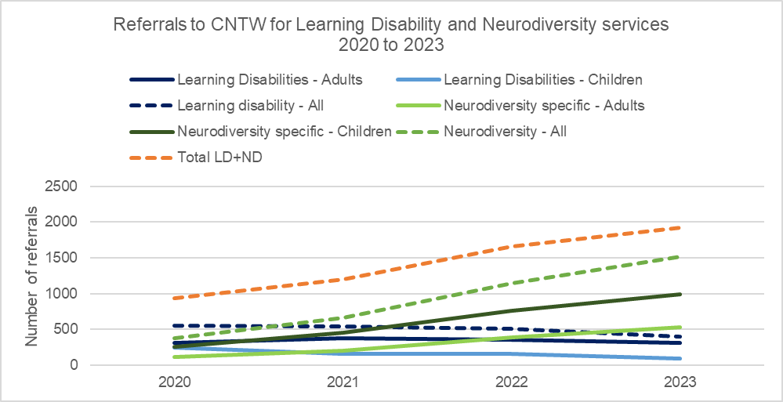

Source: Cumbria, Northumberland, Tyne & Wear NHS Foundation Trust

In 2023, there were 2,259 referrals into Child and Adolescent Mental Health services for children and young people living in Cumberland. Numbers of referrals into the service have fallen compared to previous years (see **Table 15**).

**Table 15**: Number of referrals into Child and Adolescent Mental Health services; 2020 to 2023

|  |  |  |  |  |
| --- | --- | --- | --- | --- |
|  | 2020 | 2021 | 2022 | 2023 |
| Male | 1,294 | 1,185 | 904 | 793 |
| Female | 1,563 | 1,755 | 1,733 | 1,466 |
| Total | 2,857 | 2,940 | 2,637 | 2,259 |

Source: Cumbria, Northumberland, Tyne & Wear NHS Foundation Trust

Although referral numbers have fallen, there has been a continuous increase in the proportion of referrals for females over the years while referrals for males have continuously decreased. In 2023, 2 in 3 (64.9%) referrals were for females, this compares to just over half (54.7%) in 2020.

**Table 16**: Proportion of referrals into Child and Adolescent Mental Health services by sex; 2020 to 2023

|  |  |  |  |  |
| --- | --- | --- | --- | --- |
|  | 2020 | 2021 | 2022 | 2023 |
| Male | 45.3% | 40.3% | 34.3% | 35.1% |
| Female | 54.7% | 59.7% | 65.7% | 64.9% |

Source: Cumbria, Northumberland, Tyne & Wear NHS Foundation Trust

Increases in demand for services have led to increases in waiting times for some key CNTW services. There has been a significant rise in the number of children waiting more than 18 weeks for ADHD services, numbers increasing ten-fold from around 30 in January 2022 to more than 300 in January 2024. There have been notable increases in waiting times for Autism services for Adults, from around 190 people in January 2022 to more than 300 in January 2024. Conversely, waiting times for Child and Adolescent Mental Health Services (CAMHS) have remained relatively stable with fluctuations throughout the years; as at January 2024, there were 27 children and young people waiting more than 18 weeks, similar to the previous couple of years. Waiting times for some specialist Learning Disability services for children appear to fluctuate however the number fell to 25 children in January 2024 compared to more than 70 in the previous couple of years. (See **Figure 43**).

**Figure 43**: Waiting times for CNTW key services – number of people waiting >18 weeks; 2020 to 2023

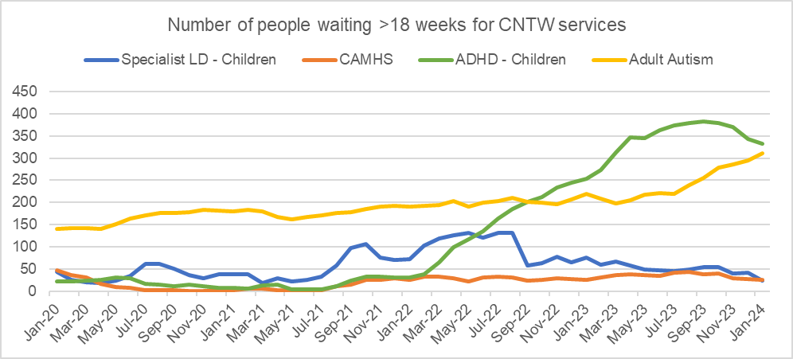

Source: Cumbria, Northumberland, Tyne & Wear NHS Foundation Trust

There are likely many reasons and explanations as to why there has been a significant demand for services in Cumberland including changes in patterns of need as well as advancements in awareness and improvements in services. More information about the likely factors impacting on the rising demand can be found in the Cumberland Public Health Annual Report 2023/24 (Source 36).

Using more recent quarterly information, 70.9% of children and young people in Cumberland were waiting less than 18 weeks for CAMHS following referral (as at Quarter 1, April-June 2024). As mentioned earlier, waiting times do fluctuate but it appears they have improved compared to early in the previous year 2023/24. Waiting times for children and young people in Cumberland with an EHCP are better than those without with greater proportions waiting less than 18 weeks: during Quarter 1 (Apr to Jun-24) 80% of children and young people with an EHCP are waiting less than 18 weeks for services compared to 69.7% for those without an EHCP (10.3% less). See **Table 17**.

**Table 17**: Quarterly performance data - referrals into Child and Adolescent Mental Health services; 2023/24 to 2024/25

|  |  |  |  |  |  |
| --- | --- | --- | --- | --- | --- |
|  | Q1 23/24 | Q2 23/24 | Q3 23/24 | Q4 23/24 | Q1 24/25 |
| Rate of crisis intervention of those with SEND/ASD as a proportion of the population with an EHCP - countywide | 0.8% | 0.6% | 0.6% | 0.5% | 0.6% |
| Rate of admission to Tier 4 services of those with SEND/ASD as a proportion of the population with an EHCP - countywide | 0.0% | 0.0% | 0.0% | 0.0% | 0.0% |
| Percentage of all children and young people waiting less than 18 weeks (Cumbria) | 48.7% | 36.9% | 47.3% | 80.2% | 70.9% |
| Percentage of children and young people with an EHCP waiting less than 18 weeks (Cumberland) | 55.8% | 35.6% | 49.2% | 87.5% | 80.0% |
| Percentage of children and young people without an EHCP waiting less than 18 weeks (Cumberland) | 47.4% | 37.1% | 47.0% | 79.6% | 69.7% |
| Ratio (difference) in waiting times for those with an EHCP compared to those without (Cumberland) | -8.4 | 1.6 | -2.2 | -7.9 | -10.3 |

Source: Cumbria, Northumberland, Tyne & Wear NHS Foundation Trust

All statutory SEND services across the partnership are currently experiencing demand above capacity.

# Current services and assets in Cumberland

Details of services and assets available in Cumberland to support children and young people and their families with SEND are set out below.

## SEND and Alternative Provision Strategic Partnership Board

Cumberland SEND and Alternative Provision (AP) Strategic Partnership is made up of practitioners from across education, health and social care and SEND Alliance Cumbria, our parent carer forum. The purpose of the SEND Strategic Partnership Board is to act as a Strategic Governance Body to oversee the delivery of the improvements to SEND services across the Local Area.

The Membership of the Board is reflective of the Local Area and includes representation from key stakeholders. The Board receives progress reports from operational Workstreams, tasked with delivering key elements of the SEND Strategic Plan and in turn will report progress and risks in line with the agreed Governance structure. Co-production is fundamental to all activities relating to the role of the SEND and AP Strategic Partnership Board and associated Workstreams.

## SEND Local Offer

Every Local Authority in England has a statutory duty to publish a Local Offer. Cumberland Council’s SEND Local Offer can be found here: [Cumberland Council SEND Information Hub (Local Offer)](https://fid.cumberland.gov.uk/kb5/cumberland/directory/localoffer.page?localofferchannel=0).

The Local Offer has 2 key purposes:

* To provide clear, comprehensive, accessible and up-to-date information about the available provision and how to access it, and
* To make provision more responsive to local needs and aspirations by directly involving disabled children and those with SEN and their parents, and disabled young people and those with SEN, and service providers in its development and review.

What is the Local Offer?

* The Local Offer gives children, young people and their families information about what services are likely to be available in their area.
* The local offer is not a guarantee that a particular service will be available but should be a guide to what you can expect to find and how you can access it.
* The Local Offer needs to be available on the internet.
* The Local Authority must also say how people without internet can access the Local Offer.
* The local offer should not just be a list of services. It should give a broad range of information about the support available.
* The information should be clear and easy to find.

## Special (Specialist) Schools

Special schools are for children and young people with an Education, Health and Care Plan (EHCP). A special school caters specifically for children whose needs cannot be met with the provision and support provided by a mainstream school, even with an EHCP in place. **Table 18** below presents Special Schools in Cumberland by provision of need. (Please note the term ‘specialist schools’ is used locally).

**Table 18**: Special Schools in Cumberland by provision of need

|  |  |  |  |  |  |
| --- | --- | --- | --- | --- | --- |
| School & Link to further information | Autism | Speech, Language, communication (SLCN) | Social, Emotional, Mental Health (SEMH) | Physical & Medical | Severe Learning Difficulties |
| [Cumbria Academy for Autism](https://fid.cumberland.gov.uk/kb5/cumberland/directory/service.page?id=mNBZ-GjgGTY) ages 4-19 | X |  |  |  |  |
| [James Rennie School](https://fid.cumberland.gov.uk/kb5/cumberland/directory/service.page?id=rsDq5XMLtXE) ages 3-19 | X |  |  | X | X |
| [Mayfield School](https://fid.cumberland.gov.uk/kb5/cumberland/directory/service.page?id=Z5dI-nqtts0) ages 3-19 |  |  |  |  | X |

Source: Cumberland Council

## Resourced Provisions (RP)

Specialist RP places are for children and young people with an Education, Health and Care Plan (EHCP).

A resourced provision is not always a separate building with a unique identity. There may be several spaces that can offer opportunities for students, where they can join activities and learn with their peers. The time students spend in regular classes depends on their individual needs. For some, short amounts of time on a specific activity with support may be appropriate. Others may benefit from joining in one or more curriculum areas for increasing periods. Children and young people will have access to different resources. Some of the things offered may be small group teaching, speech therapy, and mainstream experiences.

Benefits of RPs include:

* pupils attend their local school/in their community;
* receive the targeted support they need to make progress in their learning;
* alongside other children/young people in their peer group.

**Table 19**: Schools with Resourced Provisions in Cumberland

|  |  |  |  |  |  |
| --- | --- | --- | --- | --- | --- |
| School & Link to further information | Autism | Speech, Language, communication (SLCN) | Social, Emotional, Mental Health (SEMH) | Physical & Medical | Severe Learning Difficulties |
| Infant/Junior/Primary |  |  |  |  |  |
| [All Saints](https://fid.cumberland.gov.uk/kb5/cumberland/directory/service.page?id=mJ1AvJOyVUQ) Primary - Cockermouth | X |  |  |  |  |
| [Ashfield Junior](https://fid.cumberland.gov.uk/kb5/cumberland/directory/service.page?id=CtzJtfxHzNM) - Workington | X |  |  |  |  |
| [Bransty Primary](https://fid.cumberland.gov.uk/kb5/cumberland/directory/service.page?id=uMV_BZEkC6g) - Whitehaven | X |  |  | X (deaf & Hearing Impaired) | X |
| [Ellenborough Primary](https://www.ellenborough.cumbria.sch.uk/about-us/) - Maryport |  | X |  |  |  |
| [Hensingham](https://fid.cumberland.gov.uk/kb5/cumberland/directory/service.page?id=QZQsk8qMcXw) Primary - Whitehaven | X | X |  |  |  |
| [Kingmoor Infants](https://fid.cumberland.gov.uk/kb5/cumberland/directory/service.page?id=58b8asDx9Cg) - Carlisle | X | X | X | X | X |
| [St Cuthbert’s Primary](https://fid.cumberland.gov.uk/kb5/cumberland/directory/service.page?id=OGO383VTvfg) - Carlisle |  |  | X |  |  |
| [St Patrick’s RC Primary](https://www.st-pats.co.uk/) – Cleator Moor | X |  |  |  |  |
| [St James Catholic Primary](https://fid.cumberland.gov.uk/kb5/cumberland/directory/service.page?id=O3teC1VHx7w) - Millom | X |  |  | X | X |
| [Thomlinson Junior](https://fid.cumberland.gov.uk/kb5/cumberland/directory/service.page?id=1Fbgy--jFkA) Wigton | X |  |  |  | X |
| [Wigton Infants](https://fid.cumberland.gov.uk/kb5/cumberland/directory/service.page?id=km4VUDJu7YQ) - Wigton | X |  |  | X | X |
| Secondary Schools |  |  |  |  |  |
| [Caldew](https://fid.cumberland.gov.uk/kb5/cumberland/directory/service.page?id=E5HgGBXQFG0) – Carlisle | X |  |  |  |  |
| [Cockermouth](https://fid.cumberland.gov.uk/kb5/cumberland/directory/service.page?id=DhWNJHruDlY) | X |  |  |  |  |
| [Trinity](https://fid.cumberland.gov.uk/kb5/cumberland/directory/service.page?id=cpiSmG3iR7I) - Carlisle | X |  |  |  | X |
| [William Howard](https://fid.cumberland.gov.uk/kb5/cumberland/directory/service.page?id=8P4w6sLc_Ek) - Brampton | X |  |  | X | X |
| [Workington](https://fid.cumberland.gov.uk/kb5/cumberland/directory/service.page?id=ySw7egX2eOY) Academy - Workington | X |  |  | X | X |

Source: Cumberland Council

RP assists SEND students in mainstream schools by providing additional help and support to achieve academically and in social settings. This targeted support ensures that students with SEND have equitable access to education and are empowered to achieve their full potential. RP fosters collaborative learning within the classroom, benefiting all students. From September 2024 the number of schools providing specialist resourced provisions (RP) has increased from 11 to 16.

**Table 20**:

|  |  |  |  |  |  |
| --- | --- | --- | --- | --- | --- |
| School | Designation | No. | School | Designation | Commissioned places |
| St. Patrick's Catholic Primary, Cleator Moor | Autism | 8 | Workington Academy (Secondary) | PHYS/Med SLD | 7 |
| Kingmoor Infants, Carlisle | All SEN | 10 | All Saints C of E Primary | Autism | 15 |
| Hensingham Primary, Whitehaven | SLCN/Autism | 8 | Ashfield Junior | Autism | 4 |
| Ellenborough Primary, Maryport | SLCN | 6 | Bransty Primary | Deaf and Hearing Impaired | 8 |
| St Cuthberts Catholic primary- Carlisle | SEMH | 12 | St James Catholic Primary | Autism/SLD Phys/Med | 8 |
| Cockermouth Secondary | Autism | 33 | Thomlinson Junior | Autism/SLD | 9 |
| Caldew Secondary | Autism | 7 | Wigton Infants | Autism/SLD  PMLD | 6 |
| Trinity Secondary | Autism/SLD | 8 | William Howard Secondary | Autism/SLD/  PHYS/MED | 9 |

Source: Cumberland Council

## Pupil Referral Units and Alternative Provision

Cumberland's AP can support pupils in Cumberland schools. It provides full or part-time placements for those finding mainstream education challenging. Schools can use Alternative Provision to help prevent school exclusions or to re-engage pupils in their education.

Table 21:

|  |  |  |  |
| --- | --- | --- | --- |
| School & Link to further information | [Gillford Centre, Carlisle](https://fid.cumberland.gov.uk/kb5/cumberland/directory/service.page?id=iHMNJuvdBBA) | [School 180](https://www.thegillfordcentre.co.uk/page/school-180/99341)  Carlisle | [West Cumbria Learning Centre](https://fid.cumberland.gov.uk/kb5/cumberland/directory/service.page?id=C4mgRXpNT8g) |
| Age Range | 5-18 | Year 10 & 11 | Year 3 - 11 |

Source: Cumberland Council

Other types of AP include:

* Therapeutic farms
* Forest schools
* Outdoor learning centres
* Sports facilities
* Hospital home tuition
* Animal-assisted therapeutic centres
* Vocational and practical courses

Pupils may attend AP full or part-time. The rest of their education takes place at their usual school. They must receive a full-time education.

## SEND Teaching Support Team

The Special Educational Needs and Disabilities Teaching Support Team (SEND TST) is an integral part of the SEND, Education and Inclusion Team. The Team is committed to work in partnership with Cumberland schools, settings, families and other agencies e.g. NHS, to improve and enhance the personal, social and academic success of children and young people (0-25) with special educational and/or additional needs.

The SEND TST includes Specialist Advisory Teachers and a Higher-Level Teaching Assistant (HLTA).

All staff:

* have significant experience and maintain high levels of specialist knowledge.
* hold or pursue additional specialist SEND qualifications.

The team:

* is skilled in the assessment of children and young people with SEND
* understands and is knowledgeable about the wide range of learning contexts and interventions in Cumberland.
* has well established links with relevant professionals.
* holds a wide range of skills to support Special Educational Needs and Disabilities Coordinators (SENDCOs).

The work of the SEND TST is carried out via the ‘Planning and Consultation’ model and includes:

* working with schools, settings, families, and other services to enable increased access to learning for identified children and young people.
* providing coherent, co-ordinated, integrated and focussed support to schools, settings and families to help improve outcomes for children and young people with SEND.
* raising standards of teaching and learning by increasing capacity in schools/settings.
* helping to embed the principles of inclusive education and share good practice in assessment and interventions.
* supporting SENDCOs within the leadership teams, teachers, teaching assistants and other school staff, offering coaching, modelling and support with evaluation.
* providing recommendation of helpful strategies, approaches, resources and specialism specific programmes.
* supporting the assessment of children and young people with SEND (including supporting NHS assessment for autism and neurodiversity).
* providing comprehensive range of SEND training to schools, settings and services within Cumberland Council.

## Children with Disabilities – Child and Family workers service

The Children and Disabilities Team have a Child and Family workers service. The Child and Family workers support families to access social care, targeted short breaks, specialist short breaks and provide input and information for Education Health and Care Plans about social care support appropriate to a child or young person’s individual needs.

## Autism Education Trust

The Autism Education Trust (AET) provides training aimed at helping education professionals understand autism and support autistic children and young people. Their training programs are designed to promote good autism practice and create a positive educational experience for autistic students. This is delivered in Cumberland via Cumberland Councils Specialist Teaching Support Team. The team has delivered the basic level of AET training to 95% of all schools in Cumberland and continues to roll-out the higher levels, supporting schools toward National Autistic Society accreditation.

## Autism Hub – online resource

The Autism Hub is an online resource which was co-produced in response to feedback from families that information about autism was fragmented, in different places and not always easy to understand. In response, we worked with autistic young people, practitioners and families to co-produce the [Autism Hub](https://fid.cumberland.gov.uk/kb5/cumberland/directory/advice.page?id=z9pbHY7zYrE), which sits on the SEND Local Offer website and is a central point for information about all things autism.

## Carer Support Organisations

Support for carers is provided by two local organisation, Carer Support Carlisle and Eden, and Carer Support West Cumbria. Both organisations are independent charities providing support for cares across the Cumberland footprint. They offer carers’ wellbeing reviews to identify needs and explore support options and support parent carers locally with specific groups and information.

In addition, carers across Cumberland can access free online support from [Mobilise](https://www.mobiliseonline.co.uk/), an organisation commissioned by Cumberland Council to provide information and access to peer support via virtual communities. Mobilise offer tailored support for parent carers as they recognise the specific issues faced by those caring for children and young people with SEND.

## Quality Assurance

Education Health and Care Plans (EHCP) depend on expert advice from specialist professionals in a range of organisations. Although the responsibility for co-ordinating EHCPs lies with the Council; the quality of the plans relies heavily on the advice of experts and the format in which they are delivered.

Each organisation that provides advice to the Council is responsible for managing the quality of advice given. To guarantee the consistency of information received by the Local Authority, templates and guidance have been developed to aid professionals.

A Quality Assurance tool called Invision360 is used to review and compare advice, and plans against Invision360’s quality criteria. These objective markers reduce the subjectivity of reviews and were developed by a former Principal Educational Psychologist, in collaboration with national organisations and 50 other local authorities.

ID codes for each child are uploaded to Invision360 on a monthly basis. The service uses a peer review methodology and audits are randomly assigns reports amongst team members. Team members will not be assigned their own advice and outputs from audits will inform individual and service development.

The SEND Partnership also conduct multi-agency audits. It is the role of auditors to check the quality of randomly sampled EHCPs and ensure that the Quality Control and Assurance process’ are operating as intended. In an effort to maintain independence and objectivity the Council have selected a small team of auditors from across the system that are not regularly involved in the operational work of providing advice or writing EHCPs.

It is important that auditors have a background and appropriate skillset to provide high quality comments and feedback to the teams. It is recommended that all auditors complete the Council for Disabled Children Level 2: SEND Basic Awareness training prior to starting their role as an auditor.

The dip sampling will be based on a 3-month rolling schedule that will include two audits on new plans and one themed audit to focus on particular areas identified in previous moderations. This allows the Quality system to dig under any recurring themes and develop a good evidence base for further training and development activity.

In the spirit of continuous improvement, the audit process will continue to be refined and improved over time.

It is anticipated that the group of auditors will expand to include a wider variety of SEND professionals. These auditors will not necessarily have Local Authority SEND experience but will have highly valuable points of view from their current positions. Subsequently they may require more focussed development and training to ensure a high quality of audit and actionable feedback.

Reporting on quality assurance is available via live dashboards, and a report on multi-agency audits is provided to the partnership after every round. As these processes are currently being embedded, long-term data insights are not currently available. It is our hope that enough assurance and audit activity will have been conducted by September 2025 to be able to draw useful insights.

## Preparing for Adulthood and Transition

We recognise that good Preparation for Adulthood (PfA) and effective transition planning are essential in supporting young people with Special Educational Needs (SEN) as they move toward greater independence and life beyond education.

We are continuing to develop policies and process across all areas to ensure a smooth transition into adulthood for our young people with SEND as well as effective planning.

We are currently developing a PfA Strategy which is in the early stage of planning to addresses critical areas like employment, independent living, community inclusion, and health, ensuring that young people gain the skills and confidence needed to navigate adult life successfully.

The plan is to fully coproduce this strategy with our young people utilising the various young person engagement groups that have been created to support this work and ensure they are fully involved in the content.

Cumberland has 2 post 16 colleges with 12 schools which have sixth form provision. Routes to employment are supported at both colleges through various pathways. For young people with an EHCP, both colleges offer a Supported Internship scheme which provides a work placement. Further developments are currently underway to support an increase of the Supported Internship scheme, including an offer of internship placement through Cumberland County Council and potential placement for young adults who have moved into Day Opportunities, to provide an additional route to employment for those who may not have had the opportunity whilst in education.

Work has been done to further embed the PFA planning across the annual review process, with various training activities for SENCOs and new Annual Review paperwork and guidance. This is an ongoing process due to the high turnover of staff within schools.

Since the previous SEND Local Area inspection, improvements have been made to the Transitions pathways between children’s and adult’s services in social care, with the creation of dedicated Transition Caseworkers and a Transitions Locality Planning group to focus on those approaching or going through transition to adulthood.

A Transition Audit tool has also been introduced across social care to review case management for those undergoing transition and assess if correct actions were taken in respect of transition planning, this is also completed in partnership with all supporting agencies. Data captured from this audit process is used for service development, and individual caseworker development.

All transition work across Social Care is underpinned by the Transition Operating Practice Guidance document which provides to clarity around roles and responsibilities for all staff involved in transitions across Education, Health and Social Care.

A Data Dashboard is being used to capture and monitor all the above activity.

Cumberland Council had developed a Transitions Protocol in partnership with Health and Social Care teams and with the involvement of young people with SEND to provide information on how transitions work across the 3 areas at all stages of the transition to adulthood journey. This covers what support is available through each team and how to access it. This is due to be rolled out early in 2025.

Across both health trusts, there have been a number of improvements made to various services such as CAMHS and Crisis teams, with the roll out of overarching Transitions Policies and trust wide audits being carried out on transitions cases.

A Chief Transition Nurse has been appointed to provide oversight of transitions. Work is in various stages of development or embedding across a number of services on their own individual Transition Pathway.

# Voices of Children and Young People with SEND, their families and stakeholders

## Cumberland SEND Youth Forum – Unique Voices

In order to deliver our strategic priority of working together and building trust we recognise it is essential to listen and act upon the things that children and young people with SEND and their families tell us. We need to embed a culture of co-production across the Partnership, whereby children, young people and parents/carers work with services to not only contribute to their own plans and support, but also help to plan services and support to ensure that they meet the needs of those who will use them.

We know that engagement with children and young people has been an area of weakness in the past, and our SEND Youth Voice groups have been established to strengthen co-production and support the priority of working together and building trust. Supported by Children’s Rights Officers, the groups are self-led and provide a safe environment for children and young people to come together, socialise and support the Partnership to understand their experiences and the things that are important to them.

The Unique Voices group was launched by Cumberland Council in July 2024. Unique Voices identify with physical and learning disabilities or neurodiversities. Their current priorities are; challenging stigma, raising aspirations (jobs and education) and reducing discrimination/ feeling comfortable in non-SEND settings, spaces and places. Unique Voices provides children and young people aged 11-24 years with SEND with a regular mechanism for face-to-face engagement with staff and managers. It provides them with the opportunity to get their voices heard by council officers in order to enable changes to the way services work for children and young people in Cumberland.

The Group is still in its infancy, but work is underway in relation to the branding of the Group; further recruitment of members; and general administration including appropriate terms of reference. There is a designated officer in Cumberland Council who is responsible for managing the Group. Developments and achievements so far include engaging with a wide range of organisations and education settings including: People First, Mencap, William Howard School, Morton Academy, Whitehaven Academy.

Feedback from the Group will be used by senior officers and managers in the council and partners across the wider health and care system.

## SEND Alliance Cumbria – our Parent Carer Forum

SEND Alliance Cumbria (SENDAC) is an independent and parent lead group, representing families of children and young people up to 25 years’ old who have disabilities or additional needs in Cumbria, including the Cumberland district. SENDAC is a key and equal partner in our SEND and AP Strategic Partnership and are members of the Partnership Board. SENDAC works in co-production with stakeholders to make improvements and to enable better access to information about services, to improve channels of communication between services, professionals and parents and carers, as set out in the SEND Code of Practice and the Children's and Families Act 2014. The PFBA is one of 152 Parent Carer Forums across England and is a member of the National Network of Parent Carer Forums, which collectively represents 110,000 members.

## Cumberland SENDIASS

The Cumberland Special Educational Needs and Disabilities Information Advice and Support Service (SENDIASS) provide information, impartial advice and support for children and young people with SEND and their parents and carers. Under the Children Under the Children & Families Act (2014) (54) it is a legal requirement that all Local Authorities have a SEND IAS Service. The SENDIASS co-ordinators help parents and children to work together with schools and the local authority so that they have a good understanding of what support is needed and to make sure that it is put in place. Information and support can also be provided around health and social care needs in relation to SEND.

## Family Hub

A wide range of services and information for children and young people with SEND and their families is available at the Family Hub, with plans to extend the reach of those services further using the hub and spoke model when it launches later this year.

Currently, SEND ‘Stay and Play’ sessions provide a ‘one stop shop’ for families to find out more about SEND services in one place whilst children and young people use the facilities at the hub, such as the dedicated sensory room. During these sessions practitioners from a range of services are on hand to provide information and support, including SENDIASS, autism Pathway Navigators, health visitors, SENDAC and a range of third sector organisations that provide support and advice.

SENDIASS also offer a range of ‘drop in’ sessions for families in addition to the stay and plan sessions.

Feedback from families is gathered by Hub colleagues and is used to improve services and support offerings in the Family Hub and in the wider community.

## Co-production work

Effective co-production is an ambition of all partners within the Cumberland SEND Partnership. As a part of the new governance arrangements a specific coproduction group as been established in order to coordinate work and ensure that volunteers are not overwhelmed with requests.

This group is currently chaired by the Local Authority however it is the hope of all stakeholders that this will be handed over to SENDAC (Parent/Carer forum) or another third sector representative as the group becomes more well established.

The group has already delivered actions against the Accelerated Progress Plan, has contributed to the development of the Local Offer and is working on parent friendly documentation to support the EHC process.

# Sources

The documents listed below are referred to throughout the document.

1. Special Educational Needs in England, DfE, 2023/24. <https://explore-education-statistics.service.gov.uk/find-statistics/special-educational-needs-in-england>

2. Rural Urban classifications, Office for National Statistics, 2011. <https://www.ons.gov.uk/methodology/geography/geographicalproducts/ruralurbanclassifications>

3. Indices of Deprivation, 2019. <https://www.gov.uk/government/statistics/english-indices-of-deprivation-2019>

4. Office for National Statistics, 2020-2022; and Inequality Tool, Office for Health Improvement and Disparities.

5. Mid-2022 Population Estimates, Office for National Statistics. <https://www.ons.gov.uk/>

6. SEN2, Department for Education, 2024. <https://explore-education-statistics.service.gov.uk/find-statistics/education-health-and-care-plans>

7. 2021 Census, Office for National Statistics. <https://www.ons.gov.uk/census>

8. School Census, January 2024. <https://explore-education-statistics.service.gov.uk/find-statistics/school-pupils-and-their-characteristics>

9. © Experian 2023 - All rights reserved.

10. Department for Work and Pensions, 2024. <https://www.gov.uk/government/organisations/department-for-work-pensions/about/statistics>

11. ONS Claimant Count January 2024, Nomis. <https://www.nomisweb.co.uk/>

12. Fingertips, Office for Health Improvement & Disparities. <https://fingertips.phe.org.uk/>. Accessed July 2024.

13. Dean, M., Harwood, R., & Kasari, C. (2017). The art of camouflage: Gender differences in the social behaviors of girls and boys with autism spectrum disorder. Autism, 21(6), 678–689. <https://journals.sagepub.com/doi/10.1177/1362361316671845>

14. Genetic conditions, NHS, Cambridgeshire. <https://www.cambspborochildrenshealth.nhs.uk/> Accessed July 2024.

15. Foetal alcohol spectrum disorder, NHS <https://www.nhs.uk/conditions/foetal-alcohol-spectrum-disorder/> Accessed July 2024.

16. Foetal Alcohol Spectrum Disorder: Health Needs Assessment; Department of Health and Social Care. <https://www.gov.uk/government/publications/fetal-alcohol-spectrum-disorder-health-needs-assessment/fetal-alcohol-spectrum-disorder-health-needs-assessment>

17. Wehby, G.L., Murray, M.D., (2011). The Impact of Maternal Smoking during Pregnancy on Early Child Neurodevelopment. J Hum Cap. Summer; 5(2): 207–254).

18. Morris, J.K., Mutton, D.E., Ide, R., et al. (1994). Monitoring trends in prenatal diagnosis of Down's syndrome in England and Wales, 1989-92. Journal of Medical Screening, 1, 233-7. <https://www.down-syndrome.org/en-gb/library/research-practice/10/1/changes-maternal-age-england-wales-implications-down-syndrome/>

19. Short and long-term effects of preterm birth; UK Healthcare Strategy. <https://ukhealthcare.uky.edu/wellness-community/health-information/short-long-term-effects-preterm-birth#:~:text=Preterm%20babies%20can%20suffer%20lifelong,Learning%20difficulties>

20. ONS, Premature live births by IMD, Office for National Statistics, 2012-2014.

21. Zhang M, Gazimbi MM, Chen Z, et al Association between birth weight and neurodevelopment at age 1–6 months: results from the Wuhan Healthy Baby CohortBMJ Open 2020;10:e031916. doi: 10.1136/bmjopen-2019-031916. <https://bmjopen.bmj.com/content/10/1/e031916>

22.NHS <https://www.nhs.uk/pregnancy/keeping-well/infections-that-may-affect-your-baby/> Accessed July 2024.

23. Infectious Causes of Childhood Disability: Results from a Pilot Study in Rural Bangladesh, Journal of Tropical Paediatrics. Published 13 June 2014. <https://academic.oup.com/tropej/article/60/5/363/1658763>

24. Obesity and weight management for people with learning disabilities: guidance; Public Health England, September 2020. <https://www.gov.uk/government/publications/obesity-weight-management-and-people-with-learning-disabilities/obesity-and-weight-management-for-people-with-learning-disabilities-guidance#the-prevalence-of-obesity-in-people-with-learning-disabilities>

25. National Child Measurement Programme, 2022/23; Fingertips, Office for Health Improvement & Disparities. <https://fingertips.phe.org.uk/> Accessed July 2024.

26. Oral care and people with learning disabilities, Public Health England, 2019. <https://www.gov.uk/government/publications/oral-care-and-people-with-learning-disabilities/oral-care-and-people-with-learning-disabilities>

27. Health and Care of People with LD, Experimental Statistics, 2022-23, NHS Digital. <https://digital.nhs.uk/data-and-information/publications/statistical/health-and-care-of-people-with-learning-disabilities/experimental-statistics-2022-to-2023>

28. Special educational needs and their links to poverty; Joseph Rowntree Foundation, February 2016. Shaw, B., Bernardes, E., Trethewey, A., and Menzies, L., (2016). Special educational needs and their links to poverty. Joseph Rowntree Foundation.

29. Special Educational Needs. Post note Number 450 December 2013. Houses of Parliament. <https://researchbriefings.files.parliament.uk/documents/POST-PN-450/POST-PN-450.pdf>

30. Education, children’s social care and offending, Descriptive Statistics, March 2022. <https://assets.publishing.service.gov.uk/media/6227a9b58fa8f526dcf89e17/Education_children_s_social_care_and_offending_descriptive_stats_FINAL.pdf>

31. Mental Health of Children and Young People in England 2017 and 2021, NHS Digital. <https://digital.nhs.uk/data-andinformation/publications/statistical/mental-health-of-children-and-young-people-in-england/2017/2017>

32. Safeguarding Network; 19. Child maltreatment, NICE. <https://safeguarding.network/content/safeguarding-resources/specific-risks-children-additional-needs>

33. Children's Act 1989; and Children and Families Act 2015.

34. Cumberland Council. Accessed July 2024.

35. The Education Hub - Why is school attendance important and what support is available? 2023, GOV.UK. <https://educationhub.blog.gov.uk/2023/09/28/what-are-ghost-children-and-why-is-school-attendance-important/>

36. Cumberland’s Public Health Annual Report 2023/24. <https://cumbria.gov.uk/elibrary/Content/Internet/535/17941/38356/4541394120.pdf>

37. [National Audit Office: Support for children and young people with special educational needs, 2024](https://www.nao.org.uk/reports/support-for-children-and-young-people-with-special-educational-needs/).

The SEND JSNA was produced between June and November 2024 by Ali Bragg, Performance and Insight at Cumberland Council, with support from Hayley Stewart, Partnership and Improvement Manager - Cumberland SEND Partnership; Daniel Walker, SEND Project Manager; and Sally Senejko, Senior Manager - SEND and Inclusion. The information contained herein is correct at time of publication, December 2024.