Cumbria Substance Use Needs Assessment (SUNA)

November 2024

*SUNA produced in line with the requirements of local Combating Drugs Partnerships. This document is produced for Cumbria’s Combating Drugs Partnership, the function of which is provided by the Safer Cumbria Partnership Board and its subgroup, the Cumbria Addictions Board.*

**Acronyms** 8

**Executive Summary** 9

**Introduction** 10

**National and Local Policy Context** 10

**Key Messages**  11

**Recommendations** 14

**Reducing Drug Use** 16

Prevalence of Problematic Drug Use 16

Table 1: National, regional and local prevalence estimates of opiate and crack users aged 15 to 64 years; Rates per 1,000 population; 2019 – 2020. 16

Prevalence of Problematic Alcohol Use 16

Table 2: Estimated number and rate of alcohol dependent adults 18+ years; Rates per 1,000 adult population; 2019 – 2020. 17

Club-related drug use 17

Table 3: Adults new to drug treatment citing club drug use (and opiate use); 2022 – 2023. 17

Misuse of Prescription Drugs 18

Adult Treatment Services 18

Table 4: Number of clients in treatment in the last 12 months; Q4 2022 – 2023. 18

Figure 1: Adults in Drug Treatment by Substance in Cumbria; 2009 – 2023. 20

Figure 2: Proportion (%) of clients successfully completing treatment (All substances and Opiate users); Cumbria v North West v England; 2009 – 2023. 21

Table 5: Wait times and treatment length; March, 2022 – 2023. 21

Table 6: Length in treatment of a client as a proportion; March, 2022 – 2023. 22

Figure 3: Length in treatment of a client as a proportion, from 2009 – 2022. Comparing Cumbria to national proportion. 23

Table 7: Adults all in treatment by drug group and sex; March, 2022 – 2023. 24

Table 8: Adults all in treatment by sex and age; March, 2022 – 2023. 24

Figure 4: Cumbria: Adults in Drug Treatment by age group; 2009 – 2023. 25

Table 9: Estimates of unmet need of drug and alcohol users, June, 2023. 26

Parents with Problem Alcohol and Drug Use 26

Table 10: Proportion of clients in alcohol and drugs treatment by family category, March, 2022 – 2023. 26

Figure 5: Breakdown of substance groups for new presentations to treatment in Cumbria; March, 2022 – 2023. 27

Table 11: Estimated number of adults living with children in England and Cumbria, and rates per 1,000 of the population and unmet treatment need. 2022 – 2023. 27

Recommendations 28

**Reducing Drug-Related Crime** 28

**Reducing Drug-Related Harm** 28

Drug Related Deaths 28

Figure 6: Number of deaths related to drug poisoning, persons, 2011 – 2023. 29

Figure 7: Number of deaths related to drug use, persons, 2011 – 2023. 29

Table 12: Number of deaths and age-standardised mortality rates per 100,000 for deaths related to drug poisoning, persons, 2021 – 2023. 30

Table 13: Age-standardised mortality rates per 100,000 for deaths related to drug use, persons, 2021 – 2023. 30

Table 14: Number of deaths and age-standardised mortality rates per 100,000 for deaths related to drug poisoning, Males and Females, 2020 – 2023. 30

Table 15: Number of deaths and age-standardised mortality rates per 100,000 for deaths related to drug use, persons, 2020 – 2023. 30

Deaths in Treatment 31

Police Recorded Drug Related Deaths 31

Table 16: Police recorded number of drug-related deaths per year by area; 2021 – 2023. 31

Figure 8: Number of police recorded drug-related deaths by month between 2021 – 2024. 32

Figure 9: Police recorded drug-related deaths by area; 2021 – 2023. 32

Recommendations 33

Trends in Alcohol-Specific and Alcohol-Related Mortality 34

Figure 10: Potential Years of Life Lost (PYLL) due to alcohol-related conditions – **Males in Westmorland and Furness**,2016 – 2022. 34

Figure 11: Potential Years of Life Lost (PYLL) due to alcohol-related conditions – **Males in Cumberland**,2016 – 2022. 35

Table 17: Potential Years of Life Lost (PYLL) due to alcohol-related conditions – **Males in Westmorland and Furness**,2016 – 2022. 35

Table 18: Potential Years of Life Lost (PYLL) due to alcohol-related conditions – **Males in Cumberland**,2016 – 2022. 36

Figure 12: Potential Years of Life Lost (PYLL) due to alcohol-related conditions – **Females** **in Westmorland and Furness**,2016 – 2022. 36

Figure 13: Potential Years of Life Lost (PYLL) due to alcohol-related conditions – **Females** **in Cumberland**,2016 – 2022. 37

Table 19: Potential Years of Life Lost (PYLL) due to alcohol-related conditions – **Females in Westmorland and Furness**,2016 – 2022. 37

Table 20: Potential Years of Life Lost (PYLL) due to alcohol-related conditions – **Females in Cumberland**,2016 – 2022. 38

Figure 14: Alcohol related Mortality – deaths from alcohol-related conditions, **All ages in Westmorland and Furness**, Directly Standardised Rate per 100,000,2016 – 2022. 38

Table 21: Alcohol related Mortality – deaths from alcohol-related conditions, **All ages in Westmorland and Furness,** Directly Standardised Rate per 100,000,2016 – 2022. 39

Table 22: Alcohol related mortality per district, Directly Standardised Rate per 100,000, 2022. 39

Hospital Admissions for Drug-Related Issues 39

Table 23: Drug-related hospital admissions, All persons; March, 2022 – 2023. 40

Hospital Admissions for Alcohol-Related Issues 40

Figure 15 and Table 24: Admissions episodes for alcohol specific conditions (all persons), directly Standardised Rate per 100,000 for **Westmorland and Furness**; 2016 – 2023. 40

Figure 16 and Table 25: Admission episodes for alcohol-related conditions (narrow); all persons, Directly Standardised Rate per 100,000 for **Cumberland**; 2016 – 2023. 41

Table 26: Counties: Admission episodes for alcohol related conditions (narrow); all persons, Directly Standardised Rate per 100,000; March, 2022 – 23. 41

Preventing Infectious Diseases 41

Bacterial infections -Blood-Bourne Viruses (BBVs) 41

Table 27: Hepatitis C tests and treatment; Hepatitis B vaccinations; Q4 March, 2022 – 2023. 42

Table 28: Injecting behaviour per substance type in Cumbria; March, 2022 – 2023. 42

Mental Health Conditions 43

Table 29: Mental health need for Cumbria; March, 2022 – 2023. 43

Homelessness 44

Youth homelessness 44

Recommendations 44

**Reducing Supply** 45

County Lines 45

Figure 17: Number of County Lines active in Cumbria; July 2022 – July 2024. 46

Figure 18: Number of County Lines active in Cumbria by area; July 2022 – July 2024. 46

Organised Crime Groups Mapping 47

Figure 19: Active Organised Crime Groups in Cumbria by Principal Crime Type; July 2022 – July 2024. 48

**Crime and Offenders** 49

Cannabis Cultivation 49

Figure 20: Cannabis Cultivation Volume; 2021 – 2024. 50

Class A Drugs 50

Table 30: Possession of Class A Drugs; 2022 – 2024. 50

Figure 21: Possession of Class A Drugs Volume; April 2023 – March 2024. 51

Figure 22: Class A Drug Trafficking Volume; April 2023 – April 2024. 51

Alcohol Related Crime/Incidents 52

Figure 23: Alcohol-related **crimes** 5-year trend; 2019 – 2024. 52

Table 31: District data on alcohol-related **crimes**; 2022 – 2024. 52

Table 32: Offence Group data on alcohol-related **crimes**; 2022 – 2024. 53

Figure 23: Alcohol-related **incidents** 5-year trend; 2019 – 2024 54

Table 33: District data on alcohol-related **incidents**; 2022 – 2024. 54

Recommendations 55

**Criminal Justice System** 55

Table 34: Clients in treatment who are in contact with the Criminal Justice System clients in treatment; and successful completions of CJS clients (last 12 months); 2022 – 2023. 55

Table 35: Cumbria Probation Service: Caseload profile by Age; August 2024. 56

At Risk Vulnerable Groups 56

Offenders Criminogenic Need 57

Prison Continuity of Care 57

Drug Use in Prison 57

**Children and Young People** 58

Problematic Drug Use in Young People 58

The Youth Substance Use 59

Table 36: Number of Referrals to the Youth Substance Use Team; April 2023 – March 2024. 59

Hospital Admissions for Alcohol in Under 18s 59

Figure 25: Admission episodes for alcohol-specific conditions-under 18s: all persons, crude rate per 100,000 in **Westmorland and Furness**; 2012 – 2023. 60

Figure 26: Admission episodes for alcohol-specific conditions-under 18s: all persons, crude rate per 100,000 in **Cumberland**; 2012 – 2023. 60

Table 37: Admission episodes for alcohol-specific conditions-under 18s: all persons, crude rate per 100,000 in **Westmorland and Furness**; 2012 – 2023. 61

Table 38: Admission episodes for alcohol-specific conditions-under 18s: all persons, crude rate per 100,000 in **Cumberland**; 2012 – 2023. 61

Alcohol-Related Crime in Under 18s 62

Safeguarding of Vulnerable People and Children 62

Cumbria Addictions Advice & Solutions (CADAS) 63

Table 39: Breakdown of services, engagement and outcomes; 2023 – 2024. 64

**Authors and Contributors** 65

**Links to References and Data Sources** 65

**Appendix 1** 67

Pathways Programme; Cumbria Constabulary and the Police and Crime Commissioner 67

Recovery Steps 67

County Lines Informed Cumbria (1CLIC) 67

Case Study One - Pathways Programme 69

Case Study Two - Pathways Programme 70

Case Study Three – 1CLIC 70

Case Study Four – 1CLIC 71

# **Acronyms**

|  |  |
| --- | --- |
| 1CLIC | County Lines Informed Cumbria |
| 4P | Pursue, Prevent, Protect and Prepare |
| BBVs | Blood-Bourne Viruses |
| CADAS | Cumbria Addictions Advice & Solutions |
| CCG | Clinical Commissioning Group |
| CDP | Combating Drugs Partnership |
| CJIT | Criminal Justice Intervention Team |
| CJS | Criminal Justice System |
| CL | County Lines |
| CLCG | County Lines Criminal Groups |
| CPS | Crown Prosecution Service |
| DOMES | Diagnostic Outcomes Monitoring Executive Summary |
| DSR | Directly Standardised Rate |
| ICB | Integrated Care Board |
| JSNA | Joint Strategic Needs Assessment |
| MAPPA | Multi-agency public protection arrangements |
| MDMA | 3,4-methylenedioxy-methamphetamine (Ecstasy) |
| MECC | Make Every Contact Count |
| NDTMS | National Drug Treatment Monitoring System |
| NEET | Not in Education, Employment or Training |
| NHS | National Health Service |
| NPS | New psychoactive substances |
| NR | Not Reported |
| OASys | Offender Assessment System (National Probation Service) |
| OCGM | Organised Crime Group Mapping |
| OCGs | Organised Crime Groups |
| OGP | OASys General reoffending Predictor |
| OGRS | Offender Group Reconviction Scale |
| OHID | Office for Health Improvement & Disparities |
| OTC | Over-the-counter medicine |
| OVP | OASys Violence Predictor |
| PCR | Polymerase Chain Reaction |
| POM | Prescription-only medicines |
| PYLL | Potential Years of Life Lost |
| RSC | Recovery Steps Cumbria |
| SOC | Serious and Organised Crime |
| SUNA | Substance Use Needs Assessment |
| TPA | Territorial Policing Area |
| Q4 | Quarter 4 |

# **Executive Summary**

The use of drugs has a negative impact on individuals, families, and communities, and is often a symptom of wider societal issues. While the proportion of the population who are affected by drug use may be relatively small, its impacts are significant and often felt across the wider community. This Needs Assessment for Cumbria provides a comprehensive needs assessment to assess the health, wellbeing, and social effects of drug use across Cumbria.

The assessment reports on:

* the scale of problematic drug and alcohol dependency
* identifying gaps in current service provision
* recommendations for changes to meet people’s needs

**Definitions and overall approach**

‘Substance misuse or use’ is defined in this report as ‘intoxication and/or regular excessive consumption of alcohol and/or dependence on – psychoactive substances, leading to social, psychological, physical, or legal problems. It includes problematic use of both legal and illegal drugs’.1 ‘Psychoactive substance’ means a substance that changes brain function and results in alterations in perception, mood, consciousness, cognition, or behaviour. 1 For the purposes of this report, the term ‘substance use’ will be used. ‘Harmful drinking’ is defined by the National Institute for Health and Care Excellence (NICE) as a pattern of alcohol consumption that causes health problems, including psychological problems such as depression, alcohol-related accidents or physical illness such as acute pancreatitis. Harmful drinkers can become alcohol dependent, which NICE defines as characterised by craving, tolerance, a preoccupation with alcohol and continued drinking in spite of harmful consequences.2

Drugs and alcohol are combined because the use of different substances share a similarity in risk factors and root causes. Dependency on substance use does not exist in isolation, effectively addressing an individual and community substance use issue means addressing the wider determinants of health, social, economic and environmental factors impacting on people’s health. Evidence shows that alcohol is the third leading risk factor for death and disability after smoking and obesity, causing an estimated £21billion to society3. Evidence from OHID estimates that alcohol-specific causes accounts for roughly a third of all deaths in the UK.4

This Substance Use Needs Assessment (SUNA) report provides an overview of local need and current services regarding substance use in Cumbria and identifies unmet needs and gaps. It focusses on substance use in the community. It excludes substance use amongst prisoners and patients with long-term health conditions caused by substance use.

# **Introduction**

In December 2022, an Alcohol and Drug Use Needs Assessment was published to inform the recommissioning of drug and alcohol treatment and recovery services in Cumbria. That assessment summarised key alcohol and drugs use statistics across Cumbria and the impact of substance use on Cumbria’s population including hospital admissions, mortality, employment and crime.5 Available here: [Cumbria Alcohol and Drug Use Health Needs Assessment 2022](https://cumbria.gov.uk/elibrary/Content/Internet/536/671/4674/17217/17226/44985152658.pdf).

Since the Alcohol and Drug Use Needs Assessment and the recommissioning of drug and alcohol services in Cumbria, the Secretary of State for Health and Social Care, the Secretary of State for the Home Department and the Combating Drugs Minister have produced a 10-year Drugs Strategy setting out how the Government and public services will work together to combat illegal drug use, reduce crime, and save lives.6 [Source: [From Harm to Hope: A 10-year drugs plan to cut crime and save lives, December 2021](https://assets.publishing.service.gov.uk/media/629078bad3bf7f036fc492d1/From_harm_to_hope_PDF.pdf)].

In response to the national strategy, local partners have produced a follow-up Cumbria Joint Drugs and Alcohol Needs Assessment presenting key evidence and data to understand local issues and patterns of drug harm which will help to inform and target areas of greatest need. This assessment aims to provide an evidence-base of local issues and needs across Cumbria; where services are; and highlight gaps in provision.

This SUNA draws on existing information and intelligence from across all partners including national datasets and public health tools; local police force assessments; Joint Strategic Needs Assessments; Community Safety Strategic Assessments; Case Studies and Case Reviews.

# **National and Local Policy Context**

This needs assessment includes data available from April 2022 up to March 2024. Permissions have been granted to publish data from the Cumbrian Constabulary and NDTMS and cleansed, so it is appropriate for publication. For example, National Drug Treatment Monitoring System (NDTMS) Diagnostic Outcomes Monitoring Executive Summary (DOMES) report reports on data no later than March 2023 and smaller values than 5 have been amended to <5.

It is important to note the context of this report, including the following issues:

• **Local Government Reform:** Since the publication of the previous Cumbria Drug and Alcohol Joint Strategic Needs Assessment (JSNA) report and from 1st April 2023, the six district and single county councils of Cumbria have been reorganised into two new unitary authorities: Cumberland Council and Westmorland and Furness Council. Given the delay between collation, publication of statistics and due to the amount of joint work (Addictions Board, Combating Drugs Partnership (CDP), Safer Cumbria board, along with the data reporting from colleagues who operate on a Cumbria wide footprint (e.g., Criminal Justice System (CJS), Probation and Police), not all data included here could be split into these new geographies. This may cause some difficulties with interpreting findings into action, wherever possible, actions must be split along new local authority geographies.

• **Local Combating Drugs Partnership.** Following the previous publication, partners have formed a Local CDP for Cumbria as a whole, aligned, and accountable to the Safer Cumbria Partnership remit. The Safer Cumbria Partnership Board act as the formal local Combating Drugs Partnership, with most actions delegated to the Cumbria Addictions Board.

# **Key Messages**

**Prevalence of Problematic Drug and Alcohol Use**

* There are around 2,400 individuals who use opiate and crack in Cumbria. The rate for those using opiate is significantly higher than that of the North West or England, but the rate of those who use crack is significantly lower.
* There are around 5,594 adults in Cumbria who are dependent on alcohol, a similar proportion of the population to that for England.
* The proportion of adults in treatment for drug use in Cumbria who report a problem with prescription or over-the counter medicines is higher than that seen in England (16% vs 9%).

**Adults Treatment Services**

* In 2023 there were 2,739 people in treatment for substance use in Cumbria (all drugs and alcohol users); an increase of 214 people from 2022.
* Overall proportions of clients successfully completing their treatment (within 12 months) in Cumbria is slightly higher compared to England (48% vs 46%).
* The proportion of alcohol-only clients successfully completing treatment between 2022-2023 in Cumbria was higher compared to England.
* Most adults in treatment are male; and most are aged 30-49 years followed by those aged +50 years, mirroring the national picture.
* Opiate users and alcohol dependent users make up the majority of people in treatment.
* Fewer adults in treatment in Cumbria report cannabis, cocaine or combined opiate and crack cocaine use compared to the rest of England.
* ‘Unmet need’ is the proportion of people dependent on a substance who are not in treatment. The levels of unmet need in Cumbria are similar to the national average for alcohol, however, lower for crack cocaine, but higher for opiates compared to the national average.

**Parents with Problem Alcohol and Drug Use**

* The proportion of clients in treatment that are parents, mirroring the national proportion. Of these, two thirds live with children, a higher proportion than that seen in England.

**Drug-related Deaths**

* In 2023, there were 104 registered drug poisoning deaths in Cumbria (67 deaths in Cumberland and 37 in Westmorland and Furness), 54 deaths were recorded as related to drug use in Cumbria (30 deaths in Cumberland and 24 in Westmorland and Furness).
* The rate of drug poisoning deaths in Cumbria is significantly higher than England. The trends over time in Cumberland are similar to Westmorland and Furness although the rates are higher in Cumberland.
* The rate of drug poisoning deaths is significantly higher in males than females for Cumberland and Westmorland and Furness.
* Rates of alcohol-related deaths have slightly decreased in Cumbria (although not statistically significant) since 2022. Rates are highest in Westmorland and Furness compared to Cumberland; however, both are (non-significantly) higher than the national average.

**Hospital admissions for Drug- and Alcohol-related Issues**

* 2023 rates of hospital admissions for poisoning by drug use are comparable to those seen in 2022 and remain high compared to the national average.
* Rates of alcohol-specific hospital admissions are significantly lower than the national average for Westmorland and Furness and comparable to the national average for Cumberland.

**Preventing Infectious Diseases**

* Half of clients in treatment were offered and accepted a Hepatitis C test, compared to just over half nationally; a slightly higher percentage of those who tested positive were referred to treatment compared to the national average (21.9% vs 19%).
* A small percentage of adults presenting to drug treatment are currently injecting, just below the national average. Less than a quarter had previously injected, slightly above the national average; while the majority had never injected, the proportion was slightly lower than the national average.

**Mental Health conditions**

* The majority of adults entering treatment for drug use in Cumbria have a mental health need, higher than the national average.
* Co-occurring mental health needs are prevalent in all clients in treatment for both alcohol and opiates; for clients in treatment for non-opiates it was significantly higher; and for clients in treatment for opiates, co-occurring mental health needs are prevalent in over half of this cohort.

**Homelessness**

* Almost all adults in treatment reported no housing problem at the start of their treatment, slightly higher than the national average.
* A small percentage reported a housing problem, compared to nationally (5% vs 11%); while a smaller percentage reported an urgent housing problem/no fixed abode (3% vs 5%).

**Crime and Offenders**

* In 2023-24 there was 45.6% increase in drug crime offenders compared to 2022-23.
* In 2023-24 the majority of both drug and alcohol-related crimes were committed by White-British male/transgender male offenders, with alcohol-related crimes tending to be carried out by older offenders than drug-related ones. Urban areas such as Barrow-in-Furness and Carlisle experience the most crime, related to alcohol and drugs, respectively.

**Drugs – Cannabis & Class A**

* Cannabis related drug offences account for the majority of drug offences (59%).
* Possession with intent to supply/supplying or offering to supply cannabis offences have decreased by 10% between 2023-2024 when compared to the previous year. However, the possession of cannabis offence has seen a 64% increase.
* Heroin related offences have decreased for the year 2023-24.

**Children and Young People**

* Nationally, cannabis is the most common substance for young people’s substance use, followed by cocaine. Nitrous oxide use has fallen from 9% in 2019 – 2020 to 4% in 2022 – 2023.
* Nationally, one in five young people aged 16-24 years had taken a drug in the last year.
* Drug use in children and young people is more apparent in low-income households.
* Nationally, the proportions of young people in substance use treatment who have problems with cannabis have been between 85% - 90% for the last decade. Alcohol problems continue to fall steadily from 2020 to 2022-2023.
* In 2023, the youth substance use team received around 100 referrals for young people for both Westmorland and Furness and Cumberland areas. The majority of referrals were for males. Over half the referrals were for drugs, around a third were for alcohol, and a smaller proportion were for both alcohol and drug problems.
* Numbers of alcohol-specific hospital admissions for under 18s have fallen in Westmorland and Furness but increased in Cumberland since 2020. However, for both authorities, rates remain significantly higher than the national average (42.5 and 48.8 per 1000,000, respectively, vs 26 per 1000,000).
* There has been a decrease in, alcohol-related criminal incidents involving under-18s in 2023-24 compared to 2022-23. Under-18s accounted for 1.2% of all alcohol-related offences in 2023-24.

# **Recommendations**

Following our key messages from the data in our report, the following recommendations include:

1. **To continue work via System Improvement Board to understand levels of unmet need** and to put actions in place to bring Cumbria below the national average. This approach will need to consider reducing unmet need for those individuals using opiates and not in treatment, Hidden Harms, engaging complex individuals and a range of statutory and non-statutory services.
2. **To work with the provider to reduce re-presentation rates and improve successful completion rates at 6 months**.
3. **Cumbria constabulary will continue to monitor levels of drug/alcohol-related deaths** and push the need to record and share as much relevant information as possible.
4. To work with the provider **to develop continuity of care data for both Westmorland and Furness and Cumberland, to support safe transfer of care post release from prison.**
5. **Both Local Authorities recognise the need to undertake further insight work to better determine the level of need around those who are and are not parents and carers with unmet need around drug and alcohol addiction, and their barriers to accessing support.**
6. **Further review and develop hepatitis figures and associated plans to improve performance to at least National averages.**
7. As a system, **to continue to work in collaboration with NHS colleagues to; monitor pregabalin and other associated prescribing** and, in relation to raising awareness of the risks associated with suspected long-term prescribing of these medications.
8. **Maintain the Combating Drugs Intelligence subgroup tasked with building active data systems** to enable and support improvements to Combating Drugs outcomes.
   1. Intelligence subgroup to investigate the nature of alcohol use across Cumbria, including type of use, and make recommendations to prevent and tackle alcohol overuse. In addition, interrogate data on alcohol and develop actions through the Addictions Board subgroup for response.
   2. To further support the development of Drug and Alcohol Related Death (DARD) panels in collaboration with Liverpool John Moores University, specifically examining trends in age-specific death rates and recorded cause of death: to identify what proportion of the increase in drug-related deaths is caused by drug poisoning and overdose, and what proportion are caused by chronic illness in long-term drug-users.
   3. As part of ongoing service reviews, the local authorities want to commit to working with all members of the communities they service and seek out those with protected characteristics to ensure that all engagement is as inclusive, accessible, supporting the Equity, Diversity and Inclusion (EDI) framework of the local authorities.
9. **Providers and commissioners of drug and alcohol treatment services should work together to develop priority treatment system metrics** from those identified in this report and present an agenda item sharing improvement updates to the Addictions Board.
10. **The Addictions Board and appropriate subgroups to work in collaboration with Liverpool John Moores University (via DARD processes and panels) in relation to ongoing work on Drug and Alcohol Related Deaths.** Taking into consideration gender and locality inequities.
11. **Appropriate subgroups of the Addictions Board to** c**onsider a focused review and analysis of homelessness and addiction** within West Cumbria and to make recommendations to inform service development.
12. **Youth subgroup & intelligence subgroup to work in collaboration** on a specific piece of work **to improve quality and compatibility for national reporting services related to young people and their substance use.**

# **Reducing Drug Use**

## Prevalence of Problematic Drug Use

As reported in the previous [Alcohol and Drug Use in Cumbria Assessment](https://cumbria.gov.uk/elibrary/Content/Internet/536/671/4674/17217/17226/44985152658.pdf), the estimated number of opiate and crack users to be around 2,400 people aged 15 to 64 years; a prevalence rate of 9.53 per 1,000 population, this compares to a rate of 9.54 per 1,000 in England. The estimated prevalence rate for opiate users in Cumbria is 7.99 per 1,000, this compares to 4.60 for England. The prevalence rate for Crack Cocaine use in Cumbria is statistically lower than the national average at 0.58 per 1,000 compared to 1.32 (see Table 1).

### Table 1: National, regional and local prevalence estimates of opiate and crack users aged 15 to 64 years; Rates per 1,000 population; 2019 – 2020.

|  |  |  |  |  |  |  |  |  |  |
| --- | --- | --- | --- | --- | --- | --- | --- | --- | --- |
| **Local authority** | **OCU** | **Lower limit 95% CI** | **Upper limit 95% CI** | **Opiate use only** | **Lower limit CI** | **Upper limit 95% CI** | **Crack use** | **Lower limit 95% CI** | **Upper limit 95% CI** |
| Cumbria | 9.53 | 8.75 | 10.88 | 7.99 | 7.35 | 9.12 | 0.58 | 0.43 | 0.73 |
| North West | 11.94 | 11.15 | 13.01 | 6.14 | 5.70 | 6.71 | 1.54 | 1.39 | 1.74 |
| England | 9.54 | 8.84 | 10.26 | 4.60 | 4.24 | 4.95 | 1.32 | 1.19 | 1.46 |

*Source:* *OCU prevalence estimates England 2019-2020* *(**Opiate and crack cocaine use: prevalence estimates - GOV.UK (www.gov.uk)**)*

As of June 2022, there were an estimated 1 in 11 adults (aged 16 to 59 years) and 1 in 5 young people (aged 16 to 24 years) reporting using drugs; a stable trend since March 2019. Although drug use overall has not changed, there have been decreases in the use of Class A drugs, ecstasy and nitrous oxide, which may have been a result of social contact restrictions. (Source: Crime Survey for England and Wales). As of November 2024, updated 2022 to 2024 data is currently unavailable.

## Prevalence of Problematic Alcohol Use

Using the most recent data available at local authority level (2019-20), there are an estimated 5,594 adults (aged 18+) in Cumbria who are dependent on alcohol; a prevalence rate of 13.73 per 1,000 adult population, this is similar to the national prevalence rate of 13.75 (see Table 2). In the Alcohol and Drug Use Health Needs Assessment published in 2020, it was reported that there has been a gradual reduction in prevalence estimates of alcohol dependency. An update for this data was unavailable for the 2024 update.

### Table 2: Estimated number and rate of alcohol dependent adults 18+ years; Rates per 1,000 adult population; 2019 – 2020.

|  |  |  |  |  |  |  |
| --- | --- | --- | --- | --- | --- | --- |
| **Local authority** | **Alcohol prevalence estimate** | **Alcohol prevalence estimate (lower limit)** | **Alcohol prevalence estimate (upper limit)** | **Alcohol prevalence rate per 1000 adult population** | **Alcohol prevalence rate per 1000 adult population (lower limit)** | **Alcohol prevalence rate per 1000 adult population (upper limit)** |
| Cumbria | 5,594 | 4,542 | 7,010 | 13.73 | 11.15 | 17.20 |
| England | 608,416 | 501,037 | 766,536 | 13.75 | 11.32 | 17.32 |

*Source:* [*Alcohol dependence prevalence in England, GOV.UK*](https://view.officeapps.live.com/op/view.aspx?src=https%3A%2F%2Fassets.publishing.service.gov.uk%2Fmedia%2F65f05627ff11700019615961%2FEstimates_of_alcohol_dependent_adults_2015-16_to_2019-20.ods&wdOrigin=BROWSELINK)[*https://www.gov.uk/government/publications/alcohol-dependence-prevalence-in-england*](https://www.gov.uk/government/publications/alcohol-dependence-prevalence-in-england)

## Club-related drug use

Opiate users often face more complex challenges and are much harder to treat than non-opiate users. Adults in treatment citing club drug use with no additional opiate use tend to have better lives including their employment, relationships, housing and are more likely to be successful in treatment. Nationally, for non-opiate users, ketamine was the most cited club drug accounting for 40%, followed by NPS accounting for 23%; the picture in Cumbria is similar although numbers are relatively small, therefore caution should be used when drawing conclusions (see Table 3).

### Table 3: Adults new to drug treatment citing club drug use (and opiate use); 2022 – 2023.

|  |  |  |  |  |
| --- | --- | --- | --- | --- |
| **Club drugs and new psychoactive substances** | **England** | | **Cumbria** | |
| **No.** | **%\*** | **No.** | **%\*** |
| Ecstasy | 1081 | 0 | 5 | 0 |
| Ketamine | 3041 | 1 | 10 | 1 |
| GHB/GBL | 559 | 0 | 0 | 0 |
| Methamphetamine | 953 | 0 | 0 | 0 |
| Mephedrone | 253 | 0 | 10 | 0 |
| New Psychoactive Substances# | 1792 | 1 | 5 | 0 |
| **Total** | **7679** | - | **30** | - |
| Key: GHB/GBL, Gamma-hydroxybutyric acid/Gamma-butyrolactone. | | | | |

*Source:* [*NDTMS data*](https://www.ndtms.net/ViewIt/Adult)

***Note:*** *\*Proportions of ecstasy, ketamine, GHB/GBL, methamphetamine, mephedrone and any NPS as a percentage of any club drug use. Adults citing the use of multiple club drugs will be counted once under each drug they cite. Therefore, figures may exceed the total (labelled any club drug use) and proportions may sum to more than 100%.*

*#Substances such as mephedrone, spice, salvia and other emerging substances are collectively known as new psychoactive substances (NPS). This was often previously referred to as "legal highs". These substances are usually intended to mimic the effects of "traditional" drugs such as cannabis, ecstasy, or cocaine. They come in different forms including herbal mixtures that are smoked, powders, crystals, tablets, or liquids.*

## Misuse of Prescription Drugs

Concerns are increasing over prescription drugs and their ingredients being increasingly diverted towards recreational drug use and illicit drugs markets.

In 2021-22, 281 adults in treatment in Cumbria reported illicit use of prescription-only medicines (POM) or over-the-counter medicines (OTC), accounting for 16%, this compares to 9% nationally. 153 adults reported no illicit use, accounting for 9%, this compares to 4% nationally. (Source: [POM/OTC 2021-22; NDTMS](https://www.ndtms.net/resources/secure/Commissioning%20Support%20Products/North%20West/Drug/North%20West_Cumbria_Adult_Drug_Commissioning_Support_Pack_Key_data_2023-24.html#819_Prescription_only_medicineover-the-counter_medicine_(POMOTC)))

## Adult Treatment Services

As of Q4 2022-2023, there were 2,739 clients in treatment for substance use in Cumbria (all drugs and alcohol users); numbers of clients in treatment for substance use have increased slightly compared to previous years. Opiate users (1,376) and alcohol dependent service users (973) make up the majority of people who are currently in treatment. (Source: Diagnostic Outcomes Monitoring Executive Summary (DOMES)).

As of Q4 2022-2023, 391 out of 973 clients in treatment for alcohol only successfully completed their treatment within 12 months accounting for 1 in 4 (40.2%); this is above the national average of 35.4%. 37.41% of clients in treatment for alcohol and non-opiates successfully completed their treatment, this is higher than the national average of 33.7%. While 26.8% of non-opiate only clients successfully completed their treatment, this is below the England average of 32% (see Table 4). Both authorities will work to further analyse and understand the differences in Table 4 compared to the published Drug and Alcohol JSNA report (2022) and work with the provider to reduce re-presentation rates and improve successful completion rates at 6 months.

### Table 4: Number of clients in treatment in the last 12 months; Q4 2022 – 2023.

|  |  |  |  |  |  |  |  |  |
| --- | --- | --- | --- | --- | --- | --- | --- | --- |
|  | **Client in treatment (12 months)** | **Successful completions (12 months)** | | | **Re-presented within 6 months** | **Successful Completions (first 6 months)** | | |
| **No.** | **Cumbria %** | **England %** | **No.** | **Cumbria %** | **England %** |
| Alcohol Only | 973 | 391 | 40.18 | 36.03 | 176 | 10 | 5.68 | 8.94 |
| Alcohol and non-opiate only | 139 | 52 | 37.41 | 30.34 | 23 | ≤5 | ≤21.73 | 8.78 |
| Non opiate only | 265 | 71 | 26.79 | 33.74 | 33 | ≤5 | ≤15.15 | 6.11 |
| Opiate alcohol and non-opiate | 49 | ≤5 | ≤10.00% | 5.48 | 0 | 0 | 0 | 19.59 |
| Opiate and alcohol | 76 | ≤5 | ≤6.57 | 7.57 | ≤5 | ≤5 | ≤100 | 15.14 |
| Opiate and non-opiate | 369 | 13 | 3.52 | 4.55 | 6 | ≤5 | ≤83.33 | 16.05 |
| Opiate only | 1362 | 36 | 3.9 | 6.00 | 16 | ≤5 | ≤31.25 | 12.66 |

*Source:* [*NDTMS/DOMES*](https://www.ndtms.net/NDTMSReports/GetDOMESExtractReports?ReportName=DOMES%20Data%20extract&ReportDescription=DOMES%20Data%20extract&Width=100&Height=1200)

Numbers of clients in treatment during the COVID-19 pandemic period declined slightly overall by -1.9% from 2019-20 to 2020-21. However, comparing 2021 – 2022 trends highlight variation across the different drug groups: the number of alcohol and non-opiate clients decreased by -2.1%; conversely, the number of non-opiate clients increased by 14.8%; there was a small increase in the number of opiate clients of 0.2%. (Source: [Adult Drug Commissioning Support Pack: 2023-24](https://www.ndtms.net/resources/secure/Commissioning%20Support%20Products/North%20West/Drug/North%20West_Cumbria_Adult_Drug_Commissioning_Support_Pack_Key_data_2023-24.html#numbers-in-treatment)).

Using trend data from the NDTMS, numbers of adults in treatment are lower compared to previous years. Numbers of opiate users have remained relatively stable, decreasing slightly the past year; numbers of alcohol only users have slightly increased; while numbers of non-opiate users have remained relatively stable but with some variation (see Figure 1).

### Figure 1: Adults in Drug Treatment by Substance in Cumbria; 2009 – 2023.

*Source:* [*NDTMS - ViewIt - Adult*](https://www.ndtms.net/ViewIt/Adult)

**Successful treatment**

Successful treatment is defined by NDTMS as the proportion of all in treatment, who successfully completed treatment and did not re-present within 6 months. During the COVID-19 pandemic period, the number of clients successfully completing treatment declined overall by -3%, from 2019-20 to 2020-21. Comparing previous data with 2021 – 2022, successful completions declined in all except one drug groups: alcohol and non-opiate clients increased by 5%; while non-opiates clients decreased by 4%; and opiate clients -2%. (Source: [Adult Drug Commissioning Support Pack: 2022-23; NDTMS](https://www.ndtms.net/resources/secure/Commissioning%20Support%20Products/North%20West/Drug/North%20West_Cumbria_Adult_Drug_Commissioning_Support_Pack_Key_data_2023-24.html)).

In the period 2022 – 2023, there were a total of 570 people exiting treatment who had successfully completed (all substances) accounting for 48%, this compares to 46% nationally. Compared to the previous year (2021/22) numbers and proportions of people successfully completing their treatment (all substances) increased, (n=380, 43%). Prior to the pandemic, proportions of successful completions were increasing in Cumbria and nationally. Proportions of clients successfully completing their treatment are broadly inline with the national levels for all clients/all substances and for opiate users (see Figure 2).

### A screenshot of a computer Description automatically generatedFigure 2: Proportion (%) of clients successfully completing treatment (All substances and Opiate users); Cumbria v North West v England; 2009 – 2023.

*Source:* [*NDTMS*](https://www.ndtms.net/ViewIt/Adult)

**Waiting Times**

As of Q4 2022-2023, client waiting times for treatment are better in Cumbria compared to England. There was no alcohol, non-opiate, opiate and/or alcohol and non-opiate clients waiting over 3 weeks to start their first interventions in Cumbria; this compares to 2.3%, 1.8%, 1.2% and 2.3%, respectively in England. However, despite positive reports on low wait times, there are persistent challenges within the system at the current time which may impact both wait times and service capacity in both the short- and long-term.

The average years in treatment in Cumbria varies from 0.3 years for non-opiate clients to 6.4 years for opiate clients. The average years in treatment in Cumbria is below the national average for non-opiate clients. However, it is considerably above the national average for opiate, alcohol and non-opiate (9.19 years compared to 6.79 years) and opiate and non-opiate clients (8.37 years compared to 5.44 years) (see Table 5).

### Table 5: Wait times and treatment length; March, 2022 – 2023.

|  |  |  |  |  |
| --- | --- | --- | --- | --- |
| **Substance Category** | **Proportion of clients waiting over three weeks for intervention (%)** | | **Average years in treatment** | |
| **Cumbria** | **England** | **Cumbria** | **England** |
| Alcohol | 0.00 | 2.33 | 0.41 | 0.61 |
| Alcohol and non-opiate | 0.00 | 2.31 | 0.50 | 0.64 |
| Non-opiate | 0.00 | 1.79 | 0.32 | 0.66 |
| Opiate alcohol and non-opiate | 0.00 | 1.27 | 9.19 | 6.79 |
| Opiate and alcohol | 0.00 | 2.64 | 6.35 | 6.60 |
| Opiate and non-opiate | 0.00 | 0.97 | 8.37 | 5.44 |
| Opiate only | 0.00 | 1.38 | 6.4 | 6.24 |

*Source:* [*NDTMS/DOMES*](https://www.ndtms.net/NDTMSReports/GetDOMESExtractReports?ReportName=DOMES%20Data%20extract&ReportDescription=DOMES%20Data%20extract&Width=100&Height=1200)

**Time in treatment**

In Cumbria, the length of treatment of adults is roughly the same as the national average. There are slightly more (16%) clients in Cumbria who are in for treatment for more than 6 years compared to 14% nationally. Also, there are slightly less (55%) clients in Cumbria that require less than one year of treatment compared to the national average (59%) (see Table 6).

### Table 6: Length in treatment of a client as a proportion; March, 2022 – 2023.

|  |  |  |
| --- | --- | --- |
| **Length in treatment** | **Cumbria**  **(%)** | **England**  **(%)** |
| Under 1 Year | 55 | 59 |
| 1 to 2 Years | 11 | 11 |
| 2 to 4 Years | 11 | 10 |
| 4 to 6 Years | 7 | 6 |
| Over 6 Years | 16 | 14 |

*Source:* [*NDTMS/DOMES*](https://www.ndtms.net/ViewIt/AdultBeta)

The graph illustrates a clear difference between England and Cumbria in terms of the proportion of adults across various age groups. England consistently shows higher percentages of clients only in treatment for under 1 year, while Cumbria shows lower and more variable proportions. The overall trend indicates stability in these proportions over the reporting periods (see Figure 3).

### Figure 3: Length in treatment of a client as a proportion, from 2009 – 2022. Comparing Cumbria to national proportion.

**Cumbria:**

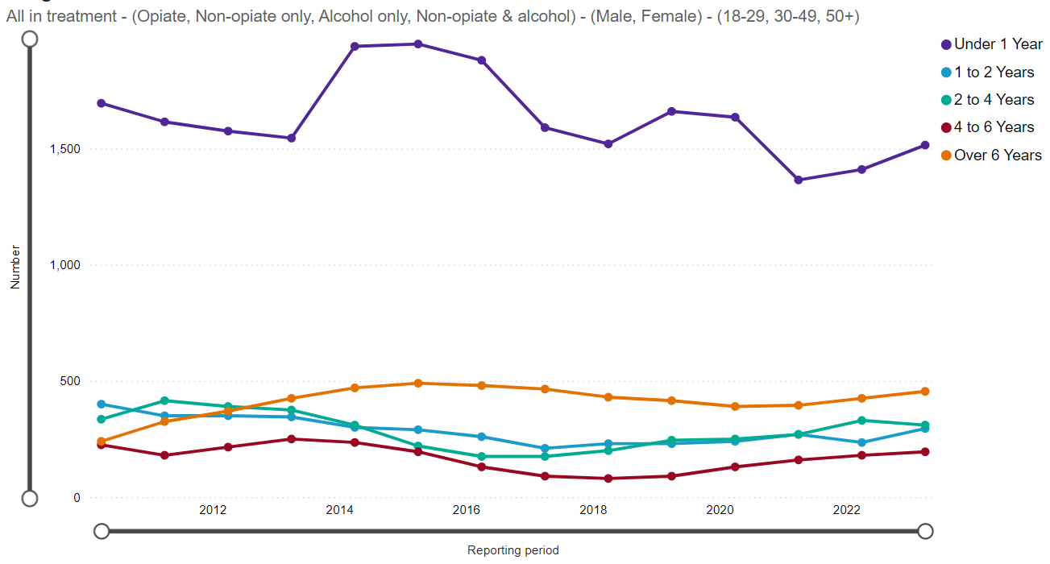

**England:**

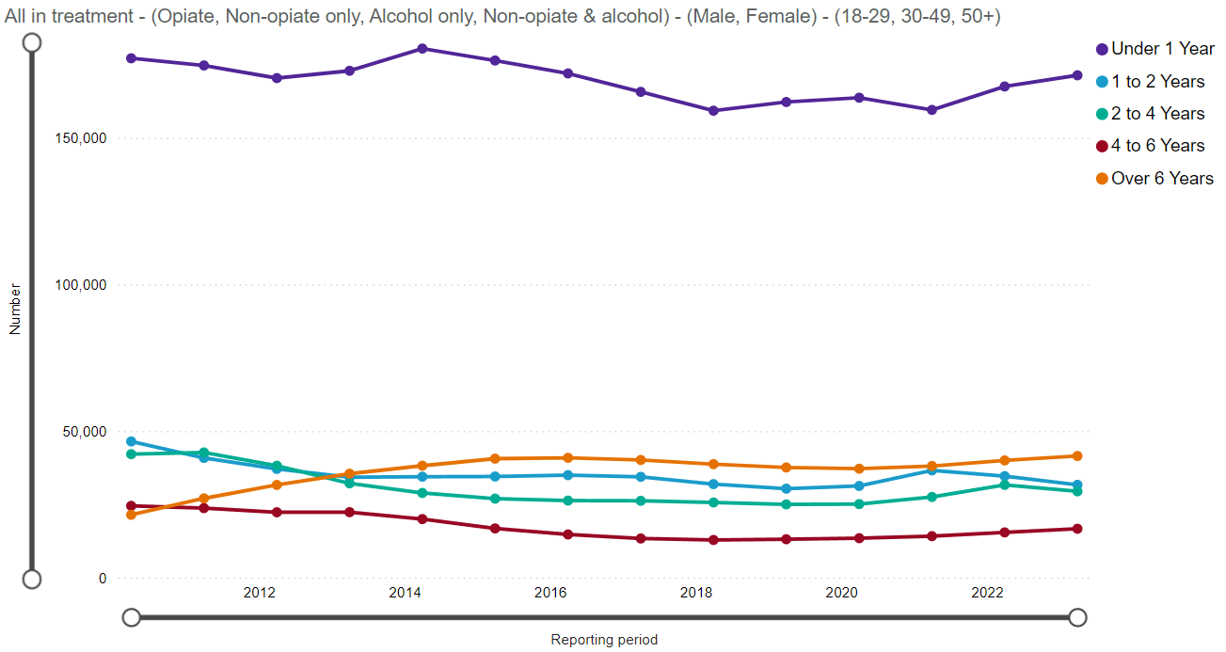

Source: [NDTMS](https://www.ndtms.net/ViewIt/Adult)

**Demographics**

In 2022-23, most adults in treatment were male, accounting for 65% compared to 35% females, reflecting the national picture (see Table 7). Most adults were aged 30-49 years accounting for 62%, followed by those aged 50+ years accounting for 27%, highlighting an upward trend since 2017. Therefore, evolving as a ‘growing’ cohort in Cumbria to focus on in delivering support and care (see Table 8).

Regarding ethnicity, 99% of adults presenting to treatment in Cumbria are White British, this compares to 90% nationally. 73% report no religion, compared to 60% nationally; 22% report Christian, similar to the national average at 21%; while 1% decline to answer, compared to 3% nationally. 96% of adults report their sexuality as heterosexual, compared to 90% nationally; 2% report as gay/lesbian, similar to the national average at 3%; while 2% report as bisexual, reflecting the national average. 12% of adults report having a behaviour and/or emotional disability, below the national average of 16%; while 4% report having a mobility and/or gross motor disability, compared to 6% nationally.

### Table 7: Adults all in treatment by drug group and sex; March, 2022 – 2023.

|  |  |  |  |  |  |  |
| --- | --- | --- | --- | --- | --- | --- |
| **Substance category** | **Cumbria** | | | **England** | | |
| **Total number** | **Male**  **(%)** | **Female**  **(%)** | **Total number** | **Male**  **(%)** | **Female**  **(%)** |
| Alcohol only | 985 | 60 | 40 | 86257 | 60 | 40 |
| Alcohol and non-opiate | 145 | 70 | 30 | 35773 | 79 | 21 |
| Non-opiate only | 270 | 72 | 28 | 30001 | 68 | 32 |
| Opiate only | 1375 | 67 | 33 | 138604 | 72 | 28 |
| Total | 2775 | 65 | 35 | 290635 | 68 | 32 |

*Source:* [*NDTMS*](https://www.ndtms.net/ViewIt/Adult)

### Table 8: Adults all in treatment by sex and age; March, 2022 – 2023.

|  |  |  |  |  |  |
| --- | --- | --- | --- | --- | --- |
| **Age group** | **Cumbria** | | | | **England** |
| **Total number** | **Male**  **(%)** | **Female**  **(%)** | **All in treatment (%)** | **All in treatment (%)** |
| 18 – 29 | 300 | 67 | 33 | 11 | 13 |
| 30 – 49 | 1710 | 64 | 36 | 62 | 60 |
| 50+ | 760 | 67 | 33 | 27 | 28 |

*Source:* [*NDTMS*](https://www.ndtms.net/ViewIt/Adult)

### Figure 4: Cumbria: Adults in Drug Treatment by age group; 2009 – 2023.

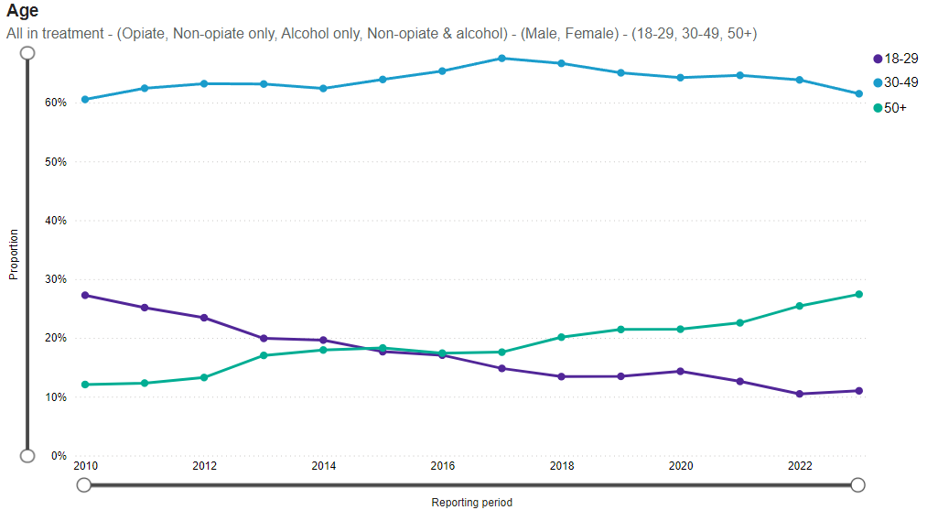

*Source:* [*NDTMS*](https://www.ndtms.net/ViewIt/AdultBeta)

**Substances**

The most common cited substances by adults in drug treatment (all drugs) during 2022-23 in Cumbria were opiate (not crack cocaine) accounting for 45% of adults (1260), compared to 24% nationally; and alcohol accounting for 45% (1255 adults), notably lower than the rest of England at 50%. Fewer adults in treatment in Cumbria cited cannabis, 9% (260) compared to 20% nationally. 8% (215) cited cocaine, compared to 13% nationally. While Benzodiazepine use accounts for 8% of adults (235), compared to 5% nationally. Significantly fewer adults cited crack cocaine in Cumbria 2% (55) compared to England (3%). (Source: [NDTMS](https://www.ndtms.net/ViewIt/Adult)).

**Employment**

During 2022-23, the majority of adults in treatment reported being unemployed at the start of their treatment, accounting for 38% (440 adults); closely followed by 36% (420) reported being in regular employment; 25% (285 adults) reported long-term sick or disabled; data was missing or not stated for 1%; while 0% (10 adults) were in education/other. (Source: [NDTMS](https://www.ndtms.net/ViewIt/Adult)).

**Unmet need/not in treatment**

As reported in the latest DOMES report there are an estimated 79.8% of people in Cumbria dependent on alcohol who are not in treatment, this mirrors the national estimate; for people dependent on crack, the estimate is 65.0%, lower than the national average of 82.5% (see Table 9). Unmet need for all substances apart from opiate, has reduced since the last report. Unmet need for those who use opiates has increased from 40% to 63.5% and is a priority for joint investigation with the provider moving forward.

### Table 9: Estimates of unmet need of drug and alcohol users, June, 2023.

|  |  |  |
| --- | --- | --- |
|  | **Cumbria (%)** | **England (%)** |
| Opiates and/or crack cocaine | 38.6 | 46.6 |
| Opiates | 63.5 | 59.8 |
| Crack | 65.0 | 82.5 |
| Alcohol | 79.8 | 79.8 |

[*Source: NDTMS/DOMES*](https://www.ndtms.net/NDTMSReports/PrevalenceAndUnmetNeedToolkit)

## Parents with Problem Alcohol and Drug Use

The prevalence of parents with problematic alcohol and/or drug use is not routinely measured; however, local alcohol and drug treatment services collate data on parents in treatment and on service users who live with children. These data provide some insight into the size of the issue but may not reveal hidden and unmet need.

As reported in the ‘[Parents with problem alcohol and drug use: Data for England and Cumbria, 2022 to 2023’ report by Public Health England](https://www.ndtms.net/resources/secure/Commissioning%20Support%20Products/North%20West/Drug/North%20West_Cumbria_Adult_Drug_Commissioning_Support_Pack_Key_data_2023-24.html), there were 1,177 new presentations to treatment for alcohol and drug services for adults aged 18+ in Cumbria. Almost half (43%) of all new presentations for treatment were parents: 29% were parents or adults living with children; 18% were parents not living with children; while 53% were not a parent and had no contact with children - referred to as “not a parent.” Overall, around a third (33%) of all those in treatment were parents, just above the national average of 32% (see Table 10).

### Table 10: Proportion of clients in alcohol and drugs treatment by family category, March, 2022 – 2023.

|  |  |  |  |  |
| --- | --- | --- | --- | --- |
|  | **New Presentation (%)** | | **All in treatment (%)** | |
| **Parental status** | **England** | **Cumbria** | **England** | **Cumbria** |
| Not a parent and not living with children | 66 | 63 | 57 | 53 |
| Parent not living with children | 14 | 11 | 20 | 18 |
| Not a parent and living with children | <5 | <5 | <5 | <5 |
| Parent living with children | 18 | 22 | 20 | 25 |

Source: [NDTMS](https://www.ndtms.net/ViewIt/Adult)/DOMES

Substance use and family status varies. Those adults who are new presentations for treatment for alcohol (660), 26% were currently living with children, this compares to 21% nationally. Opiate only clients, 26% were living with children, which is much higher than the national picture (9%). Non-Opiate only clients, 55% are not parents and not living with children compared the national number of 58%. Non opiate and alcohol clients, 26% are living with children compare to 20% nationally (see Figure 5). For all substance categories, since the previous Drug and Alcohol JSNA report (published in 2022), there has been a significant increase in those individuals not a parent and not living with children newly presenting for all substances. For example, in 2022, 30% of opiate users were not a parent, this has now increased to over 70%. It is unclear why this cohort increased significantly. More research needs to be conducted in collaboration with the provider to find out why the landscape for newly presenting adult has changed so much.

### Figure 5: Breakdown of substance groups for new presentations to treatment in Cumbria; March, 2022 – 2023.

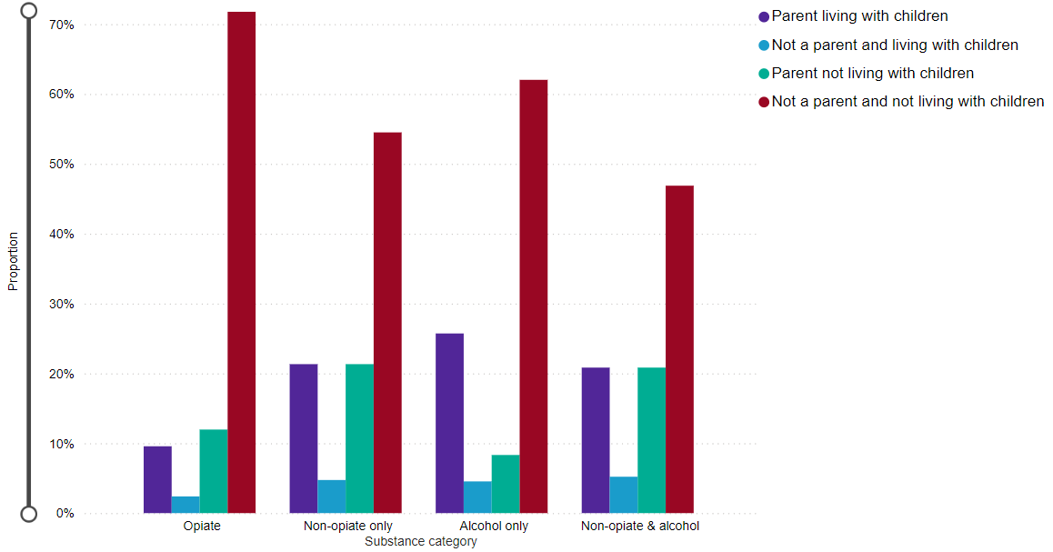

Source: [NDTMS](https://www.ndtms.net/ViewIt/AdultBeta)

Most clients in treatment have never injected (78%) compared to 83% nationally.

**Prevalence of Unmet Need – parental substance dependency prevalence**

The estimated number of ‘newly presented into treatment’ opiate dependent clients (13%) living with children is much lower than non-opiate or alcohol and ‘alcohol and non-opiate’ clients (25.9%, 28.0% and 29%, respectively), reflecting the national picture. Furthermore, there are a greater proportion of successful completions of clients who live with children under 18 years old who are non-opiate or alcohol and ‘alcohol and non-opiate’ clients (35.3%, 45.9% and 44.4%, respectively) compared to 3.2% for opiate clients, reflecting the national picture (see Table 11).

### Table 11: Estimated number of adults living with children in England and Cumbria, and rates per 1,000 of the population and unmet treatment need. 2022 – 2023.

|  |  |  |  |  |  |  |
| --- | --- | --- | --- | --- | --- | --- |
|  | **New presentations to treatment who live with children under the age of 18 (%)** | | **Successful completions of clients who live with children under the age of 18 (%)** | | **Proportion of clients living with children who successfully completed treatment in the first 6 months of the latest 12-month period and re-presented within 6 months (%)** | |
|  | **Cumbria** | **England** | **Cumbria** | **England** | **Cumbria** | **England** |
| Opiate | 13.3 | 10.2 | 3.2 | 6.1 | 28.6 | 11.2 |
| Non-opiate | 25.9 | 24.8 | 35.3 | 39.9 | 9.1 | 5.9 |
| Alcohol | 28.0 | 22.9 | 45.9 | 40.3 | 10.0 | 8.5 |
| Alcohol and Non-opiate | 29.0 | 20.2 | 44.4 | 36.7 | 0.0 | 7.8 |

*Source:* [*NDTMS/DOMES*](https://www.ndtms.net/NDTMSReports/GetDOMESReports?ReportName=Diagnostic%20Outcomes%20Monitoring%20Executive%20Summary%20CDSP&ReportDescription=Diagnostic%20Outcomes%20Monitoring%20Executive%20Summary%20CDSP&Width=100&Height=1200)

## Recommendations

* Carry out further insight work to better determine the level of need around those who are and are not a parent or carer with unmet need around drug and alcohol addiction, and their barriers to accessing support.
* To continue work via System Improvement Board to understand levels of unmet need and to put actions in place to bring Cumbria below the national average. This approach will need to consider Hidden Harms, engaging complex individuals and a range of statutory and non-statutory services.
* Investigate the lack of up-to-date parental opiate dependency prevalence data and feed back to the National Combating Drugs Unit, if appropriate.

# **Reducing Drug-Related Crime**

As provided by the Cumbria Constabulary for this SUNA update, there were 1,664 drug crimes (trafficking and possession) in Cumbria. Levels of drug crime have increased in Cumbria during the 2023 – 2024 financial year; levels of drug crime increased by +45.6% (521) compared to the previous year (2022). 87.3% of drug crime offenders were male/transgender male; 51.2% were age between 18 and 30 years old; 85.2% were White – British; and 21% were located in Carlisle.

# **Reducing Drug-Related Harm**

# Drug Related Deaths

ONS’s definition of a drug use death is “(a) deaths where the underlying cause is drug abuse or drug dependence and (b) deaths where the underlying cause is drug poisoning and where any of the substances controlled under the Use of Drugs Act 1971 are involved.”9

In 2023, there were 104 registered drug poisoning deaths in Cumbria (67 deaths in Cumberland and 37 in Westmorland and Furness), more than five times the number registered in 2011 (See Table 13 & Figure 6). In addition, 54 deaths were recorded as related to drug misuse in Cumbria (30 deaths in Cumberland and 24 in Westmorland and Furness), more than treble the number registered in 2011 (see Figure 7).

### Figure 6: Number of deaths related to drug poisoning, persons, 2011 – 2023.

*Source:* [*ONS; Deaths related to drug poisoning/use by local authority*](https://www.ons.gov.uk/peoplepopulationandcommunity/birthsdeathsandmarriages/deaths/datasets/drugmisusedeathsbylocalauthority)

### Figure 7: Number of deaths related to drug misuse, persons, 2011 – 2023.

*Source:* [*ONS; Deaths related to drug poisoning/use by local authority*](https://www.ons.gov.uk/peoplepopulationandcommunity/birthsdeathsandmarriages/deaths/datasets/drugmisusedeathsbylocalauthority)

In Cumbria, the rate of deaths related to drug poisoning is significantly higher than the national average at 8.5 per 100,000 compared to 20.7 for Cumberland and 13.7 for Westmorland and Furness (see Table 12). Comparatively, the rate of deaths related to drug misuse is lower for both authorities at 9.8 and 9.9 respectively. However, this is still double the national average (see Table 13).

### Table 12: Number of deaths and age-standardised mortality rates per 100,000 for deaths related to drug poisoning, persons, 2021 – 2023.

|  |  |  |
| --- | --- | --- |
|  | **Deaths (No.)** | **Rate** |
| England | 14,157 | 8.5 |
| Cumberland | 155 | 20.7 |
| Westmorland and Furness | 86 | 13.7 |

*Source:* [*ONS; Deaths related to drug poisoning/use by local authority*](https://www.ons.gov.uk/peoplepopulationandcommunity/birthsdeathsandmarriages/deaths/datasets/drugmisusedeathsbylocalauthority)

### Table 13: Age-standardised mortality rates per 100,000 for deaths related to drug misuse, persons, 2021 – 2023.

|  |  |  |
| --- | --- | --- |
|  | **Deaths (No.)** | **Rate** |
| England | 9,105 | 5.5 |
| Cumberland | 74 | 9.8 |
| Westmorland and Furness | 60 | 9.9 |

*Source:* [*ONS; Deaths related to drug poisoning/use by local authority*](https://www.ons.gov.uk/peoplepopulationandcommunity/birthsdeathsandmarriages/deaths/datasets/drugmisusedeathsbylocalauthority)

In Cumberland and Westmorland and Furness, the rate of deaths related to drug poisoning is higher in males than females at 27.5 and 18 per 100,000 respectively, compared to 14.2 and 9.7; furthermore, the rate in Cumbrian men is significantly higher than the national average at 11.7 per 100,000 (see Table 14).

### Table 14: Number of deaths and age-standardised mortality rates per 100,000 for deaths related to drug poisoning, Males and Females, 2020 – 2023.

|  |  |  |  |  |
| --- | --- | --- | --- | --- |
|  | **Male Numbers** | **Male Rate** | **Female Numbers** | **Female Rate** |
| England | 9,436 | 11.7 | 4,721 | 5.5 |
| Cumberland | 101 | 27.5 | 54 | 14.2 |
| Westmorland and Furness | 53 | 18.0 | 33 | 9.7 |

*Source:* [*ONS; Deaths related to drug poisoning/use by local authority*](https://www.ons.gov.uk/peoplepopulationandcommunity/birthsdeathsandmarriages/deaths/datasets/drugmisusedeathsbylocalauthority)

### Table 15: Number of deaths and age-standardised mortality rates per 100,000 for deaths related to drug misuse, persons, 2020 – 2023.

|  |  |  |  |  |
| --- | --- | --- | --- | --- |
|  | **Male Numbers** | **Male Rate** | **Female Numbers** | **Female Rate** |
| England | 6,457 | 8.0 | 2,648 | 3.1 |
| Cumberland | 50 | 13.7 | 24 | 6.0 |
| Westmorland and Furness | 40 | 13.4 | 20 | 6.4 |

*Source:* [*ONS; Deaths related to drug poisoning/use by local authority*](https://www.ons.gov.uk/peoplepopulationandcommunity/birthsdeathsandmarriages/deaths/datasets/drugmisusedeathsbylocalauthority)

For deaths related to drug use, the rates of death are similarly higher for males than females. Cumberland and Westmorland and Furness share similar rates for men at 13.7 and 13.14, respectively. Death rates for women are also similar across the two authorities and are much higher than the national rate of death for both genders (see Table 15).

# Deaths in Treatment

in Q4 2022 – 2023, there were a total of 74 deaths of clients accessing treatment in Cumbria, accounting for 2.7% of all clients in treatment. Most deaths reported (54) were opiate clients, followed by alcohol clients (13). (Source: [DOMES/NDTMS](https://www.ndtms.net/NDTMSReports/GetDOMESReports?ReportName=Diagnostic%20Outcomes%20Monitoring%20Executive%20Summary%20CDSP&ReportDescription=Diagnostic%20Outcomes%20Monitoring%20Executive%20Summary%20CDSP&Width=100&Height=1200)). Death rates have reduced by almost half since the previously published Drug and Alcohol JSNA report whereby 110 deaths occurred between 2021 – 2022 and accounted for 4.4% of all clients in treatment.

# Police Recorded Drug Related Deaths

Cumbria Constabulary record numbers of ‘possible’ drug related deaths when attending incidents. Over the last three years, drug-related deaths have fluctuated with an average of 59 deaths per annum (See Table 16).

Derwent and Esk has experienced a greater increase in drug-related deaths since 2022 compared to other areas; and across Cumbria, the greatest numbers of drugs deaths are predominantly in the main towns and cities. Derwent and Esk had the highest number of drugs deaths accounting for 64 (36%); followed by Carlisle and Wigton with 60 (34%). Compared to 2021, numbers of drugs deaths decreased in Carlisle however they increased across all other areas of the county. There appears to be no clear pattern over which months experience higher or lower death rates related to drug use from 2021 to the first 4-months of 2024 (See Figure 8).

### Table 16: Police recorded number of drug-related deaths per year by area; 2021 – 2023.

|  |  |  |  |  |
| --- | --- | --- | --- | --- |
| **District** | **2021** | **2022** | **2023** | **District Total** |
| **Carlisle & Wigton** | 24 | 15 | 21 | **60** |
| **Derwent & Esk** | 14 | 30 | 20 | **64** |
| **Furness** | 8 | 16 | 8 | **32** |
| **Kendal & Eden** | 5 | 8 | 8 | **21** |
| **Year Total** | **51** | **69** | **57** | **177** |

*Source: Cumbria Constabulary*

### Figure 8: Number of police recorded drug-related deaths by month between 2021 – 2024.

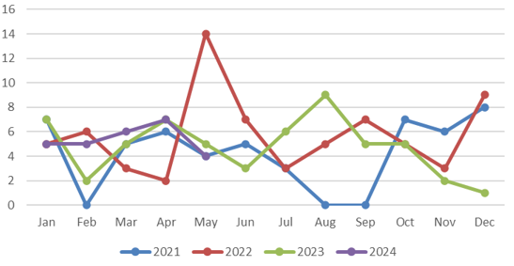

*Source: Cumbria Constabulary*

As seen in Figure 8 and 9, there was a significant spike across Cumberland (Derwent and Esk, Carlisle and Wigton) with 11 deaths in the one month. This was reported to be mainly due to a larger number of drug-related deaths due to Pregabalin, a reoccurring factor as published in the previous [Cumbria Drug and Alcohol JSNA](https://cumbria.gov.uk/elibrary/Content/Internet/536/671/4674/17217/17226/44985152658.pdf) in 2022. The report pre-empted the risk of increased rates of drug related deaths in the years following its publication.

### Figure 9: Police recorded drug-related deaths by area; 2021 – 2023.

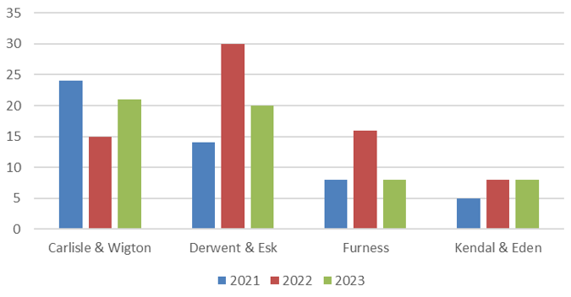

*Source: Cumbria Constabulary*

Typically, most drugs deaths are male and aged between 30 – 49 years (70%); while most drug related deaths for women occurred between 30 – 59 years (70%). Where information was available, a small number of drugs deaths were suicide or overdose of prescription drugs. However, looking at those either definitely or likely to have been suicide, the numbers are much closer between genders, 14 females and 16 males. This makes a female drug-related deaths at nearly 27% likely to be suicide but a male’s likelihood nearer 13% (see Table 17).

Table 17: Police recorded deaths by suicide per gender and age.

|  |  |  |  |  |  |  |  |  |
| --- | --- | --- | --- | --- | --- | --- | --- | --- |
|  | | **Age (years)** | | | | | | **Total** |
| **Gender** | **Suicide** | **20 to 29** | **30 to 39** | **40 to 49** | **50 to 59** | **60 to 69** | **70 to 79** |
| **Female** | Yes | - | - | 2 | 1 | 3 | 3 | **9** |
| Likely | 2 | 1 | 1 | 1 | - | - | **5** |
| No | 4 | 8 | 12 | 9 | - | 1 | **35** |
| Unknown | - | 1 | 1 | - | - | 1 | **3** |
| **Total** | **6** | **10** | **16** | **11** | **3** | **5** | **52** |
| **Male** | Yes | - | 4 | 4 | - | 1 | - | **9** |
| Likely | - | 3 | 2 | - | - | 1 | **7** |
| No | 11 | 37 | 37 | 17 | 2 | - | **105** |
| Unknown | 1 | - | 1 | 1 | - | - | **4** |
| **Total** | **12** | **44** | **44** | **18** | **3** | **1** | **125** |

*Source: Cumbria Constabulary*

All drug-related deaths appear to be linked to either suicide (18%), or existing drug use (80%). Overall, there is at least 35% drug-related deaths that have the previous illness marker. Although this does not include older/long-term drug users who will have ongoing health concerns from their drug use where it has not been made clear in the incident log entry. So, it is likely that there is a higher percentage of deaths that are linked to an existing illness.

Only three records were unclear as to the causal factor, and one of these is from April 2024 and is still under investigation, the other two are from 2021 and 2022, all three are under further investigation and currently show tentative links with illicit drugs although it is not clear if that is the causal factor in their deaths.

# Recommendations

* The Cumbria constabulary will continue to monitor levels of drug-related deaths and push the need to record as much information as possible.
* Link in with the local coroner’s office to receive information after cause of death has been confirmed.
* Further short-term analysis is required to include similar force-level data of drug-related deaths, partner agencies and investigate national levels where available for comparisons and learnings where possible.
* To continue to work with NHS colleagues to; monitor pregabalin and other associated prescribing and, in relation to raising awareness of the risks associated with long-term prescribing of these medications.

This data was consolidated by the Cumbria constabulary, utilizing data from their incident logs and DRDD1 forms.

# Trends in Alcohol-Specific and Alcohol-Related Mortality

Alcohol consumption is a contributing factor to hospital admissions and deaths from a range of conditions. Potential years of life lost (PYLL) is a measure of the potential number of years lost when a person dies prematurely. Since 2016, the rate of PYLL due to alcohol related conditions for both males and females in Cumbria has remained similar to the national average, however, more recently (2022) the rate for males was significantly higher than the national average at 1,438 and 1,405 per 100,000 in Cumberland and Westmorland and Furness, respectively, compared to 1,116 per 100,000 in England. PYLL rates for males are significantly higher than the rates for females in Westmorland and Furness and Cumberland localities (See Figures 10 - 13 and Tables 18 - 21).

### Figure 10: Potential Years of Life Lost (PYLL) due to alcohol-related conditions – **Males in Westmorland and Furness**,2016 – 2022.

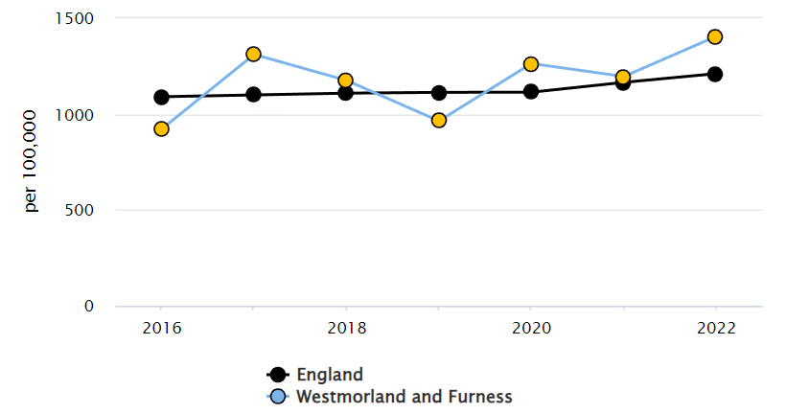

*Source:* [*Alcohol Profile - Data - OHID (phe.org.uk)*](https://fingertips.phe.org.uk/profile/local-alcohol-profiles/data#page/4/gid/1938132984/pat/6/par/E12000002/ati/501/are/E06000064/iid/93880/age/1/sex/1/cat/-1/ctp/-1/yrr/1/cid/4/tbm/1/page-options/tre-do-0)

### Figure 11: Potential Years of Life Lost (PYLL) due to alcohol-related conditions – **Males in Cumberland**,2016 – 2022.

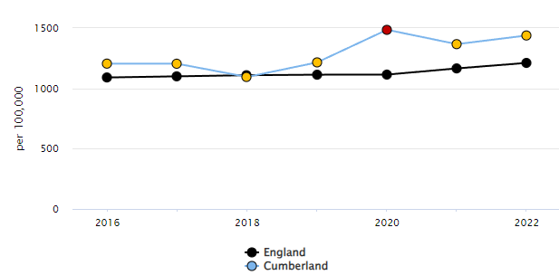

*Source:* [*Alcohol Profile - Data - OHID (phe.org.uk)*](https://fingertips.phe.org.uk/profile/local-alcohol-profiles/data#page/4/gid/1938132984/pat/6/par/E12000002/ati/501/are/E06000064/iid/93880/age/1/sex/1/cat/-1/ctp/-1/yrr/1/cid/4/tbm/1/page-options/tre-do-0)

### Table 17: Potential Years of Life Lost (PYLL) due to alcohol-related conditions – **Males in Westmorland and Furness**,2016 – 2022.

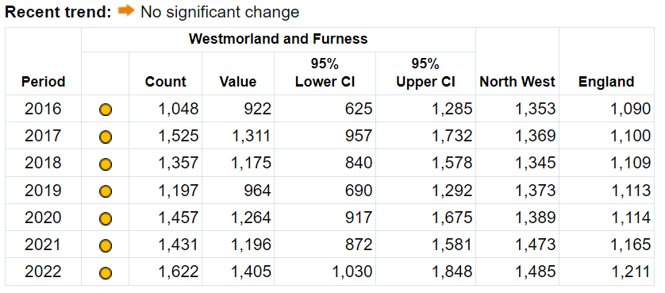

*Source:* [*Alcohol Profile - Data - OHID (phe.org.uk)*](https://fingertips.phe.org.uk/profile/local-alcohol-profiles/data#page/4/gid/1938132984/pat/6/par/E12000002/ati/501/are/E06000064/iid/93880/age/1/sex/1/cat/-1/ctp/-1/yrr/1/cid/4/tbm/1/page-options/tre-do-0)

### Table 18: Potential Years of Life Lost (PYLL) due to alcohol-related conditions – **Males in Cumberland**,2016 – 2022.

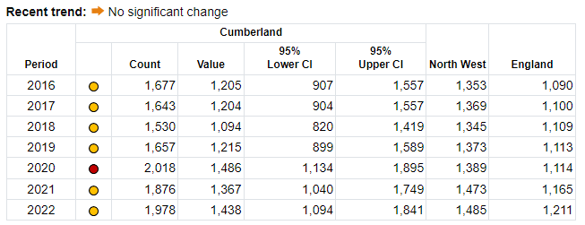

*Source:* [*Alcohol Profile - Data - OHID (phe.org.uk)*](https://fingertips.phe.org.uk/profile/local-alcohol-profiles/data#page/4/gid/1938132984/pat/6/par/E12000002/ati/501/are/E06000064/iid/93880/age/1/sex/1/cat/-1/ctp/-1/yrr/1/cid/4/tbm/1/page-options/tre-do-0)

### Figure 12: Potential Years of Life Lost (PYLL) due to alcohol-related conditions – **Females** **in Westmorland and Furness**,2016 – 2022.

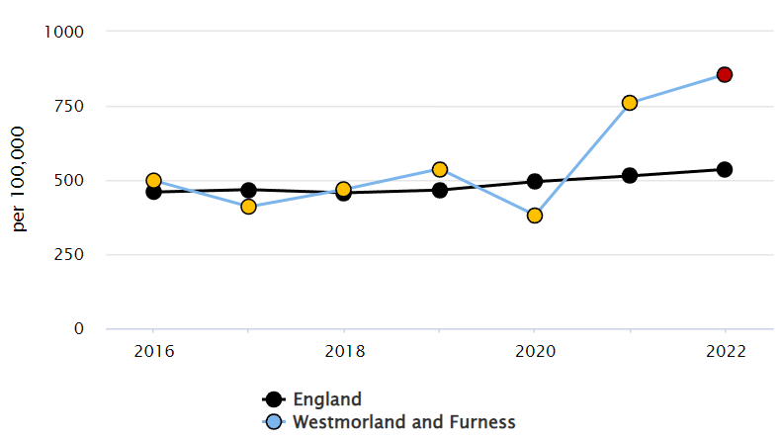

*Source:* [*Alcohol Profile - Data - OHID (phe.org.uk)*](https://fingertips.phe.org.uk/profile/local-alcohol-profiles/data#page/4/gid/1938132984/pat/6/par/E12000002/ati/501/are/E06000064/iid/93880/age/1/sex/1/cat/-1/ctp/-1/yrr/1/cid/4/tbm/1/page-options/tre-do-0)

### Figure 13: Potential Years of Life Lost (PYLL) due to alcohol-related conditions – **Females** **in Cumberland**,2016 – 2022.

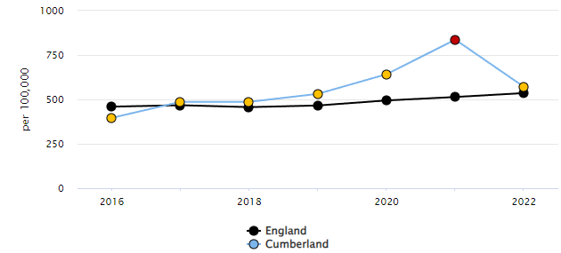

*Source:* [*Alcohol Profile - Data - OHID (phe.org.uk)*](https://fingertips.phe.org.uk/profile/local-alcohol-profiles/data#page/4/gid/1938132984/pat/6/par/E12000002/ati/501/are/E06000063/iid/93880/age/1/sex/2/cat/-1/ctp/-1/yrr/1/cid/4/tbm/1/page-options/tre-do-0)

### Table 19: Potential Years of Life Lost (PYLL) due to alcohol-related conditions – **Females in Westmorland and Furness**,2016 – 2022.

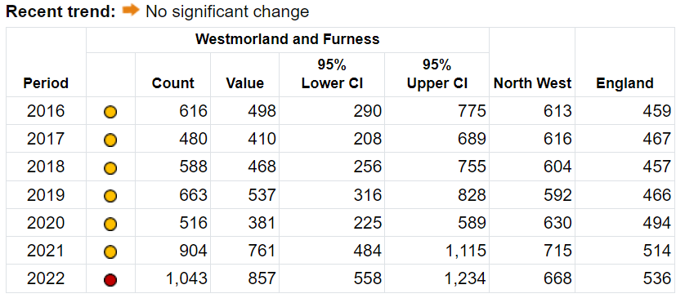

*Source:* [*Alcohol Profile - Data - OHID (phe.org.uk)*](https://fingertips.phe.org.uk/profile/local-alcohol-profiles/data#page/4/gid/1938132984/pat/6/par/E12000002/ati/501/are/E06000064/iid/93880/age/1/sex/1/cat/-1/ctp/-1/yrr/1/cid/4/tbm/1/page-options/tre-do-0)

### Table 20: Potential Years of Life Lost (PYLL) due to alcohol-related conditions – **Females in Cumberland**,2016 – 2022.

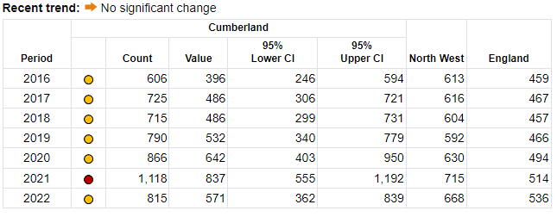

*Source:* [*Alcohol Profile - Data - OHID (phe.org.uk)*](https://fingertips.phe.org.uk/profile/local-alcohol-profiles/data#page/4/gid/1938132984/pat/6/par/E12000002/ati/501/are/E06000063/iid/93880/age/1/sex/2/cat/-1/ctp/-1/yrr/1/cid/4/tbm/1/page-options/tre-do-0)

In 2022, there were 122 alcohol-related deaths in Westmorland and Furness, although numbers have increased in the last 6 years (since 2016), recently there is no significant change. Rates of alcohol related mortality (all ages) have also increased since 2016. The current rate in Westmorland and Furness is higher than the national average at 46.4 per 100,000 compared to 39.7 per 100,000 (see Figure 14 and Table 21).

### Figure 14: Alcohol related Mortality – deaths from alcohol-related conditions, **All ages in Westmorland and Furness**, Directly Standardised Rate per 100,000,2016 – 2022.

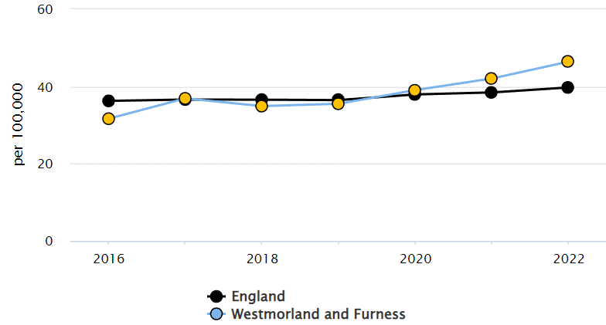

*Source:* [*Alcohol Profile - Data - OHID (phe.org.uk)*](https://fingertips.phe.org.uk/profile/local-alcohol-profiles/data#page/4/gid/1938132984/pat/6/par/E12000002/ati/501/are/E06000064/iid/93880/age/1/sex/1/cat/-1/ctp/-1/yrr/1/cid/4/tbm/1/page-options/tre-do-0)

### Table 21: Alcohol related Mortality – deaths from alcohol-related conditions, **All ages in Westmorland and Furness,** Directly Standardised Rate per 100,000,2016 – 2022.

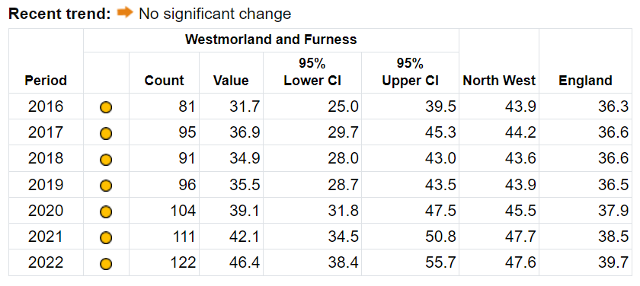

*Source:* [*Alcohol Profile - Data - OHID (phe.org.uk)*](https://fingertips.phe.org.uk/profile/local-alcohol-profiles/data#page/4/gid/1938132984/pat/6/par/E12000002/ati/501/are/E06000064/iid/93880/age/1/sex/1/cat/-1/ctp/-1/yrr/1/cid/4/tbm/1/page-options/tre-do-0)

Westmorland and Furness have a higher rate per 100,000 (46.4) of alcohol related mortality in 2022-2023 compared to the national average (39.7), with no significant trend. Westmorland and Furness stand out with a higher rate compared to Cumberland (see Table 22).

### Table 22: Alcohol related mortality per district, Directly Standardised Rate per 100,000, 2022.

|  |  |  |  |  |  |
| --- | --- | --- | --- | --- | --- |
| **District** | **Count** | **Value** | **95% Lower CI** | **95% Upper CI** | **Recent trend** |
| England | 21,912 | 39.7 | 39.2 | 40.3 |  |
| North West region | 3,462 | 47.6 | 46 | 49.2 |  |
| Westmorland and Furness | 122 | 46.4 | 38.4 | 55.7 |  |
| Cumberland | 125 | 41.4 | 34.4 | 49.5 |  |

*Source:* [*Alcohol Profile - Data - OHID (phe.org.uk)*](https://fingertips.phe.org.uk/profile/local-alcohol-profiles/data#page/3/gid/1938132984/pat/6/par/E12000002/ati/501/are/E06000064/iid/93763/age/1/sex/4/cat/-1/ctp/-1/yrr/1/cid/4/tbm/1/page-options/tre-do-0_car-do-0)

# Hospital Admissions for Drug-Related Issues

Hospital admissions for drug-specific substance use are defined as hospital admissions where the primary diagnosis is of a mental or behavioural disorder resulting from drug use, poisoning by specific drug (including narcotics such as heroin, methadone, cocaine and cannabis) or the toxic effect of drugs such as solvents. In 2022-23, there were a total of 115 drug-related hospital admissions in Cumbria. In Cumbria, the rate of admissions with a primary diagnosis of poisoning by drug use is higher than the national average at 25 per 100,000 compared to 17 in England (see Table 23).

### Table 23: Drug-related hospital admissions, All persons; March, 2022 – 2023.

|  |  |  |  |  |
| --- | --- | --- | --- | --- |
|  | **No. of patients** | **Rate per 100,000** | | |
| **Cumbria** | **Cumbria** | **North West** | **England** |
| Finished admission episodes with a primary diagnosis of poisoning by drug use | 115 | 25 | 22 | 17 |

*Source:* [*Drug-related hospital admissions, 2022-23; NHS Digital*](https://view.officeapps.live.com/op/view.aspx?src=https%3A%2F%2Ffiles.digital.nhs.uk%2FB9%2FEDB8A1%2Fadmissions-eng-2022-23-tab.xlsx&wdOrigin=BROWSELINK)

# Hospital Admissions for Alcohol-Related Issues

As reported by the Office for Health Improvement & Disparities, Alcohol consumption is a contributing factor to hospital admissions and deaths from a diverse range of conditions. Alcohol use is estimated to cost the NHS about £3.5 billion per year and society as a whole £21 billion annually. Rates in Cumbria appear to be relatively stable and have been below national averages for a number of years (See Figures 15-16 and Tables 24-25).

### A screenshot of a computer Description automatically generatedFigure 15 and Table 24: Admissions episodes for alcohol specific conditions (all persons), directly Standardised Rate per 100,000 for **Westmorland and Furness**; 2016 – 2023.

### Figure 16 and Table 25: Admission episodes for alcohol-related conditions (narrow); all persons, Directly Standardised Rate per 100,000 for **Cumberland**; 2016 – 2023.

*Source:* [*Alcohol Profile - Data - OHID (phe.org.uk)*](https://fingertips.phe.org.uk/profile/local-alcohol-profiles/data#page/4/gid/1938132984/pat/6/par/E12000002/ati/501/are/E06000064/iid/93880/age/1/sex/1/cat/-1/ctp/-1/yrr/1/cid/4/tbm/1/page-options/tre-do-0)

Cumberland have higher rates of 521 compared to Westmorland and Furness with 467 per 100,000 of admission episodes. Westmorland and Furness admission rates is slightly below the England average of 475. The confidence interval (440 to 496) overlaps with the national average, suggesting no significant difference. Compared to neighbouring regions, Westmorland and Furness is neither among the highest nor the lowest, indicating it is in a mid-range position in terms of this Admission episodes for alcohol related conditions.

### Table 26: Counties: Admission episodes for alcohol related conditions (narrow); all persons, Directly Standardised Rate per 100,000; March, 2022 – 23.

|  |  |  |  |
| --- | --- | --- | --- |
| **Area** | **Recent trend** | **Count** | **Value** |
| England |  | 262,094 | 475 |
| Cumberland |  | 1,541 | 521 |
| Westmorland and Furness |  | 1,169 | 467 |

*Source:* [*Alcohol Profile - Data - OHID (phe.org.uk)*](https://fingertips.phe.org.uk/profile/local-alcohol-profiles/data#page/4/gid/1938132984/pat/6/par/E12000002/ati/501/are/E06000064/iid/93880/age/1/sex/1/cat/-1/ctp/-1/yrr/1/cid/4/tbm/1/page-options/tre-do-0)

# Preventing Infectious Diseases

People who inject drugs are at a disproportionally higher risk of blood-borne viruses and are vulnerable to a range of bacterial infections. The practice of sharing needles, syringes and other injecting equipment and the risk from unsterile injecting increases the risk of developing BBVs. There is also a threat of people who inject contracting life-threatening infections such as anthrax and botulism from using contaminated drugs.

## Bacterial infections -Blood-Bourne Viruses (BBVs)

As reported in Q4 2022 – 2023 in [DOMES/NDTMS](https://www.ndtms.net/NDTMSReports/GetDOMESReports?ReportName=Diagnostic%20Outcomes%20Monitoring%20Executive%20Summary%20CDSP&ReportDescription=Diagnostic%20Outcomes%20Monitoring%20Executive%20Summary%20CDSP&Width=100&Height=1200), on average 50.09% of eligible clients in treatment were offered and accepted a Hepatitis C test, this compares to 56.2% nationally. 21.9% were PCR positive, this is slightly higher than the national average of 19.0%. 28.6% of eligible clients in treatment were offered and accepted a Hepatitis B vaccination; this aligns with 28.4% nationally. A breakdown by substance can be found in Table 27.

### Table 27: Hepatitis C tests and treatment; Hepatitis B vaccinations; Q4 March, 2022 – 2023.

|  |  |  |  |  |  |  |
| --- | --- | --- | --- | --- | --- | --- |
| **Partner-ship** | **Substance** | **Proportion all clients in treatment offered and accepted a Hep B vaccination (%)** | **Proportion of clients offered and accepted a Hep C test who were eligible at the end of the reporting period (%)** | **Proportion of clients with a positive antibody test of all clients who were offered and accepted a Hep C test in the reporting period (%)** | **Proportion of clients with a positive PCR test of all clients with a positive antibody test in the reporting period (%)** | **Proportion of clients who were referred to Hep C treatment who have a positive PCR test at the end of the reporting period (%)** |
| **Cumbria** | Alcohol only | 22.22 | 48.02 | 3.31 | 50.00 | 100.00 |
| Alcohol and non-opiate only | 42.86 | 62.50 | 0 | 0 | 0 |
| Non-opiate only | 32.00 | 55.42 | 19.57 | 77.78 | 71.43 |
| Opiate alcohol and non-opiate | 38.46 | 40.63 | 46.15 | 33.33 | 50.00 |
| Opiate and alcohol | 28.57 | 37.29 | 50.00 | 0 | 0 |
| Opiate and non-opiate | 35.11 | 54.42 | 49.35 | 14.47 | 72.73 |
| Opiate only | 28.27 | 51.16 | 42.37 | 22.67 | 85.29 |
| **National** | Alcohol only | 19.79 | 36.93 | 2.34 | 21.46 | 76.60 |
| Alcohol and non-opiate only | 28.48 | 48.49 | 3.45 | 19.58 | 72.97 |
| Non-opiate only | 25.50 | 42.27 | 6.11 | 26.24 | 82.76 |
| Opiate alcohol and non-opiate | 35.97 | 68.48 | 42.11 | 18.24 | 84.93 |
| Opiate and alcohol | 29.81 | 61.62 | 36.60 | 16.29 | 88.74 |
| Opiate and non-opiate | 34.80 | 66.44 | 35.76 | 19.63 | 83.52 |
| Opiate only | 26.33 | 57.01 | 28.39 | 17.76 | 80.85 |

*Source:* [*DOMES/NDTMS*](https://www.ndtms.net/NDTMSReports/GetDOMESExtractReports?ReportName=DOMES%20Data%20extract&ReportDescription=DOMES%20Data%20extract&Width=100&Height=1200)

### Table 28: Injecting behaviour per substance type in Cumbria; March, 2022 – 2023.

|  |  |  |  |  |  |  |  |  |
| --- | --- | --- | --- | --- | --- | --- | --- | --- |
|  | Opiate | | Alcohol & non-opiate | | Non-opiate | | Alcohol | |
| N | % | N | % | N | % | N | % |
| Never injected | 70 | 34 | 80 | 83 | 150 | 73 | 605 | 92 |
| Previously injected | 100 | 46 | 15 | 10 | 40 | 19 | 40 | 6 |
| Currently injecting | 40 | 17 | 5 | 5 | 20 | 7 | 10 | 1 |

*Source:* [*NDTMS/DOMES*](https://www.ndtms.net/ViewIt/AdultBeta)

Between 2022-23, the proportion of adults newly presenting to drug treatment in Cumbria who were currently injecting is low (5%) and similar to the national proportion (6%). 16% (190) of adults had previously injected, above the England average of 11%; while 78% (905) had never injected, compared to 83% nationally. 17% (40) of opiate clients in Cumbria were currently injecting, this compares to 20% nationally. 46% (100) of opiate clients had previously injected, compared to 32% nationally (see Table 28).

# Mental Health Conditions

The co-occurrence of mental health conditions among people with substance use is complex. Substance use and addictions may stem from underlying mental health problems, while misusing substances can both generate or worsen mental health conditions.

In 2022-23, 81% of adults who entered drug treatment in Cumbria were identified as having a mental health treatment need, this is higher than the national average at 69%. Whilst co-occurring mental health needs were highly apparent in all clients, it was highest in treatment for alcohol and opiates at 100%; for clients in treatment for non-opiates it was 72%; and for clients in treatment for opiates it was 67% (source: [NDTMS/DOMES](https://www.ndtms.net/NDTMSReports/GetDOMESExtractReports?ReportName=DOMES%20Data%20extract&ReportDescription=DOMES%20Data%20extract&Width=100&Height=1200)). Please note that further mental health data is no longer reported by Fingertips and therefore, no longer included in this report.

### Table 29: Mental health need for Cumbria; March, 2022 – 2023.

|  |  |  |  |  |
| --- | --- | --- | --- | --- |
| **Area** | **Substance type** | **Number of clients entering treatment with a mental health treatment need** | **New presentations to treatment in the last 12 months** | **Proportion of clients entering treatment identified as having a mental health treatment need (%)** |
| Cumbria | Alcohol only | 477 | 650 | 73.38 |
| Alcohol and non-opiate only | 80 | 93 | 86.02 |
| Non-opiate only | 148 | 205 | 72.2 |
| Opiate alcohol and non-opiate | <5 | <5 | 100 |
| Opiate and alcohol | 12 | 13 | 92.31 |
| Opiate and non-opiate | 32 | 43 | 74.42 |
| Opiate only | 97 | 144 | 67.36 |
| England | Alcohol only | 39232 | 56304 | 69.68 |
| Alcohol and non-opiate only | 17864 | 23429 | 76.25 |
| Non-opiate only | 14584 | 20733 | 70.34 |
| Opiate alcohol and non-opiate | 2826 | 3740 | 75.56 |
| Opiate and alcohol | 953 | 1336 | 71.33 |
| Opiate and non-opiate | 13668 | 20518 | 66.61 |
| Opiate only | 4548 | 8076 | 56.32 |

*Source:* [*NDTMS/DOMES*](https://www.ndtms.net/NDTMSReports/GetDOMESExtractReports?ReportName=DOMES%20Data%20extract&ReportDescription=DOMES%20Data%20extract&Width=100&Height=1200)

Within Cumberland we are aware there is the SMMILES programme funded by the CCF and NHS, and in collaboration with The Well and CADAS, they are working to engage with highly complex cohorts and engage them with mental health and Substance Use support.

# Homelessness

Nationally, 84% of new adult clients to treatment (drugs and alcohol) reported having “no problem” with their housing situation. In 2022-23, rates were better in Cumbria with 90% stating they have “no problem” with their housing situation. Only 5% of adult clients presenting to treatment services in Cumbria reported a housing problem at the start of treatment, this compares to 11% nationally; 3% reported an urgent housing problem/no fixed abode in Cumbria, reflecting the national picture (5%). (Source: [NDTMS](https://www.ndtms.net/ViewIt/AdultBeta)).

# Youth homelessness

At the time this report was in development, numbers on young people active on NDTMS reporting systems was below the minimum dataset threshold, therefore adequate interpretation of the information was not possible.

# Recommendations

* To build on the early engagement around the Drug and Alcohol Related Death panel (managed in conjunction with Liverpool John Moores University), and to seek to expand this provision with a practice based sub-group.
* To further develop live links to share actionable DRD and near-miss intelligence between police and treatment system, to enable proactive responses and early prevention actions.
* Develop a system, drawing on work from other areas, to proactively identify service users who are at high-risk of harm or DRD and provide bespoke support. To consider approaches such as the Blue Light Model currently being piloted in Northumberland
* With partners, develop a framework, activity plan, metrics, and regular performance management. National Outcomes Framework – overarching measures which local areas are held accountable on progress.
* Develop a robust process to regularly refresh this health needs assessment every three years.

# **Reducing Supply**

## County Lines

County Lines (CL) is exploitative drugs supply and an ongoing issue in Cumbria and nationally.

It describes a type of organised crime network that traffics drugs using dedicated mobile phone lines. Typically, a ‘bulk text’ is sent out by a ‘line controller’ advertising the availability of heroin and crack which is then sold to users through local supply networks. Crime groups sometimes exploit children and vulnerable adults to facilitate county lines by having them move and/or store drugs and cash. Cumbria Constabulary are disrupting county lines by identifying those involved and bringing them to justice or safeguarding them from harm and exploitation. Numbers of active lines fluctuate and are sporadic in their activity in Cumbria. In the last two years there have between 1 to 6 lines identified as active at any one time in Cumbria, with only 1 month in the last two years where there were no CL drug supply identified in the county. Please note the figures are based on the Intelligence picture at that time therefore more lines may actually be in operation. The lines have often travelled up to Cumbria to do a quick sale, as they look to sell out as fast as possible. This is to avoid spending a long time in the area, in attempts to avoid detection from law enforcement.

### Figure 17: Number of County Lines active in Cumbria; July 2022 – July 2024.

*Source: Cumbria Constabulary*

### Figure 18: Number of County Lines active in Cumbria by area; July 2022 – July 2024.

*Source: Cumbria Constabulary*

Operation **RAMPART** is the Cumbria Constabulary operational response to County Lines Drugs Supply. **RAMPART** will encompass all operational activity across the Prepare, Prevent, Protect and Pursue strands with the primary objective of **defending our communities against County Lines.**

The strategy in pursuance of the overarching objective is to **IDENTIFY**, **DISRUPT, DETER, SAFEGUARD**against County Lines at every opportunity and is to be adopted by all operational Officers and Staff and embedded into ‘daily policing’:

*Pursue*

* Relentlessly target identified CLCG operating in Cumbria utilising partners and front line, community and specialist police resources.
* Target CLCG on local road, rail, neighbourhoods and within exporting force areas.
* Utilise all appropriate legislation & civil and criminal legal instruments to disrupt CLCG.

*Prevent*

* Create a hostile environment for CLCG to operate.
* Empower neighbourhoods against CL.
* Support drug user community to become resilient against CLCG.

*Prepare*

* Create awareness, support and engagement against CL within Cumbria Constabulary.
* Create awareness, support and engagement against CL with new & established partners and the community at large.
* Create sustainable processes & practice to improve intelligence collection, analysis and positive 3P action against CL.

*Protect*

* Employ a multi-agency approach to the early identification of potential victims of CL.
* Implement early intervention / safeguarding measures in relation to potential victims & ‘at risk’ groups of CL.
* Support victims to become resilient against future CL involvement.

## Organised Crime Groups Mapping

The profile of Serious and Organised Crime (SOC) in Cumbria is heavily dominated by drug supply. Since the start of Organised Crime Group Mapping (OCGM) over a decade ago, there have been 113 Organised Crime Groups (OCGs) identified in Cumbria. In July 2024, there were 25 active OCGs in Cumbria; while 88 OCGs had been closed/archived. Numbers of OCGs active in Cumbria in any one month ranges between 16 to 25, with a monthly average of 21 (2 year average). An active category contains groups that are no longer criminally active but remain active for the purpose of OCGM until conclusion of the criminal justice process.

### Figure 19: Active Organised Crime Groups in Cumbria by Principal Crime Type; July 2022 – July 2024.

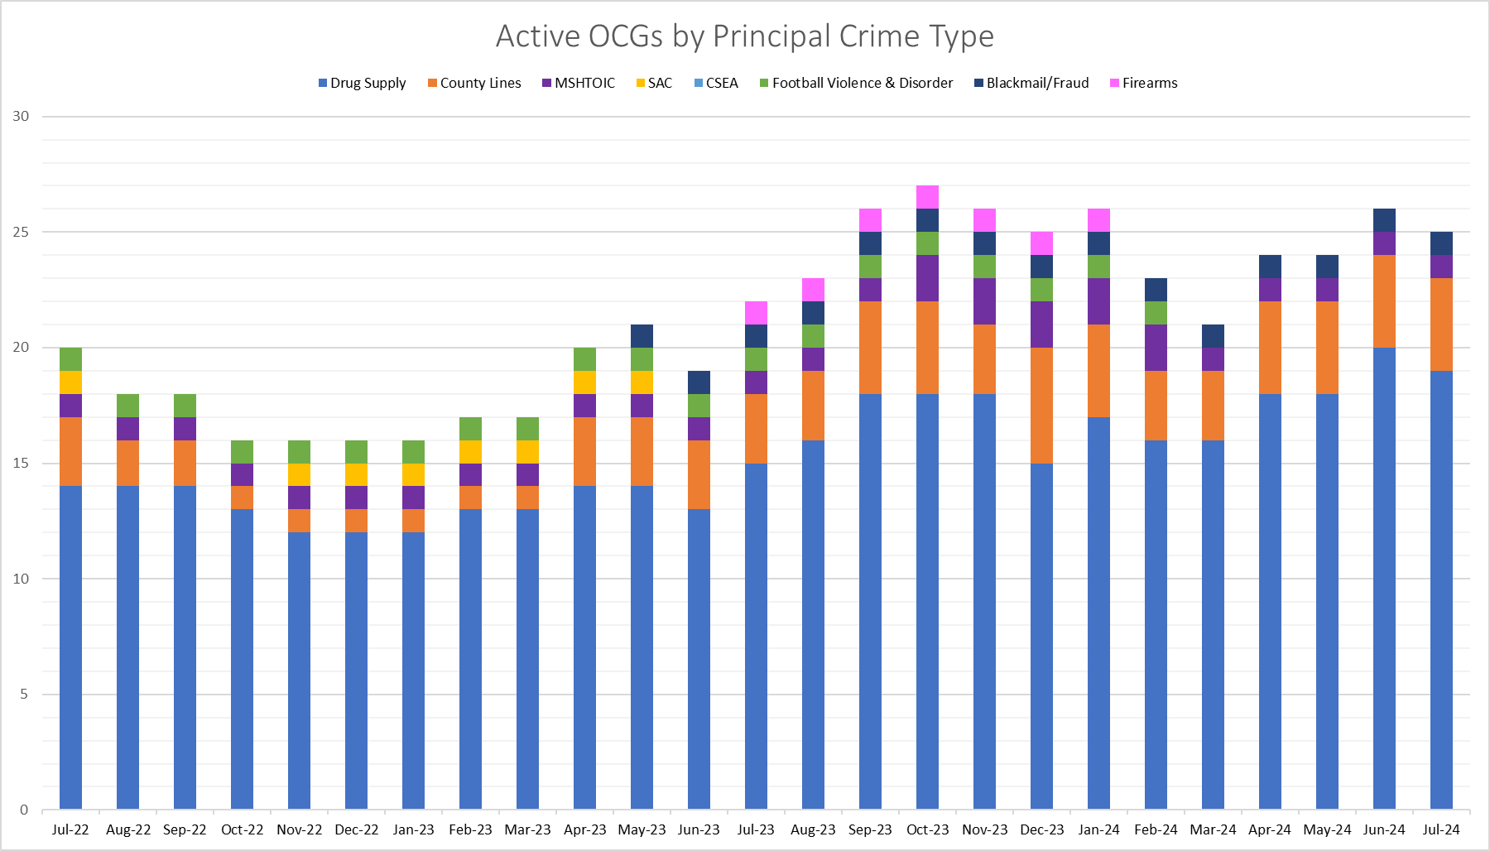

*Source: Cumbria Constabulary*

Over the past 12 months [August 2023 to July 2024] there have been 35 OCGS active at some time in Cumbria, the majority are involved in drug supply. It should be noted that this number includes a number that are classed as active for the purposes of OCGM, but which have been disrupted and are going through the criminal justice system.

Over the last 12 months there has been an increase in the number of mapped OCGs. This is due to increased formal recording of these groups to enable the correct allocation of resources and appropriate response.

The majority of all OCGs in Cumbria are involved in drug supply criminality including CL- drug supply, both now and historically. Currently, there are 23 of the 25 active groups involved in drug supply and CL – drug supply accounting for 92% of the total, with the most prevalent commodities being cocaine and heroin. This proportion is consistent over time, with 30 of the 35 groups active over the past 12 months involved in drug supply or CL – drug supply.

CL – Drug supply groups are mostly linked to the supply of heroin and crack cocaine, There are groups also involved in cannabis cultivation, supply of cocaine, and the supply of mephedrone and ketamine.

# **Crime and Offenders**

The previous Drug and Alcohol report focused on crime and exploitation, however, this year the Cumbria constabulary are unable to provide an update relating to exploitation and have focused their update on offenders.

# Cannabis Cultivation

Cannabis related drug offences accounted for 59% of all drug offences in the FY 23/24, in 22/23 they accounted for 56% of all drug offences. The offences of possession with intent to supply cannabis and supplying or offering to supply cannabis have seen a 10% decrease in FY 23/24 compared to FY 22/23 from 60 offences to 54. The offence of possession of cannabis has seen a 64% increase in FY 23/24 compared to FY 22/23 from 547 offences to 896.

In the FY 23/24 there were 34 cannabis cultivation offences in Cumbria, a decrease of 10.5% compared to the previous year (4 fewer offences). Although overall levels are lower for the 23/24 FY when compared to the previous year, between August and November the levels remained consistent with a slight peak (1 additional offence) in November. Previous years have not seen this type of consistency and have tended to see large peaks followed by steep drops (see Figure 20).

Of the 34 cannabis cultivation offences in 23/24, 62% (21) were in Cumberland and 38% were in Westmorland & Furness (13). Cumberland saw 7 fewer offences in 23/24 when compared to the previous year, whereas Westmorland & Furness saw 3 additional offences. 86% of the offenders were male, 14% were female. The largest age group for offenders was 38% (31-40), the second largest age group was 33% (41-50).

### Figure 20: Cannabis Cultivation Volume; 2021 – 2024.

*Source: Cumbria Constabulary*

# Class A Drugs

During the FY 23/24 there were 374 possession of Class A drug offences within Cumbria, an increase of 41% compared to the previous year. The table below shows the breakdown of the specific Class A drug offences and the changes seen in FY 23/24 compared to FY22/23. Cocaine offences have increased 54% (109 additional offences).

### Table 30: Possession of Class A Drugs; 2022 – 2024.

|  |  |  |  |
| --- | --- | --- | --- |
| **Offence** | **2022 – 2023** | **2023 – 2024** | **Change (%)** |
| Having Possession of a Controlled Drug – Class A Cocaine | 202 | 311 | 54 |
| Having Possession of a Controlled Drug – Class A Heroin | 31 | 26 | -16 |
| Having Possession of a Controlled Drug – Other Class A | 14 | 19 | 36 |
| Having Possession of a Controlled Drug – Class A MDMA | 9 | 12 | 33 |
| Having Possession of a Controlled Drug – Class A “Crack” | 7 | 3 | -57 |
| Having Possession of a Controlled Drug – Class A Methadone | 2 | 2 | 0 |
| Having Possession of a Controlled Drug – Class A Crystal Meth | 1 | 0 | -100 |
| Having Possession of a Controlled Drug – Class A LSD | 0 | 1 | N/A |
| **Having Possession of a Controlled Drug – Class A (ALL)** | **266** | **374** | **41** |

*Source: Cumbria Constabulary*

### Figure 21: Possession of Class A Drugs Volume; April 2023 – March 2024.

*Source: Cumbria Constabulary*

There were 232 total drug trafficking offences during FY 23/24, a 4% increase on the previous year (an additional 9 offences). Cannabis related trafficking offences accounted for the highest proportion of trafficking offences (38%); cocaine related trafficking offences had the second highest proportion (26%).

There were 87 Class A drug trafficking offences during FY23/24, a 3% decrease on the previous year (3 fewer offences). Cocaine related trafficking offences made up the largest proportion accounting for 69% of Class A drug trafficking offences; heroin was the second highest accounting for 14%.

### Figure 22: Class A Drug Trafficking Volume; April 2023 – April 2024.

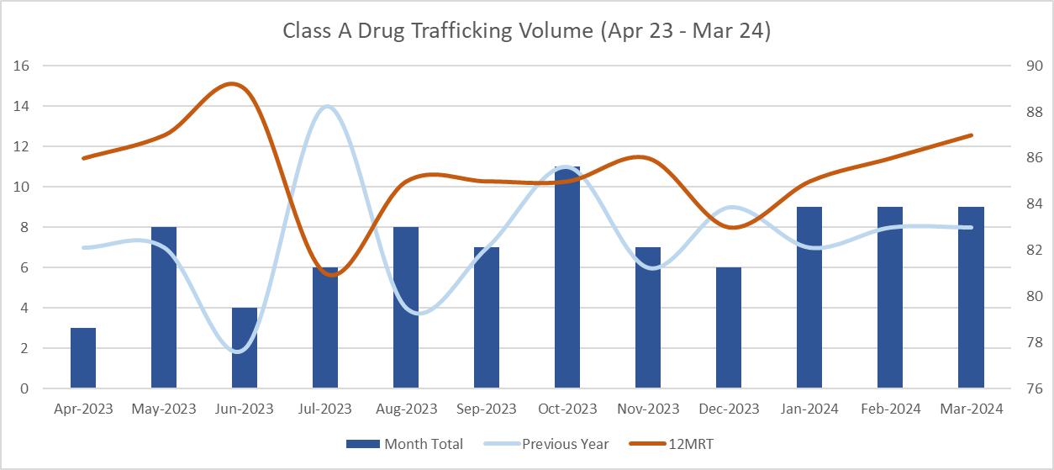

*Source: Cumbria Constabulary*

# Alcohol Related Crime/Incidents

There were 5,825 alcohol-related crimes reported in Cumbria in 2023-24, a 3.9% decrease compared to 2022-23. For comparison 2 previous years had an increase in alcohol-related crimes 2022-23 was 1.3% up (6,064 crimes recorded) and 2021-22 was 51% up (5,988 crimes recorded) compared to the previous financial years. However, the ratio for alcohol-related crime increased in 2023-24 by 0.8pp to 16.4 compared to 15.6% in 2022-23.

### Figure 23: Alcohol-related **crimes** 5-year trend; 2019 – 2024.

*Source: Cumbria Constabulary*

The figures for alcohol-related crimes decreased across both BCUs. Cumberland had 3197 alcohol-related crimes recorded, 4.9% decrease, Westmorland and Furness had 2584 alcohol-related crimes recorded, 2% decrease. The data also includes Unknown locations (crimes with errors in location data), 44 alcohol-related crimes, 31.3% decrease. Refer to Table 31 for the individual district data.

### Table 31: District data on alcohol-related **crimes**; 2022 – 2024.

|  |  |  |  |  |
| --- | --- | --- | --- | --- |
| **District** | **2022 - 2023** | **2023 - 2024** | **Difference** | **Change (%)** |
| Allerdale | 1101 | 993 | -108 | -9.8 |
| Barrow-in-Furness | 1231 | 1194 | -37 | -3.0 |
| Carlisle | 1543 | 1404 | -139 | -9.0 |
| Copeland | 719 | 800 | 81 | 11.3 |
| Eden | 331 | 395 | 64 | 19.3 |
| South Lakeland | 1075 | 995 | -80 | -7.4 |
| Unknown | 64 | 44 | -20 | -31.3 |
| **Grand Total** | **6064** | **5825** | **-239** | **-3.9** |

*Source: Cumbria Constabulary*

31.3% of alcohol-related crimes had a domestic abuse flag in 2023 – 24 compared to 30.7% in 2022 – 23. 2.6% of alcohol-related crimes had a sharp weapon flag in 2023 – 24 compared to 1.8% in 2022-23.

In 2023 – 24 there were 1,592 offenders for alcohol-related crimes, 2.9% increase from previous year. For alcohol-related crimes, 76.6% of the offenders were male/transgender male; 34.7% were age between 18 – 30; and 86.1% were White – British; 20.2% were in Barrow-in-Furness and 19.5% were in Carlisle.

Number of alcohol-related violence against the person offences had the highest decreased of 256 records, 6.4% in 2023 – 24. This offence group accounted for 64.7% of all alcohol-related crimes. Number of alcohol-related drug offences had the highest increase of 80 records, 81.6% in 2023 – 24.

### Table 32: Offence Group data on alcohol-related **crimes**; 2022 – 2024.

|  |  |  |  |  |
| --- | --- | --- | --- | --- |
| **Offence Group** | **2022 - 2023** | **2023 - 2024** | **Difference** | **Change (%)** |
| Arson and Criminal Damage | 487 | 426 | -61 | -12.5 |
| Burglary | 96 | 74 | -22 | -22.9 |
| Drug Offences | 98 | 178 | 80 | 81.6 |
| Miscellaneous Crimes Against Society | 61 | 46 | -15 | -24.6 |
| Possession of Weapons Offences | 64 | 106 | 42 | 65.6 |
| Public Order Offences | 433 | 386 | -47 | -10.9 |
| Robbery | 35 | 42 | 7 | 20.0 |
| Sexual Offences | 310 | 296 | -14 | -4.5 |
| Theft Offences | 406 | 447 | 41 | 10.1 |
| Vehicle Offences | 49 | 55 | 6 | 12.2 |
| Violence Against the Person | 4025 | 3769 | -256 | -6.4 |
| **Grand Total** | **6064** | **5825** | **-239** | **-3.9** |

*Source: Cumbria Constabulary*

In 2023 – 24 there were 6,045 alcohol related incidents recorded in Cumbria, 8.3% decrease compared to 2022 – 23. Alcohol-related incidents accounted for 6% of all incidents reported in Cumbria in 2023-24, 0.5pp decrease compared to 2022-23. The figures for alcohol-related incidents decreased across both BCUs. Cumberland had 3357 alcohol-related incidents recorded, 6.7% decrease, Westmorland and Furness had 2663 alcohol-related crimes recorded, 9.9% decrease; Unknown had 25 alcohol-related incidents recorded, 37.5% decrease. Refer to Figure 23 and Table 33 for further details.

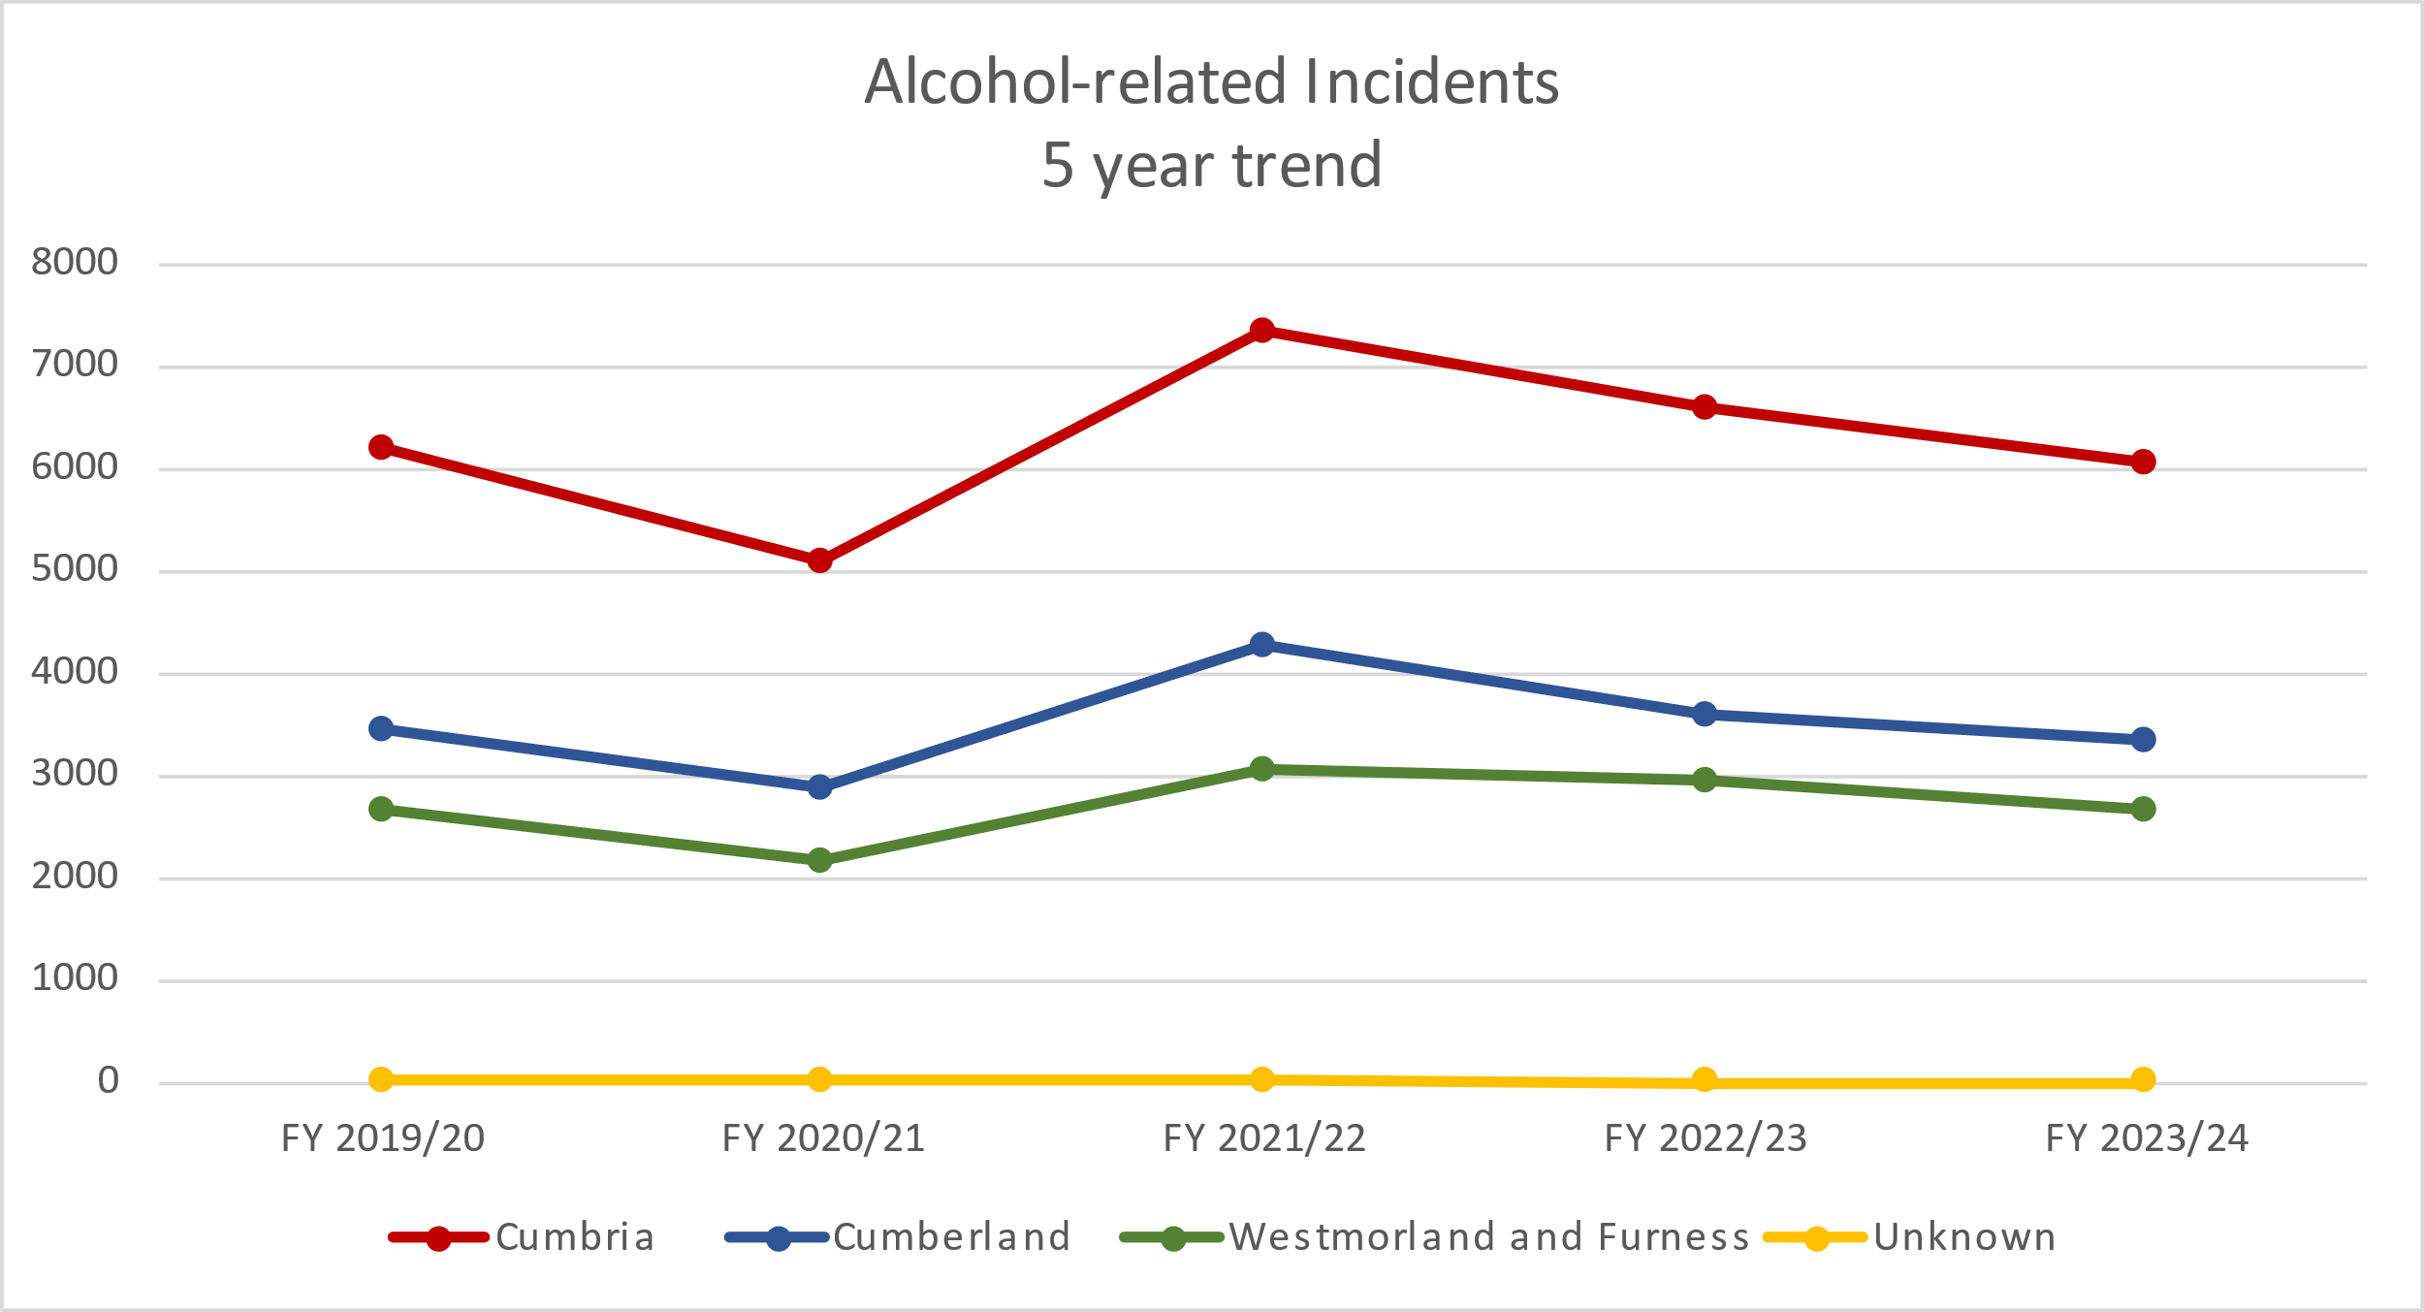Figure 23: Alcohol-related **incidents** 5-year trend; 2019 – 2024.

*Source: Cumbria Constabulary*

### Table 33: District data on alcohol-related **incidents**; 2022 – 2024.

|  |  |  |  |  |
| --- | --- | --- | --- | --- |
| **District** | **2022 - 2023** | **2023 - 2024** | **Difference** | **Change (%)** |
| Allerdale | 1058 | 1039 | -19 | -1.8 |
| Barrow-in-Furness | 1156 | 959 | -197 | -17.0 |
| Carlisle | 1689 | 1469 | -220 | -13.0 |
| Copeland | 851 | 849 | -2 | -0.2 |
| Eden | 516 | 563 | 47 | 9.1 |
| South Lakeland | 1284 | 1141 | -143 | -11.1 |
| Unknown | 40 | 25 | -15 | -37.5 |
| **Grand Total** | **6594** | **6045** | **-549** | **-8.3** |

*Source: Cumbria Constabulary*

Out of all alcohol-related incidents, 39.9% were grouped under crime; 37.4% were grouped under public safety and welfare; 12.1% were grouped under transport and 10.4% were grouped under anti-social behaviour. Anti-social behaviour had the highest decrease in numbers of alcohol related incidents, 18.7%.

# Recommendations

* The Cumbria constabulary will continue to monitor levels of alcohol-related deaths and push the need to record as much information as possible.
* Link in with the local coroner’s office to receive information after cause of death has been confirmed.
* Further short-term analysis is required to include similar force-level data of alcohol-related deaths, partner agencies and investigate national levels where available for comparisons and learnings where possible.

# **Criminal Justice System**

A large number of clients in treatment are in contact with the CJS; this is defined as clients who are taken onto a Criminal Justice Intervention Team (CJIT) caseload within 42 days of the earliest triage, or the first referral source is a criminal justice referral. Clients in treatment for opiate use are more likely to be in contact with the CJS reflecting the national picture.

In 2022-23, there were a total of 407 clients in treatment who were in contact with the CJS, accounting for 15% overall. 67 clients were in treatment for alcohol only, accounting for 6.9%, similar to England at 7.2%.

A total of 44 clients (out of 407) in contact with the CJS successfully completed their treatment (in the last 12 months) accounting for 10.81%, this is below the national average of 23.7% (see Table 34).

### Table 34: Clients in treatment who are in contact with the Criminal Justice System clients in treatment; and successful completions of CJS clients (last 12 months); 2022 – 2023.

|  |  |  |  |  |  |
| --- | --- | --- | --- | --- | --- |
| **Partnership** | **Sub Substance Category** | **Proportion of the treatment population in contact with the criminal justice system (n / N, %)** | | **Successful completions as a proportion of Criminal Justice clients of all in treatment (n / N, %)** | |
| Cumbria | Alcohol only | 67 / 973 | 6.9% | 24 / 67 | 35.8% |
|  | Alcohol and non-opiate only | 14 / 139 | 10.1% | <5 / 14 | 21.4% |
|  | Non-opiate only | 46 / 265 | 17.4% | 10 / 46 | 21.7% |
|  | Opiate only | 280 / 1362 | 20.6% | 7 / 280 | 2.5% |
| National | Alcohol only | Not reported | 7.2% | Not reported | 35.7% |
|  | Alcohol and non-opiate only | Not reported | 12.9% | Not reported | 27.4% |
|  | Non-opiate only | Not reported | 13.1% | Not reported | 28.5% |
|  | Opiate only | Not reported | 18.7% | Not reported | 3.2% |

*Source:* [*DOMES/NDTMS*](https://www.ndtms.net/NDTMSReports/GetDOMESReports?ReportName=Diagnostic%20Outcomes%20Monitoring%20Executive%20Summary%20CDSP&ReportDescription=Diagnostic%20Outcomes%20Monitoring%20Executive%20Summary%20CDSP&Width=100&Height=1200)

Cumbria Probation Service – Offenders

As of August 2024, there were 2,053 individual offenders registered with Cumbria Probation Service; of those, 175 cases were relating to drug and alcohol offences. The majority of drug offence individuals were male accounting for 76%, representative of overall cases at 86%. Most drug offence individuals were aged over 35 years, accounting for just over half of cases (60%) reflecting the age profile of all cases registered with the service (57%) (see Table 35). 92% of drug offence individuals were of British ethnicity, similar to the overall ethnicity of all cases at 93%.

### Table 35: Cumbria Probation Service: Caseload profile by Age; August 2024.

|  |  |  |  |  |
| --- | --- | --- | --- | --- |
|  | **All cases** | | **Drug offence cases** | |
|  | **Number** | **%** | **Number** | **%** |
| 18 – 23 | 148 | 7 | 12 | 7 |
| 24 – 29 | 317 | 15 | 29 | 17 |
| 30 – 34 | 373 | 18 | 29 | 17 |
| 35 and over | 1174 | 57 | 105 | 60 |
| Deceased | 3 | 2 | 0 | 0 |
| Total | 2053 | 100 | 175 | 100 |

*Source: Cumbria Probation*

The greatest proportion of offenders in Cumbria are located in the Carlisle area accounting for 38.4%; the greatest proportion of drug offence cases are also located in Carlisle accounting for 41.5%, likely reflecting population levels as well as need (see Figure 24).

# At Risk Vulnerable Groups

89 of the 175 drug offence individuals had a recorded mental illness accounting for 50.8%; this compares to 50.9% of all individual cases [please note this is likely to be higher as not all records were complete]. Since 2022, there has been a change in interpretation of vulnerable groups related to mental health, this explains why since 2022 the rate increases from 24% to 50.8%.

In addition, 21 drug offence individuals had stated they had no disability, accounting for 12%, this compares to 19.5% of all individual cases.

There are a number of offenders defined in law as eligible for MAPPA (Multi-agency public protection arrangements) management, because they have committed specified sexual and violent offences, or they currently pose a risk of serious harm to others. In Cumbria a total of 763 individual cases were subject to MAPPA accounting for 37.1%; numbers of drug offence individuals subject to MAPPA are negligible (1.7%).

# Offenders Criminogenic Need

The Offender Assessment System (OASys) is used by the National Probation Service (and Her Majesty's Prison Service) to measure the risks and needs of criminal offenders under their supervision. The system includes analysis of static (criminal history and demographic) and dynamic (social and personal) risk factors, risk of serious harm, sentence planning, a self-assessment questionnaire (i.e. offender-completed) and a summary sheet. The OASys generates a summary risk score to assess the likelihood of reoffending and risk of harm to self and others, these are known as: OASys General reoffending Predictor (OGP) and the OASys Violence Predictor (OVP).

OVP predict the likelihood of non-violent and proven reoffending respectively, by combining information on the offender’s static and dynamic risk factors. The Offender Group Reconviction Scale (OGRS) is a risk assessment tool used to estimate the likelihood of re-offending. It uses static factors such as age, gender and criminal history and then gives a score, which shows the likelihood of someone re-offending within a 12–24-month period.

As of August 2024, in Cumbria there were a total of 2035 Offender Assessments (OASys). Of those, 172 offenders had a drug-use need recorded accounting for 8.5% of all Offender Assessments; this compares to 41% drug-use need in the North West.

The risk of reconviction for offenders with a drug-use need is much greater than the average for all offenders. Out of the 172 offenders with a drug-use need, 17 have been deemed as ‘high risk’ accounting for 1 in 100 (9.9%); this compares to the average of 23.4% for all offenders.

# Prison Continuity of Care

As of March 2023, 167 adults were released from prison and transferred to community treatment; of those, 84 clients were picked up in the community (of all released from prison) and transferred to community treatment accounting for 50.3%; this is higher than the national average at 40.7%. (Source: [DOMES/NDTMS](https://www.ndtms.net/NDTMSReports/PrevalenceAndUnmetNeedToolkit)).

# Drug Use in Prison

Nationally, drugs within prisons are widely available with around 15% of prisoners testing positive to random drug tests. The problems are greatest in male local and category C prisons. New psychoactive substances have become increasingly problematic in prisons. Drug use in prisons is closely linked to the amount of purposeful activity available to prisoners. (Source: Review of Drugs; Dame Carol Black; February 2020).

Local data on drug use in prison is not readily available; anecdotally the main drugs of use in prisons are novel psychoactive substances (spice), cannabis, illicit buprenorphine, opiates, steroids.

# **Children and Young People**

# Problematic Drug Use in Young People

Although most young people do not use drugs, substance use can have a significant impact on a young person’s health, education, long-term opportunities and chances in life as well as a detrimental impact on the families and friends. Effective substance use interventions can significantly improve the overall health and wellbeing of a young person as well as reducing risk taking behaviour such as offending.

Young people most at risk of substance use and those who enter substance use services often have a range of problems and vulnerabilities including polydrug use, mental health needs, being involved with social services such as a looked after child or a child in need, or not in education, employment or training (NEET). Other risk factors include self-harming, sexual exploitation, anti-social behaviour, offending or domestic abuse. Girls tend to report more vulnerabilities than boys, in particular self-harming and sexual exploitation. (Source: Young people’s substance use treatment statistics, OHID).

Many young people receiving specialist interventions for substance use report a range of vulnerabilities and risks at the start of treatment including, not in education, employment or training (NEET), in contact with the youth justice system, victims of domestic abuse and sexual exploitation.

Nationally, cannabis is the most common substance for young people’s substance use followed by cocaine. The Crime Survey for England and Wales in 2022 – 2023 estimated 1 in 5 young people aged 16-24 years had taken a drug in the last year.7 The survey found cannabis was the most common drug used by 15% of 16–24-year-olds; nitrous oxide use has fallen from 9% in 2019 – 2020 to 4% in 2022 – 2023. Drug use was more apparent in low-income households. (Source: [Drug use in England and Wales - Appendix table - Office for National Statistics (ons.gov.uk)](https://www.ons.gov.uk/peoplepopulationandcommunity/crimeandjustice/datasets/drugmisuseinenglandandwalesappendixtable))

Nationally, 85–90% of young people presenting to substance use treatment have problems with cannabis use. Since 2013, alcohol problems continue to fall steadily from 46% in 2020 down to 44% for 2022 - 2023.8 Increases are also apparent in young people in treatment for benzodiazepines and ketamine but at much lower levels. There have been decreases in proportions of young people in treatment for cocaine, ecstasy and amphetamines. (Source: [Young people substance use treatment statistics; 2005-06 to 2023-24](https://www.gov.uk/government/statistics/substance-misuse-treatment-for-young-people-2022-to-2023/young-peoples-substance-misuse-treatment-statistics-2022-to-2023-report" \l "trends-over-time)).

The Youth Substance Use Team

The Youth Substance Use Teams in Cumbria provides a point of contact for young people aged under 18 years in crisis in relation to alcohol and substance use (There is one team covering each Local Authority area). They provide a universal early intervention service, delivering harm reduction advice to prevent the escalation of risk-taking behaviour. Services include support relating to youth substance use, homelessness, and housing.

In 2023, the youth substance use team received around 270 referrals for young people for both Westmorland and Furness and Cumberland areas. The majority or referrals were male (74 and 71 for Westmorland and Furness and Cumberland, respectively). Over half of these referrals were for drugs. Regardless of alcohol or drug use, fewer referrals were made in West Cumberland compared to North Cumberland and Westmorland and Furness (see Table 36).

### Table 36: Number of Referrals to the Youth Substance Use Team; April 2023 – March 2024.

|  |  |  |  |
| --- | --- | --- | --- |
| **Type of Referral** | **Westmorland & Furness** | **Cumberland** | |
| **N (%)** | **North N (%)** | **West N (%)** |
| Drugs | 53 (53) | 65 (64) | 34 (49) |
| Alcohol | 34 (34) | 31 (31) | 23 (33) |
| Both | 13 (13) | 5 (5) | 12 (17) |
| Total | 100 (100) | 101 (100) | 69 (100) |
| **Gender** | | | |
| Male | 74 (74) | 71 (70) | 42 (61) |
| Female | 26 (26) | 30 (30) | 27 (39) |
| **Total** | **100** | **101** | **69** |

*Source: Youth Substance Use Team, Westmorland & Furness/Cumberland Councils*

# Hospital Admissions for Alcohol in Under 18s

The COVID-19 pandemic significantly impacted hospital activity in 2020 to 2021, not only a reduction in hospital admissions overall but a reduction in the number of hospital admission episodes for under 18s where the primary or secondary diagnoses are alcohol-specific (wholly attributable). Prior to the pandemic, numbers of alcohol-specific admissions for under 18s were declining in Cumbria, reflecting the national picture; despite this, rates for 2022 – 2023 remain worse than the national average at 42.5 per 100,000 compared to 26 in England. Across the districts, rates are worse than the national average (See Figure 24 and 25 and Tables 37 and 38).

### A screenshot of a computer Description automatically generatedFigure 24: Admission episodes for alcohol-specific conditions-under 18s: all persons, crude rate per 100,000 in **Westmorland and Furness**; 2012 – 2023.

*Source:* [*Alcohol Profile - Data - OHID (phe.org.uk)*](https://fingertips.phe.org.uk/profile/local-alcohol-profiles/data#page/4/gid/1938132982/pat/6/par/E12000002/ati/501/are/E06000064/iid/92904/age/173/sex/4/cat/-1/ctp/-1/yrr/3/cid/4/tbm/1/page-options/tre-do-0)

### Figure 25: Admission episodes for alcohol-specific conditions-under 18s: all persons, crude rate per 100,000 in **Cumberland**; 2012 – 2023.

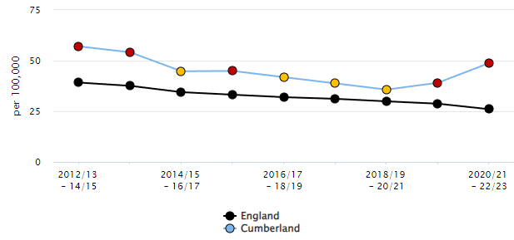

*Source:* [*Alcohol Profile - Data - OHID (phe.org.uk)*](https://fingertips.phe.org.uk/profile/local-alcohol-profiles/data#page/4/gid/1938132984/pat/6/ati/501/are/E06000063/iid/92904/age/173/sex/4/cat/-1/ctp/-1/yrr/3/cid/4/tbm/1/page-options/tre-do-0)

### A screenshot of a computer Description automatically generatedTable 37: Admission episodes for alcohol-specific conditions-under 18s: all persons, crude rate per 100,000 in **Westmorland and Furness**; 2012 – 2023.

*Source:* [*Alcohol Profile - Data - OHID (phe.org.uk)*](https://fingertips.phe.org.uk/profile/local-alcohol-profiles/data#page/4/gid/1938132984/pat/6/ati/501/are/E06000064/iid/92904/age/173/sex/4/cat/-1/ctp/-1/yrr/3/cid/4/tbm/1/page-options/tre-do-0)

### Table 38: Admission episodes for alcohol-specific conditions-under 18s: all persons, crude rate per 100,000 in **Cumberland**; 2012 – 2023.

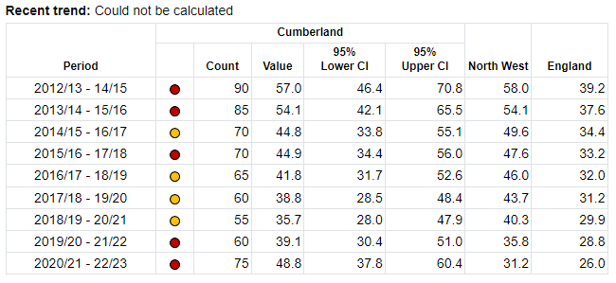

*Source:* [*Alcohol Profile - Data - OHID (phe.org.uk*](https://fingertips.phe.org.uk/profile/local-alcohol-profiles/data#page/4/gid/1938132984/pat/6/ati/501/are/E06000063/iid/92904/age/173/sex/4/cat/-1/ctp/-1/yrr/3/cid/4/tbm/1/page-options/tre-do-0)*)*

# Alcohol-Related Crime in Under 18s

For details of all alcohol related crime see chapter Crime and Offenders.

In 2023-24, there were 5,277 alcohol-related incidents in Cumbria, of those 42 were ‘youth related’ accounting for 0.79%, this is a decrease from 54 youth related incidents (-22.2%) in the previous year (2022-23). The majority of alcohol-related incidents were linked to public safety and welfare; and alcohol concerned assaults.

In 2023-24, there were 5836 alcohol-related offences in Cumbria; 72 offenders were aged under 18 years accounting for 1.2% of all offences. Of those under 18 years, almost half (35) were under the age of 16 years.

The most common alcohol-related offence by an under 18 years offender was ‘Violence Against the Person’, accounting for 43 of the 72 offences; this was closely followed by ‘Arson and Criminal Damage’ offences accounting for 11 of the 72 offences. When considering offences by those aged under 16 years ‘Violence Against the Person’ accounted for 21 of the 35 offences.

In addition to the number of alcohol-related offenders reported above. In 2023-24; 272 alcohol-related victim records involved a victim aged under 18 years. Of those, 175 records related to ‘Violence against the person’ accounting for 64.3%. 71 records related to ‘sexual offences’ (the second most common category) accounting for 26.1%.

# Safeguarding of Vulnerable People and Children

The following data is a summary of Safeguarding records created by Cumbria Constabulary only and therefore is not a complete picture across all partners, organisations and agencies in Cumbria.

Through the financial year 23/24 (01/04/2023 – 31/03/2024), Cumbria Constabulary created 23,474 safeguarding records; subcategorised into 8,931 records relating to domestic abuse; 8,307 relating to vulnerable children; and 6,236 relating to vulnerable adults.

A total of 3,895 records had a risk marker relating to alcohol, accounting for 16.6% of all safeguarding records created. 2,383 domestic abuse safeguarding records had a risk marker relating to alcohol which is 26.7% of all DA safeguarding records, or 61.2% of all alcohol related Safeguarding reports. 530 (6%) vulnerable child safeguarding records had a risk marker relating to alcohol. This does not indicate that alcohol was the only or main vulnerability, on that it was a contributing factor.

Cumberland had the higher number of alcohol related records at 2,092 (53.7%). Westmorland & Furness had 1,729 records (44.4%). The remaining 74 (1.9%) were not recorded under either BCU and were marked as “unknown”.

[Caveat: Before drawing any statistical conclusions, consideration should be given to the impact of multiple complex needs and co-morbidities. The above data relating to Safeguarding records refers to alcohol as one contributing factor and, in some cases, safeguarding records may be created due to multiple complex needs, where alcohol is not the main cause for concern. However, it is well documented that alcohol abuse increases vulnerabilities and risk of victimisation and also increases the risk of violent behaviour, criminal activity and offending/reoffending].

Further data relating to domestic violence (incidents and crimes) can be found in the Crime and Community Safety Strategic Assessment 2020-21.

# Cumbria Addictions Advice & Solutions (CADAS)

There are several third sector organisations across Cumbria providing advice and support for alcohol and substance use. Information and data in relation to the numbers of people accessing services is not available for all services however data is available from one of the providers - Cumbria Addictions Advice & Solutions (CADAS).

CADAS offers a choice of telephone, virtual and face to face 1-1 biopsychosocial interventions as well as five community-based weekly peer support groups in Westmorland & Furness, and a further five in Cumberland as well as an online peer support group for adults to support their recovery maintenance. Affected Others can access bi-weekly locality-based peer support groups as well as an online peer support group.

During the period April 2023 to March 2024, there were 422 requests for support; 350 referrals were received for Adult Recovery support (up to 12 sessions of therapeutic substance dependency support either face to face, online or phone). Of those, 64% clients required alcohol support, 12% and 16% of clients required cannabis and cocaine support, respectively. With 4% of clients requiring support for addiction to prescription medication. A further 4% use either heroin, crack, ketamine or ‘other’ substance. Of the 422 requests received, 350 (83%) were for adult recovery support services, 25 (6%) were for young people affected by addictive behaviours and 47 (11%) were from affected others (e.g. adult or child loved ones affected by a family, carers, friends addictive behaviour). Table 39 highlights the breakdown of services, sustained engagement, and positive outcome rates.

### Table 39: Breakdown of services, engagement and outcomes; 2023 – 2024.

|  |  |  |  |
| --- | --- | --- | --- |
|  | **Adult services**  **(n, %)** | **Young people services (n, %)** | **Affected others (n, %)** |
| Number of referrals | 350 | 25 | 47 |
| SNAP | 241 (69%) | 14 (56%) | 42 (89%) |
| Sustained engagement* | 165 (47%) | 11 (79%) | 33 (78%) |
| Excited CADAS having achieved a positive outcome# | 115 (70%) | 7 (63%) | 20 (60%) |
| Key: SNAP, support needs assessment & plan.  Note: *, 1-1biopsychosocial interventions or peer support groups (or a combination of both); #, positive outcomes referring to harm reduction and improved wellbeing/resilience to be in recovery capital for their loved one. | | | |

*Source: CADAS*

Throughout the same period, fewer young people engaged with CADAS and is attributed to third party referrals (professionals and parents/carers) whereby young people do not see their behaviour as problematic. Of the 25 referrals received for young people, just over half of those engaged with the service. Of those who did, 68% required support for cannabis use, 12% for VSU support, 8% for both vaping and cocaine and 4% for alcohol.

# **Authors and Contributors**

|  |  |  |
| --- | --- | --- |
| **Name** | **Role** | **Organisation** |
| Ryan Rocks | Junior Doctor in Public Health | Westmorland and Furness Council |
| Nicola Mason | Senior Analyst – Substance Use Team | Westmorland and Furness Council and Cumberland Council |
| John Salisbury | Public Health Manager – Substance Use Team | Westmorland and Furness Council and Cumberland Council |
| Ali Braggs | Senior Analyst | Cumberland Council |
| Jo Woof | Partnership Analyst | Office of the Police and Crime Commissioner – Cumbria |
| Rachel Casson | Health and Justice – Community Integration Officer | North West Probation Service |
| Emily Horrobin | Quality and Improvement Lead | CADAS |

We would like to acknowledge our special thanks to our partners at the Cumbria Multiagency Drug Harm Prevention Group, including: Cumberland Council, Westmorland & Furness Council; Cumbria Constabulary; Recovery Steps Cumbria; CADAS; The Well Communities; North Cumbria Integrated Care Board; Lancashire and South Cumbria Integrated Care Board; University Hospitals of Morecambe Bay NHS Foundation Trust; North West Ambulance Service; Criminal Justice Service; National Probation Service; HM Prison Service.

# **References and Data Sources**

1. Oliver P, Keen J. Con-commitant drugs of use and drug-using behaviours

associated with fatal opiate-related poisonings in Sheffield, UK, 1997-2000.

Addiction 2003; 98:191-7

1. NICE. Alcohol-use disorders: diagnosis, assessment and management of harmful drinking (high-risk drinking) and alcohol dependence, Clinical guidelines (CG115), <https://www.nice.org.uk/guidance/cg115/chapter/introduction>. [Published: 23 February 2011; Last updated: 21 October 2014]
2. Public Health England. Health matters: harmful drinking and alcohol dependence, GOV.UK ([www.gov.uk](http://www.gov.uk)). [Published: 21 January 2016]
3. Department of Health & Social Care. Fingertips, Public health profiles, <https://fingertips.phe.org.uk/profile/local-alcohol-profiles/data#page/1>. 2023 [Accessed: October 2024]
4. Cumbria Council. Cumbria Drug and Alcohol Joint Strategic Needs Assessment (JSNA), <https://cumbria.gov.uk/elibrary/Content/Internet/536/671/4674/17217/17226/44985152658.pdf>. [Published: December 2022; Accessed: October 2024]
5. HM Government. [From Harm to Hope: A 10-year drugs plan to cut crime and save lives](https://assets.publishing.service.gov.uk/media/629078bad3bf7f036fc492d1/From_harm_to_hope_PDF.pdf). December 2021
6. Office for National Statistics. Drug misuse in England and Wales - Appendix table, Section 3.01,[ons.gov.uk](https://www.ons.gov.uk/peoplepopulationandcommunity/crimeandjustice/datasets/drugmisuseinenglandandwalesappendixtable). [Published: 14 December 2023; Accessed: October 2024]
7. Office for Health Improvement & Disparities. Young people’s substance misuse treatment statistics 2022 to 2023: report, GOV.UK (www.gov.uk). [Published 25 January 2024: Accessed October 2024]
8. Public Health England. Understanding and preventing Drug-Related Deaths. [PHE Understanding and preventing DRDs 2016](https://assets.publishing.service.gov.uk/government/uploads/system/uploads/attachment_data/file/669308/Understanding_and_preventing_drug_related_deaths_report.pdf). [Published: September 2016; Accessed: October 2024]

|  |  |
| --- | --- |
| **Data sources** | **Link** |
| National Drug Treatment Monitoring System | <https://www.ndtms.net/> |
| Department of Health & Social Care: Fingertips | <https://fingertips.phe.org.uk> |
| Alcohol dependence prevalence in England | [www.gov.uk/government/publications/alcohol-dependence-prevalence-in-england](http://www.gov.uk/government/publications/alcohol-dependence-prevalence-in-england) |
| Alcohol and drug misuse prevention, treatment and recovery guidance | [www.gov.uk/government/collections/alcohol-and-drug-misuse-prevention-and-treatment-guidance](http://www.gov.uk/government/collections/alcohol-and-drug-misuse-prevention-and-treatment-guidance) |
| Office for National Statistics | [https://www.ons.gov.uk/peoplepopulationandcommunity/ birthsdeathsandmarriages/deaths/datasets/ drugmisusedeathsbylocalauthority](https://www.ons.gov.uk/peoplepopulationandcommunity/%20birthsdeathsandmarriages/deaths/datasets/%20drugmisusedeathsbylocalauthority) | |

# **Appendix 1**

# Pathways Programme; Cumbria Constabulary and the Police and Crime Commissioner

Since the start of Pathways Programme 1411 referrals have been received, as stated above 1,099 have completed rehabilitative conditions successfully, 232 offenders have breached *(+ 80 inappropriate referrals)*. Of the 1411 referrals, 182 of these had drugs as the primary or secondary offence. Of these 182 referrals, at the time of compiling the report 124 had successfully completed the programme.

As of 17/09/24 there are further 61 workable ongoing referrals and a further 17 potential referrals. Evidence relating to the effectiveness of the programme is shown in the current re-offending rate of those completing the programme.

The re-offending rate is currently 4.9% meaning that 95.1% of clients have successfully completed that programme and have not re-offended. In addition, the Harm Reduction Rate for clients attending the programme equates to 53.74%.

# Recovery Steps

Recovery Steps Cumbria is a drug and alcohol recovery service, providing treatment and recovery support for individuals (aged 18 years and above) and their family members who are affected by substance use (including alcohol, illicit drugs and over the counter and prescribed medication).

# County Lines Informed Cumbria (1CLIC)

County Lines Informed Cumbria (1CLIC) was a two-year pilot programme funded by Cumbria’s Police and Crime Commissioner aimed at targeting county lines in Barrow. The programme identifies vulnerable people who are most at risk of being approached by drug gangs, supports them to move away from potential criminal behaviour and make positive life decisions. 1CLIC encourages long lasting behavioural change and supports the recovery of those who are already using drugs.

Following on from the successful pilot the programme has been extended in Barrow and expanded into Carlisle with the appointment of PC Jen Lewis and Ryan Kimmins from the Well.

Cumbria Constabulary working in partnership with The Well Communities, an organisation that supports those who are recovering from addiction through counselling, peer mentoring, social activities, and other practical services such as housing and employment support.

Upon expansion in Carlisle a previously unknown County Line operating from Newcastle was identified to be working in Carlisle, they were targeting females in their 20’s to stay at and operate from their homes, numerous visits were made, and the nominals involved were identified.

Partner work with owing force built the intel picture and the visits and support for the females made their premises too hot for them to operate from and led to them leaving Carlisle, they have not returned since. This has reduced the risk of exploitation to the group of females from the line and also meant that Class A high harm drugs were removed from being in circulation from the line in Carlisle.

There has been no County Line based in Kendal in 2024 (sporadic activity in previous 5 months), this is a considerable achievement as there had previously been 2 embedded lines in Kendal, this has led to a reduction in violence linked to CL and a reduction in exploitation.

County Line activity has been much more sporadic in Barrow with periods of time with no activity, when a line does come to Barrow it is not able to run a long-haul embedded operation and comes to do a “firesale”, selling its product quickly as they are aware they will be targeted quickly.

The expansion in Carlisle has led to a large uptick in CL intel and referrals to partners for support, this has led to a much-improved intel picture around activity which has led to a number of arrests/warrants and operations targeting them.

This in turn has led to many support packages being put in place to support vulnerable people.

Key achievements since January 2024 and expansion into Cumberland include:

• A strong working relationship between The Well Communities CIC and Cumbria Constabulary through Duane Gaitskell and Kev Milby in WAF and Jen Lewis and Ryan Kimmins in Cumberland

• Proactive visits within the community (over 1050 since Jan 2024)

• 1-CLIC sit on IOM, MATAC, MAC , CHB meetings promoting good partner working

• Presentations around CL, drugs and signs of exploitation including lived experience inputs provided to 11 schools/colleges/PRU’s totaling 545 pupils (staff also present)

• Awareness of 1-CLIC raised through articles in News and Star, TV exposure on ITV Border and BBC North West and Northeast gaining widespread coverage in the whole region

• strong working relationships with Probation service

• strong working relationship with council and private housing providers

• Ryan Guest is now volunteering with 1-CLIC and has attended a number of school inputs providing lived experience inputs.

• 5 inputs to partner agencies totaling 46 staff, signs of exploitation and what to look out for explained

Naloxone training for 1-CLIC and carried on visits, ability to provide to known users on visits.

Increase in joint working with BTP – joint operation at Carlisle train station in Feb 24, this has led to BTP offering a 2-day deployment in Cumbria in Aug 24, this will be around Carlisle train station but will also include option to be used away from train station – first of its kind partner deployment.

1-CLIC took part in the largest ever StreetSafe in Cumbria – 1843 premises visited as part of CHB, residents from the Well took part with partners.

Good working relationship established with GrowingWell MH charity, referrals for support and people adopted by them already.

Pester messaging service has been expanded to allow more user access and has been used 6 times for a variety of applications, it has been used upon disruption of lines as well as when there has been potentially harmful heroin in the area, these messages post known drug users towards support and how and where to obtain or contact for support.

# Case Study One - Pathways Programme

The Pathways scheme incorporates an offender management programme that offers reparation for the victim and rehabilitation for the offender. Pathways has a dedicated team of support workers, who identify the root causes of offending, refer to therapeutic programmes whilst addressing underlying vulnerabilities and/or issues with appropriate agencies.

The criminal justice system already uses methods called out-of-court disposals, such as cautions and community resolutions, for some offences. There are two specific new disposals which come under the Pathways Programme – deferred cautions and deferred charges.

The Pathways Programme offers eligible offenders the chance to have charges and cautions deferred on some lower-level offences that are deemed appropriate. In return, offenders must abide by a number of strict conditions such as taking part in a rehabilitation programme, providing possible compensation to victims, or being prevented from going to certain places.

On completion of the Pathways Programme (if the strict conditions have been met) individuals will not receive a police caution or charge to court, removing the need for victims to potentially attend court and give evidence – but also putting the offender on a path that prevents reoffending.

Since the start of Pathways Programme 554 referrals have been received, as stated above 352 have completed rehabilitative conditions successfully, 85 offenders have breached. Of the 554 referrals, 76 of these had drugs as the primary or secondary offence. Of these 76 referrals, at the time of compiling the report 46 had successfully completed the programme.

Evidence relating to the effectiveness of the programme is shown in the current re-offending rate of those completing the programme. The re-offending rate is currently 14.1% meaning that 85.8% of clients have successfully completed that programme and have not re-offended. In addition, the Harm Reduction Rate for clients attending the programme equates to 68.4%.

# Case Study Two - Pathways Programme

Pathways received a referral of an offender, T, who had been arrested for possession of

cannabis. They admitted to using it regularly and felt it helped their mental health.

T was already receiving support for mental health and their finances, so the Pathways support worker focused on further support from Unity.

Halfway through the Pathways scheme, T experienced a family emergency and despite this, still answered their calls, coped well with the situation and didn’t turn to drink or drugs.

Pathways encouraged T to look more into the offence, how it affected people and made T think twice about their bad habits. T said they would recommend Pathways to others, as it is a better option, helpful with finding support and getting personal things sorted out.

# Case Study Three – 1CLIC

**Effective Interventions – Evidence**

Vulnerable adult female (referred to as AF).

AF has a number of mental health issues and had increased use of Class A drugs, there were serious concerns around her being exploited/cuckooed. A few visits were conducted to help establish rapport and gain her trust.

Referrals were made to RSC, Smiles and Gateway for women, this helped gain wrap around support for AF addressing several issues that she was facing.

AF was assessed for residential treatment at The Well which was conducted by 1-CLIC and fast tracked to gain her a bed in residential in Carlisle as she was at crisis point.

She was taken into residential treatment and is taking part in the 12-step program.

This has removed her from being a target by CL linked nominals, it has gained her the support that she needed to move away from substance use, stopped her from being a target to be exploited and removed her premises from being a base of operations.

Without 1-CLIC this female would not have been identified and would have been open to being exploited and continued substance use.

# Case Study Four – 1CLIC

Vulnerable adult male (referred to as DD).

DD was the largest and longest body of work and support that 1-CLIC have provided, he was a long-term Clipp and has been supported throughout the duration of the program in Barrow.

He was extremely vulnerable due to mental health issues, social isolation, location, and disability in being a wheelchair user as well as using substances.

He had been the victim of crime a number of times with him being the injured/involved party for a number of assaults in his home, thefts from him and his property and robbery. He had been targeted by CL and his premises used for a base previously.

Numerous supports were put in place, he was referred to a number of partners and improvements made in the block of flats he lived in through working with partners.

This included getting the council to repair the CCTV in the block, to repair the communal locking doors so the timer worked stopping access after 8pm, applying for and receiving a Community Protection Warning that only allowed one other person (excluding carers/emergency/council workers) in his premises at a time.

This measure worked for a period of time and he was doing well and not using however he relapsed, he used but had serious medical issues following an aneurism, he was taken to Preston hospital and had his leg amputated, he was visited in hospital and further support was put in place.

Numerous multi-agency meetings were held, it was obvious that if he was to return back to his home address, he would be at risk again and considered high risk of death.

1-CLIC explored the possibility of him being repatriated to his family in Belfast, this was agreed with DD and 1-CLIC facilitated everything to allow this to happen arranging support for him in Belfast, housing, obtaining his property and took him from hospital to the airport, he has since settled well in Belfast with no substance use.

1-CLIC identifies the key aspects to make this project work that include:

• Importance of integrated working with statutory and voluntary partners

• Using a MECC (making every contact count) approach when dealing with this cohort.

• Self-generation of referrals.

• Importance of early intervention to prevent county lines operations and exploitation

Being visible in the community conducting vulnerability visits.

The people that 1-CLIC support would fall through the cracks if it was not for the program, they would not be identified, visited, and supported. It also highlights the importance of having a point of contact for partners to report concerns too, without the 1-CLIC staff these referrals in would not be made, these have come from a variety of partners including housing, probation, schools, RSC, NHS.